  - 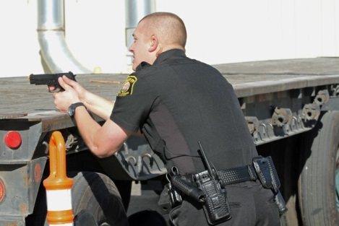

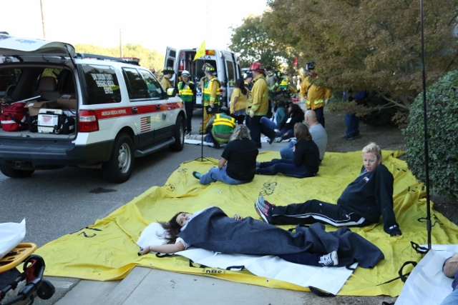

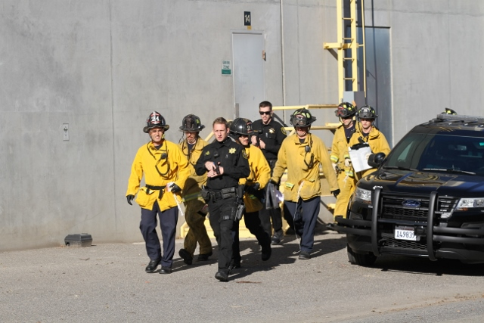

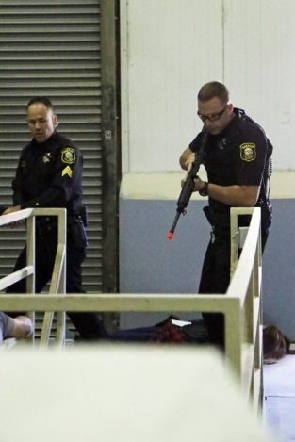

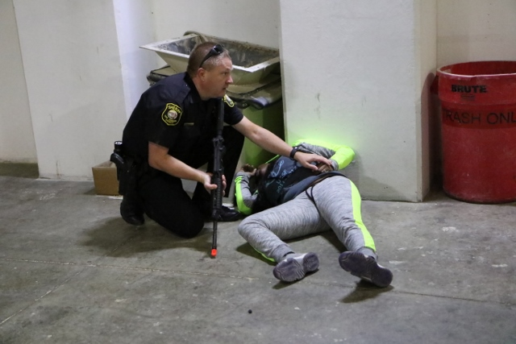

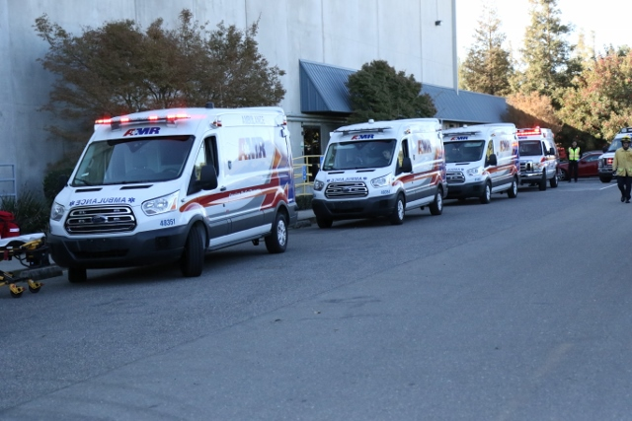

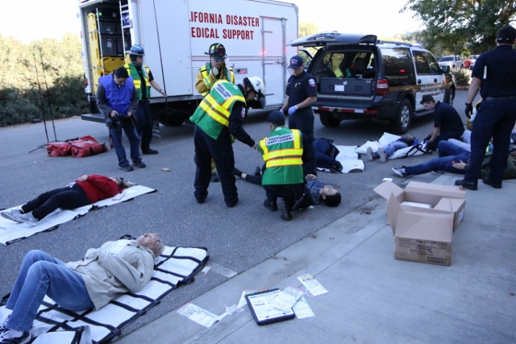

San Joaquin County



Plausible Threat 2017

Tabletop Exercise

Situation Manual

(SitMan)

September 29, 2017

This page intentionally left blank

Table of Contents
Exercise Overview 4
Preface 5
General Information 5
Module 1: Initial Response 8
Module 2: Multi-Branch Response 13
Appendix A: Exercise Schedule A-1
Appendix B: San Joaquin County Active Threat Plan EMS Agency Policy No. B-1
Appendix C: Active Threat Plan C-1
Appendix D: ICS-201 Form D-1
Appendix E: Incident Maps E-1
Appendix F: Incident Commanders’ Radio Interface F-1
Appendix G: Triage Tag Instructions G-1
Appendix H: Acronyms H-1
Appendix I: Participant Feedback Form I-1

Exercise Overview
Exercise Name | San Joaquin County Plausible Threat 2017 Tabletop Exercise
Exercise Date | September 29, 2017, 0830 to 1200 Hours
Scope | This exercise is a tabletop exercise, planned for three and a half hours at the San Joaquin County Agriculture Center, Stockton, California.
Mission Area | Response
Core Capabilities | - Operational Coordination  - Operational Communications  - On-scene Security, Protection and Law Enforcement  - Public Health, Healthcare and Emergency Medical Services
Objectives | - Evaluate the San Joaquin County Active Threat Plan (EMS Policy No. 7210) in response to a simulated Active Shooter/Hostile Event (ASHE).  - Improve participants understanding of the San Joaquin County Active Threat Plan and use of a Rescue Task Force (RTF).
Threat or Hazard | Active Shooter/Hostile Event (ASHE)
Scenario | Active Shooter/Hostile Event (ASHE) occurs at a large pet food manufacturing facility.
Sponsors | San Joaquin County EMS Agency and San Joaquin Operational Area Healthcare Coalition.
Participating Organizations | Law Enforcement, EMS and Fire personnel who are likely to respond to an Active Shooter/Hostile Event (ASHE), Base Hospital MICNs, Hospital Emergency Department Managers, Hospital House Supervisors, Hospital and SNF Emergency Preparedness Coordinators, EMS Agency Medical Directors and personnel, Behavioral Health Services and Public Health Services.
Point of Contact | Phillip Cook  San Joaquin Emergency Medical Services Agency  P.O. Box 220  French Camp, CA 95231  209-468-6818  pcook@sjgov.org

Preface
The Plausible Threat 2017 Tabletop Exercise is sponsored by the San Joaquin County EMS Agency and San Joaquin Operational Area Healthcare Coalition. The exercise was designed to evaluate the San Joaquin County Active Threat Plan and to improve the response, management and mitigation of an Active Shooter/Hostile Event in San Joaquin County. This Situation Manual (SitMan) follows guidance set forth by the U.S. Department of Homeland Security (DHS) Homeland Security Exercise and Evaluation Program (HSEEP).

The Plausible Threat 2017 Tabletop Exercise SitMan provides exercise participants with all the necessary tools for their roles in the exercise. It is tangible evidence of the San Joaquin County EMS Agency’s commitment to preparedness excellence through collaborative planning and exercises that will improve the survivability of victims of an Active Shooter/Hostile Event (ASHE).

The Plausible Threat 2017 Tabletop Exercise is an unclassified exercise. Control of this exercise information is based on public sensitivity regarding the nature of the exercise, rather than the actual exercise content. All exercise participants may view the SitMan.

General Information

Participant Roles and Responsibilities
The term participant encompasses many groups of people, not just those playing in the exercise. Groups of participants involved in the exercise, and their respective roles and responsibilities, are as follows:
- Players. Players are personnel who have an active role in discussing or performing their regular roles and responsibilities during the exercise. Players discuss or initiate actions in response to the simulated emergency.
- Observers. Observers do not directly participate in the exercise; however, they may support the group in developing responses to the situation during the discussion.
- Facilitators. Facilitators provide situation updates and moderate discussions. They also provide additional information or resolve questions as required. Key Exercise Planning Team members also may assist with facilitation as subject matter experts (SMEs) during the exercise.
- Evaluators. Evaluators are assigned to observe and document certain objectives during the exercise. Their primary role is to document player discussions, including how and if those discussions conform to plans, polices, and procedures.

Exercise Structure
This exercise will be a multimedia, facilitated exercise. Players will participate in the following two (2) modules:
- Module 1: Initial Response
- Module 2: Multi-Branch Response

Each module begins with a multimedia update that summarizes key events occurring within that time period. After the updates, participants review the situation and engage in functional group discussions of appropriate response issues. The functional groups will also be required to complete a number of functional tasks during exercise play, e.g., form a Rescue Task Force, triage simulated patients, etc. For this exercise, the functional groups are as follows:
- Field Responders
- San Joaquin OA Healthcare Coalition

After these functional group discussions, participants will engage in a moderated plenary discussion in which a spokesperson from each group will present a synopsis of the group’s actions, based on the scenario.

Exercise Guidelines
- This exercise will be held in an open, low-stress, no-fault environment. Varying viewpoints, even disagreements, are expected.
- Respond to the scenario using your knowledge of current plans and capabilities (i.e., you may use only existing assets) and insights derived from your training.
- Decisions are not precedent setting and may not reflect your organization’s final position on a given issue. This exercise is an opportunity to discuss and present multiple options and possible solutions.
Issue identification is not as valuable as suggestions and recommended actions that could improve response efforts. Problem-solving efforts should be the focus.
During exercise discussions, if a player states that they are going to ask for/provide mutual aid, they need to state specifically under which plan and to which agency they will do so.

Exercise Assumptions and Artificialities
In any exercise, assumptions and artificialities may be necessary to complete play in the time allotted and/or account for logistical limitations. Exercise participants should accept that assumptions and artificialities are inherent in any exercise, and should not allow these considerations to negatively impact their participation. During this exercise, the following apply:
- The exercise scenario is plausible, and events occur as they are presented.
- Fight the problems, not the scenario.
- There is no hidden agenda, and there are no trick questions.
- All players receive information at the same time.

Exercise Evaluation
Evaluation of the exercise is based on the exercise objectives. Players will be asked to complete participant feedback forms. These documents, coupled with facilitator observations and notes, will be used to evaluate the exercise and compile the After-Action Report (AAR).

Module 1: Initial Response

Friday September 29, 2017:

0900 hours

Ripon Police Dispatch receives a 9-1-1 call from Diamond Pet Food Company reporting several shots being fired inside the Receiving Bay. There are numerous reports of at least two suspects firing multiple shots from semi-automatic type weapons. 9-1-1 Callers reporting at least 5 people may have been shot, potentially more.

The facility is located at 942 S. Stockton Ave., Ripon, CA.

0901 hours
Law, Fire and EMS resources are dispatched to the incident.

0902 hours
Ripon Police Dispatch provides an update to responding units.
“All Units responding to Diamond Pet Food Company, caller reports 2 suspects entered from the Northeast entrance of the Receiving Bay, which is located on the Northeast corner of the property, fired several shots upon entering, at least 4 people down. Suspects are still inside the location. Not sure where the suspects are inside the building at this time”.

Key Issues
- Numerous people have been injured
- The scene is in chaos
- The location of the shooter(s) is unknown
- Several employees have fled the scene, unknown if any of them are injured
- The shooting actively continues

Questions
Based on the information provided, participate in the discussion concerning the issues raised in Module 1. Identify any critical issues, decisions, requirements, or questions that should be addressed at this time.

Instructions
Take 20 minutes to discuss the questions below and/or complete assigned tasks. Assign a group scribe to document your group’s answers and a spokesperson to share your group’s findings.

Field Responders
- Describe the initial response to this incident in your jurisdiction.
  - What types and numbers of resources would be initially dispatched?
Law:
Fire:
EMS:
Other:

  - Document this on page 4 of your ICS-201 Form

- What are your initial priorities and incident objectives at this point?

  - Document this on page 2 of your ICS-201 Form

- Describe which other agencies, entities, or organizations need to be immediately notified of this incident.

  - Why?

- Would an MCI Pre-Alert be issued at this time?

  - If yes, contact the DCF players, via radio, and provide an MCI Pre-Alert

- Identify the Incident Commander/Unified Commanders

- Which ICS positions need to be filled for the initial response?
  - Assign the positions from the available participants and have them put on position vests or ID badges

San Joaquin OA Healthcare Coalition
- Disaster Control Facility:
  - Describe the information you need in order create an MCI event in EMResource.
- Create an event in EMResource for this MCI https://emresource.demo.intermedix.com
- Describe the process for determining patient destinations from an MCI.
- Which Disaster Control Facility positions have been filled at this time?
Control Facility Supervisor
Patient Dispersal Officer
Facility Status Officer
Receiving Facility Officer

- Hospitals:
  - How many patients can you take from this MCI?
San Joaquin County | Immediate | Delayed | Minor | Decon Facility | Surgeon Available
Dameron |  |  |  | Yes
Doctor’s Manteca |  |  |  | Yes
Kaiser Manteca |  |  |  | Yes
Lodi Memorial |  |  |  | Yes
San Joaquin General |  |  |  | Yes
St. Joseph’s |  |  |  | Yes
Sutter Tracy |  |  |  | Yes

- What are your main concerns at this time?

- Medical Health Operational Area Coordinator (MHOAC):
- Explain how the MHOAC would be notified of this incident.

- Describe which other agencies, entities, or organizations need to be notified of this incident.

- Describe the MHOAC role in an Active Shooter/Hostile Event.

- What are your initial priorities and objectives at this point?

- Clinics, Long Term Care and Other Coalition Members
- Explain how your organization would be notified of this incident.

- What are your main concerns at this time?

Module 2: Multi-Branch Response

Friday September 29, 2017:

0904 hours

Law Enforcement on scene, witnesses report that the shooters are in the Receiveing Bay basement. Gun shots heard coming from the basement.
An estimated 15 to 20 injured victims are located outside and inside the Receiveing Bay first floor.
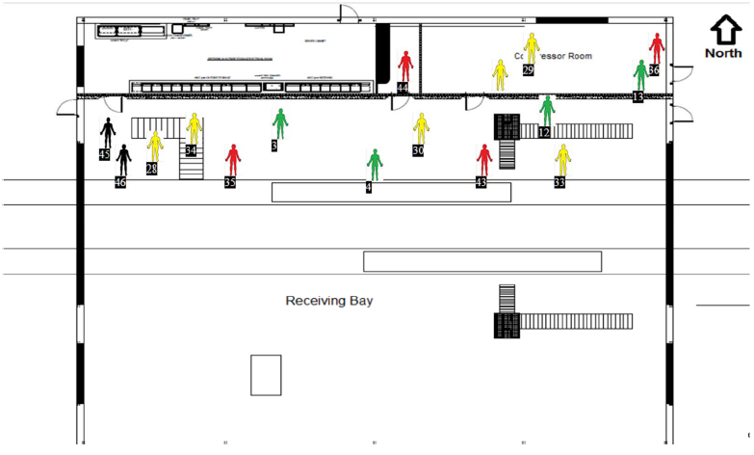

0917 hours

Contact Team encounters and nuetralized suspect 1 in the Receiveing Bay basement. The Receiveing Bay and basement are secured. The location of suspect 2 is unknown.

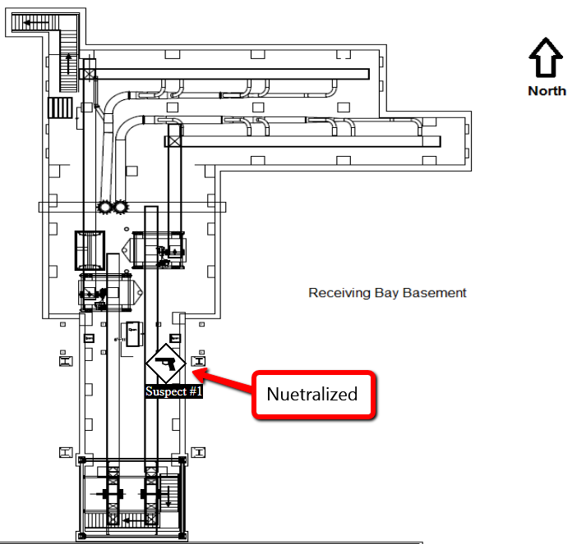

0919 hours
Rescue Task Force personnel begin moving patients from the Receiving Bay and basement to the Casualty Collection Point. 12 patients are located in the basement.

0922 hours

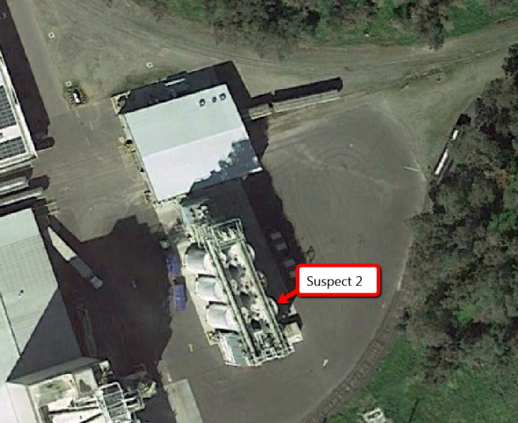
Contact Team secures the tunnel and reports an additional 6 to 10 victims in the tunnel. Total casualty count is estimated at 50 to 75 at this point.

0933 hours
The Contact Team reports that suspect 2 is barricaded inside the base of a grain silo, located south of the Receiving Bay.

Key Issues
- One suspect has been neutralized
- The second suspect has been located
- The Receiving Bay, basement and tunnel have been secured
- An accurate number and severity of casualties is unknown
- Patient destinations are needed

Questions
Based on the information provided, participate in the discussion concerning the issues raised in Module 2. Identify any critical issues, decisions, requirements, or questions that should be addressed at this time.

Instructions
Take 20 minutes to discuss the questions below. Assign a group scribe to document your group’s answers and a spokesperson to share your group’s findings.

Field Responders
- What are your priorities and incident objectives at this point?

  - Have they changed?

  - Update your ICS-201 Form, as needed.

- Describe any additional resources needed at this time.

  - Explain the requesting process for each discipline involved.

  - How long will it take for the requested resources to arrive on scene?

  - Update the resource summary on your ICS-201 Form.

- Identify the locations of staging area(s) for incoming resources:

- Explain how the locations of staging areas will be communicated to incoming resources.

- Describe how staged resources will be accounted for and managed.

- Explain how situational awareness will be shared with all response personnel on scene, in a timely manner.

  - Describe how on-scene interoperable communications is established and maintained.

- Identify the location of the following:

  - Incident Command Post

  - Hot Zone

  - Warm Zone

  - Cold Zone

  - Perimeter

  - Casualty Collection Point

  - Patient triage, treatment and loading areas

  - Refuge Area

- How long until the first patient(s) will be transported to definitive care?

  - What steps are being taken to expedite patient transport?

- Which ICS positions are filled at this time?
  - Assign the positions from the available participants and have them put on position vests or ID badges.

- Explain who is responsible for moving patients:

  - Warm Zone to Casualty Collection Point

  - Casualty Collection Point to Triage Unit

  - Triage Unit to Immediate, Delayed and Minor Treatment Areas

  - Treatment Areas to the Patient Loading Area

- Explain your ambulance loading strategy for a large MCI.

- Identify the traffic route for ambulance access and egress, to ensure the timely transport of patient off scene.

  - Describe any ambulance traffic routing challenges, and how they were resolved.

- Provide the Disaster Control Facility with an updated patient count, via radio.

Immediate | Delayed | Minor

- What is the final patient count by START criteria?

Immediate | Delayed | Minor | Deceased

- Describe the process for integrating non-transport paramedics and EMTs into Multi-Casualty Branch operations.

San Joaquin OA Healthcare Coalition
- Disaster Control Facility:
  - Update the event in EMResource for this MCI.
  - Describe the process for determining patient destinations from an MCI.
  - Provide patient destinations to the Patient Transportation Group Supervisor.
  - Explain the process to ensure that receiving hospitals fully understand the magnitude of this incident and the need to activate surge plans.
  - Which Disaster Control Facility positions have been filled at this time?
Control Facility Supervisor
Patient Dispersal Officer
Facility Status Officer
Receiving Facility Officer

- Hospitals:
- How many patients can you take from this MCI?
San Joaquin County |  | Immediate |  | Delayed |  | Minor |  | Decon Facility | Surgeon Available
Dameron |  |  |  |  |  |  |  | Yes
Doctor’s Manteca |  |  |  |  |  |  |  | Yes
Kaiser Manteca |  |  |  |  |  |  |  | Yes
Lodi Memorial |  |  |  |  |  |  |  | Yes
San Joaquin General |  |  |  |  |  |  |  | Yes
St. Joseph’s |  |  |  |  |  |  |  | Yes
Sutter Tracy |  |  |  |  |  |  |  | Yes
 | Sacramento County |  | Immediate |  | Delayed |  | Minor | Decon Facility | Surgeon Available
 | UC Davis |  | 4 |  | 4 |  | 20 | Yes | Yes
 | Kaiser South |  | 4 |  | 5 |  | 10 | Yes | Yes
 | Stanislaus County |  | Immediate |  | Delayed |  | Minor | Decon Facility | Surgeon Available
 | Doctor’s Medical Center |  | 4 |  | 4 |  | 20 | Yes | Yes
 | Memorial Medical Center |  | 3 |  | 5 |  | 10 | Yes | Yes
 | Totals

- Complete the Receiving Facility – Status Report Worksheet on the next page:
INSTRUCTIONS:
- PLACE INITIALS, OR A CHECK MARK, FOR EACH PERSON/BED AVAILABLE FOR MEDICAL TREATMENT BEGINNING WITH "IMMEDIATE TEAM" COLUMNS. WORK LEFT TO RIGHT.

- WHEN ALL POSITIONS FOR ANY TEAM ARE CHECKED, PLACE A CHECK MARK AT BOTTOM OF TEAM COLUMN BY "TOTAL PATIENT NUMBER."

- TRANSFER CHECK MARKS TO "DELAYED TEAM" COLUMNS FROM INCOMPLETE, OR UNNEEDED, "IMMEDIATE TEAMS." TRANSFER CHECK MARKS TO "MINOR TEAM" COLUMNS FROM INCOMPLETE OR UNNEEDED, "DELAYED TEAMS."
- SURGEONS NAMES MUST BE PROVIDED (for MCI Trauma). SURGEONS MUST BE IMMEDIATELY AVAILABLE TO REPORT TO THE RECEIVING FACILITY.

IMMEDIATE PATIENT TEAMS |  |  | ED STATUS  TOTAL PATIENTS ED CAN TREAT NOW  TIME: _________  DATE: ________  ______ IMMEDIATE  PATIENTS
TEAM # _____  ED PHYSICIAN _____  *SURGEON _____  NAME _______________  MICN/RN _____  ICU/ED LVN _____  Resp Tech _____  1 Ed Bed _____  1 _____ | TEAM # _____  ED PHYSICIAN _____  *SURGEON _____  NAME _______________  MICN/RN _____  ICU/ED LVN _____  Resp Tech _____  1 Ed Bed _____  2 _____ | TEAM # _____  ED PHYSICIAN _____  *SURGEON _____  NAME _______________  MICN/RN _____  ICU/ED LVN _____  Resp Tech _____  1 Ed Bed _____  3 _____

DELAYED PATIENT TEAMS
TEAM # _____  ED PHYSICIAN OR  SURGEON _____  NAME _____  MICN/RN _____  ICU/ED LVN _____  2 Ed Bed _____  2 _____ | TEAM # _____  ED PHYSICIAN OR  SURGEON _____  NAME _____  MICN/RN _____  ICU/ED LVN _____  2 Ed Bed _____  4 _____ | TEAM # _____  ED PHYSICIAN OR  SURGEON _____  NAME _____  MICN/RN _____  ICU/ED LVN _____  2 Ed Bed _____  6 _____ | ______ DELAYED  PATIENTS
MINOR PATIENT TEAMS
TEAM # _____  MICN/RN _____  LVN _____  ASSISTANT _____  5 _____ | TEAM # _____  MICN/RN _____  LVN _____  ASSISTANT _____  10 _____ | TEAM # _____  MICN/RN _____  LVN _____  ASSISTANT _____  15 _____ | _______ MINOR  PATIENTS
- Explain how your hospital will accommodate the surge in trauma patients.

    - Describe how you would alert and notify hospital personnel of the activation of your medical surge plan.

- How many behavioral health patients do you typically have in your Emergency Departments on a Friday morning?

- Explain the process for clearing the behavioral health patients, in order to free up Emergency Departments beds.

- Describe how your hospital will establish and maintain situational awareness with the MHOAC.

- Behavioral Health:

  - Describe the assistance you could provide the hospitals in clearing the behavioral health patients out of the Emergency Departments.

  - Explain the requesting process for assistance.

- Describe how you will establish and maintain situational awareness with the MHOAC.

- What are your concerns at this point in the incident?

- Clinics:

- Describe the step you take to prepare to receive a surge of self-presenting patients from the MCI.

- Explain your process for alerting and notifying personnel of the activation of your facility medical surge plan.

- Describe how you will establish and maintain situational awareness with the MHOAC.

- Long Term Care:

- How many hospital discharges can you accept within two hours of a request?

- Explain your process for alerting and notifying personnel of the activation of your facility medical surge plan.

- Describe how you will establish and maintain situational awareness with the MHOAC.

- Medical Health Operational Area Coordinator (MHOAC):
- Describe the process for sharing information concerning this incident with the California Medical Health Coordination Center (MHCC).

- Explain how you will establish and maintain situational awareness with the members of the healthcare coalition.

Appendix A: Exercise Schedule
Time | Activity
0800 - 0830 | Check-In and Registration
0830 - 0845 | Welcome and Exercise Overview
0845 - 0945 | Module 1: Initial Response
0945 - 0955 | BREAK
0955 - 1125 | Module 2: Multi-Branch Response
1125 - 1135 | BREAK
1135 - 1200 | Hot Wash, Wrap-up and Closing Comments

This page intentionally left blank

Appendix B: San Joaquin County Active Threat Plan EMS Agency Policy No. 7210

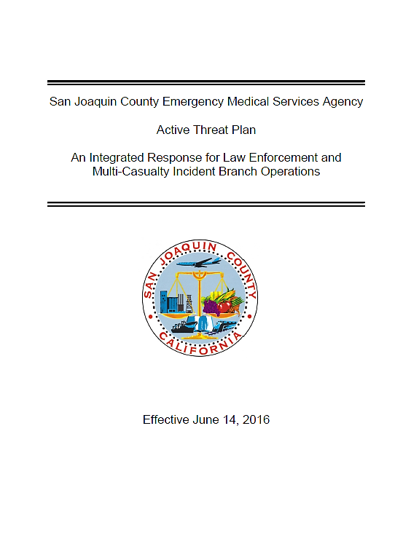

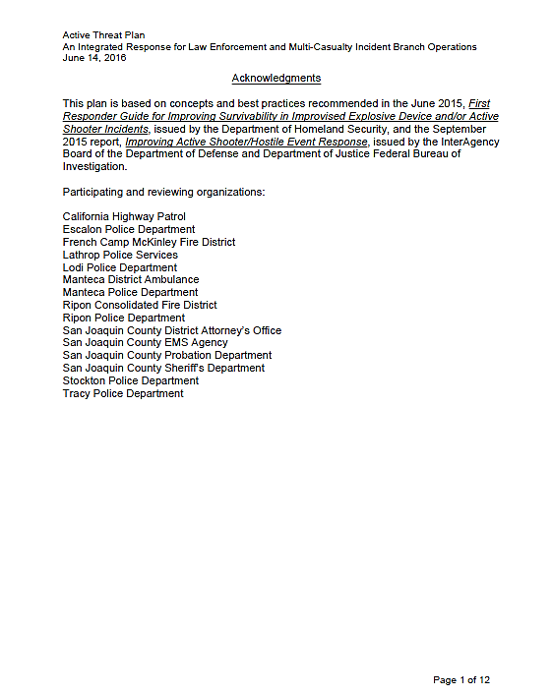

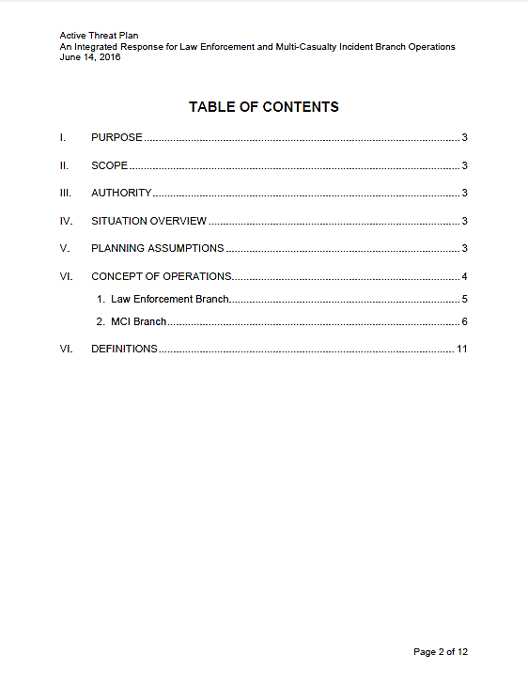
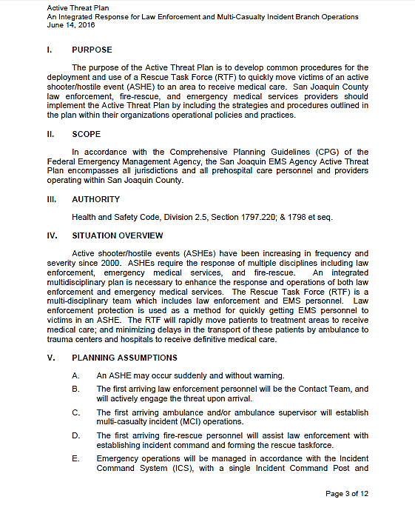

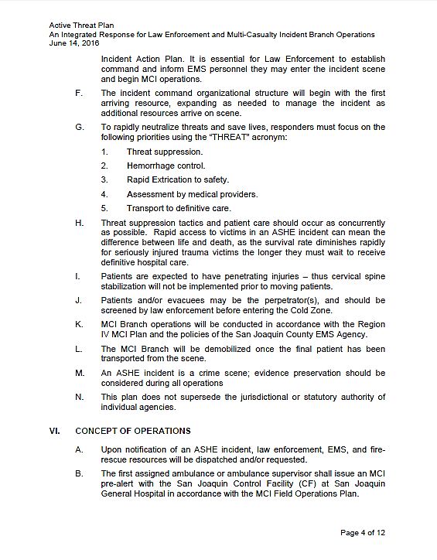
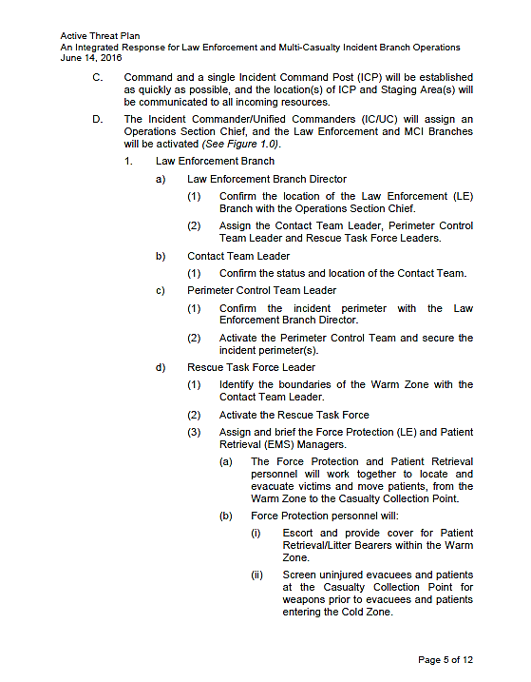

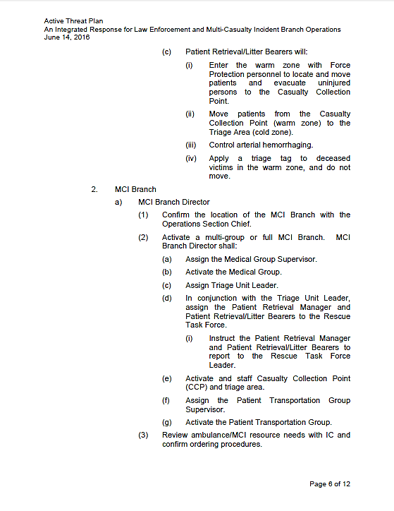

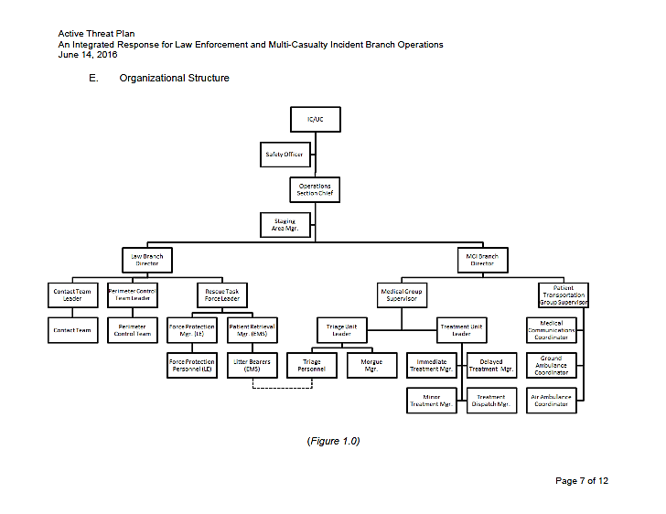
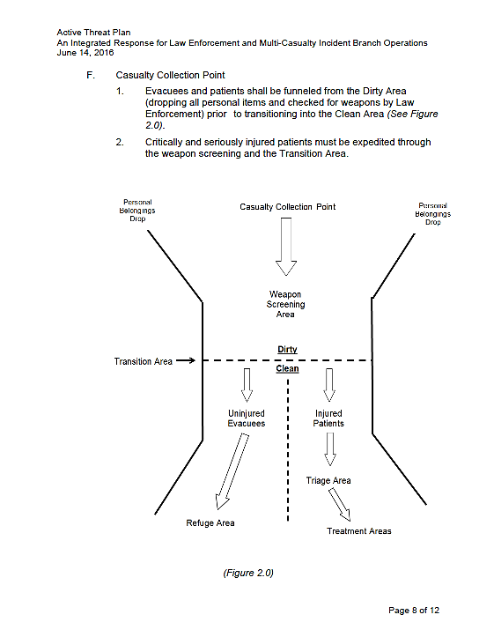

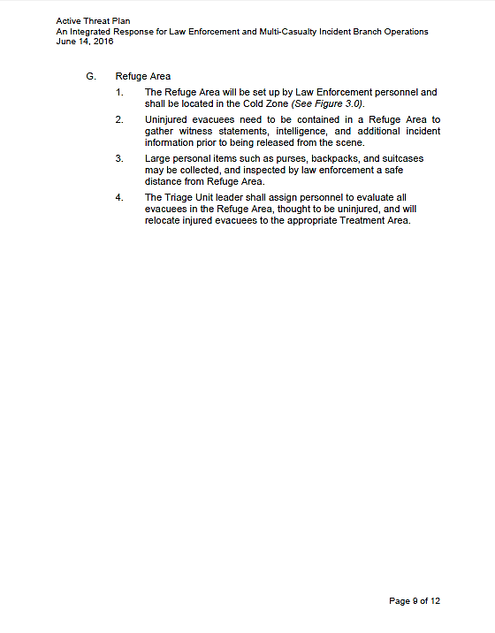
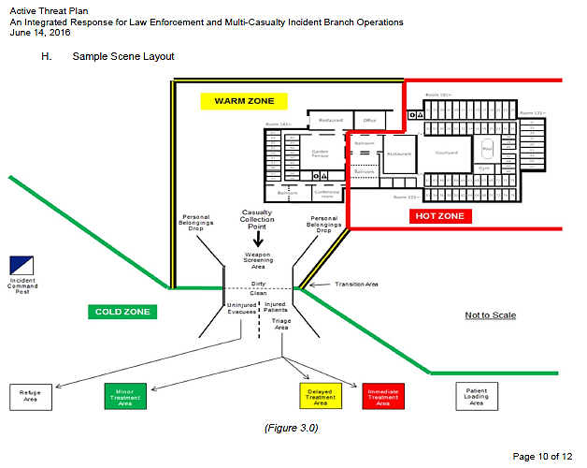
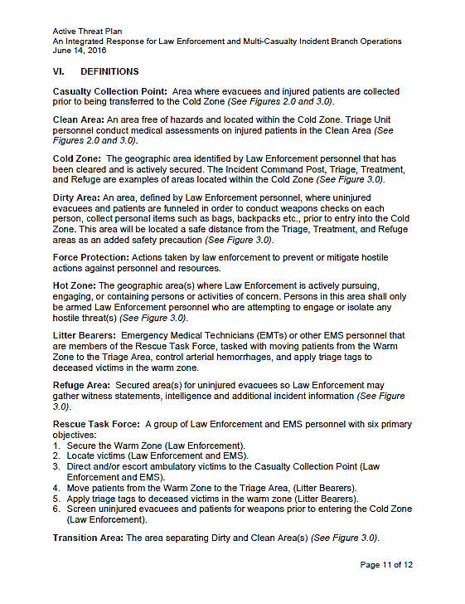

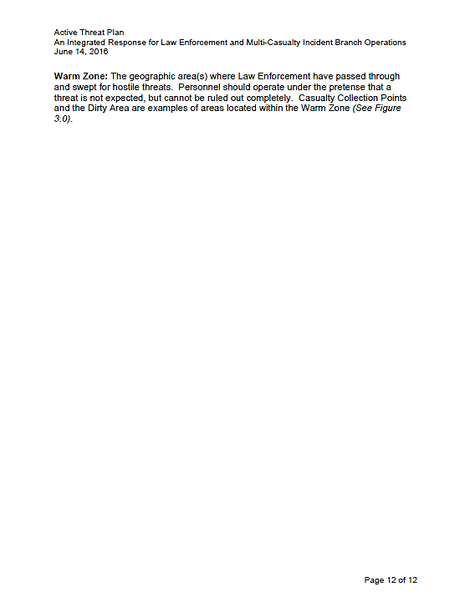

Appendix C: Active Threat Plan
ICS Modular Development
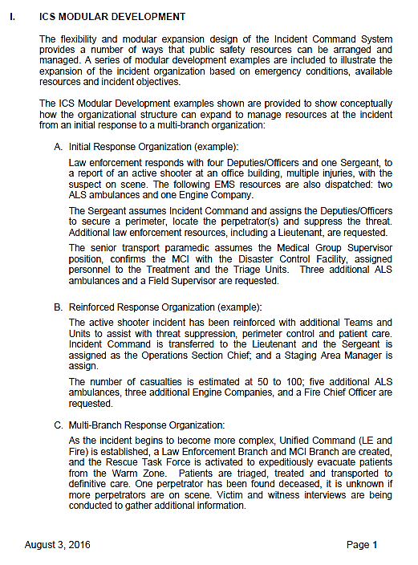
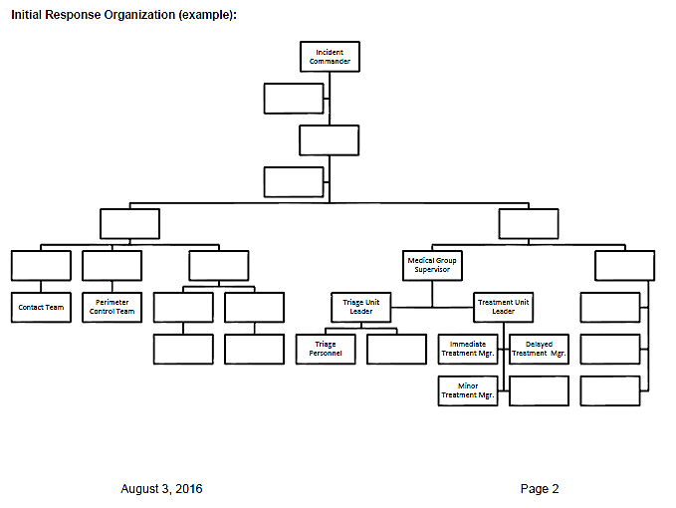
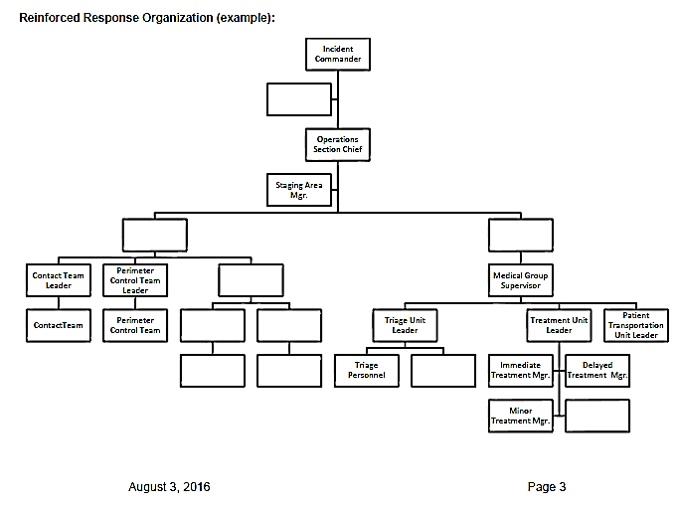
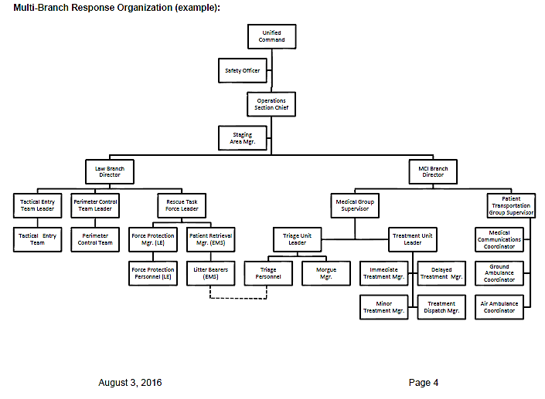

Appendix D: ICS-201 Form
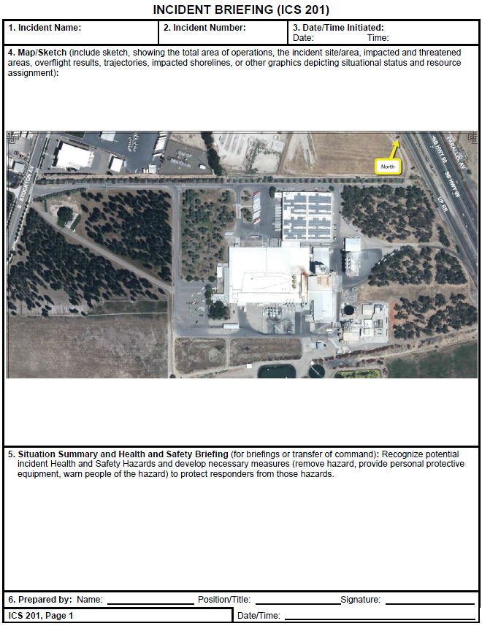
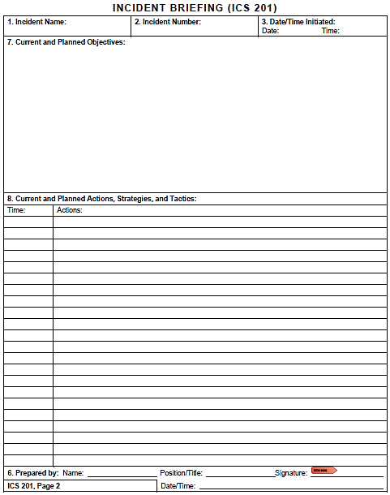
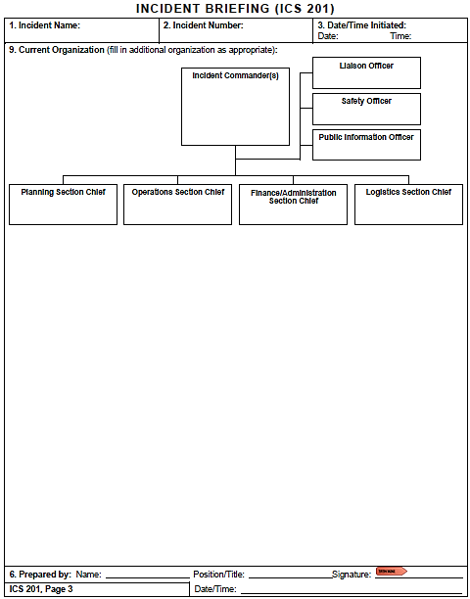
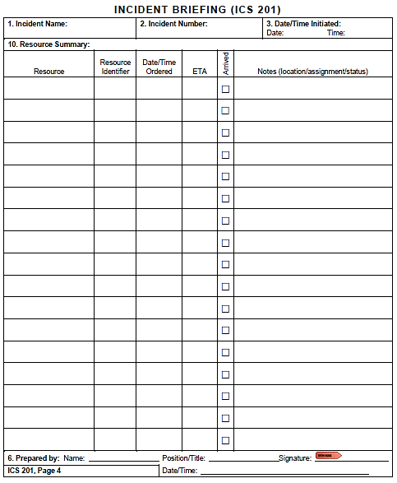

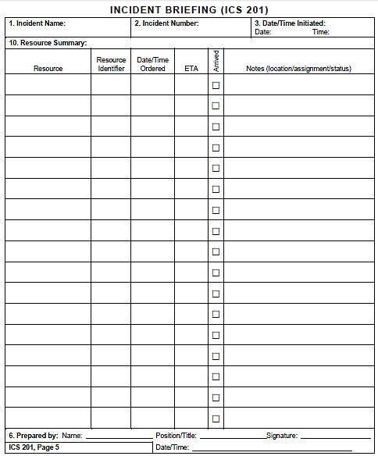

This page intentionally left blank

Appendix E: Incident Maps
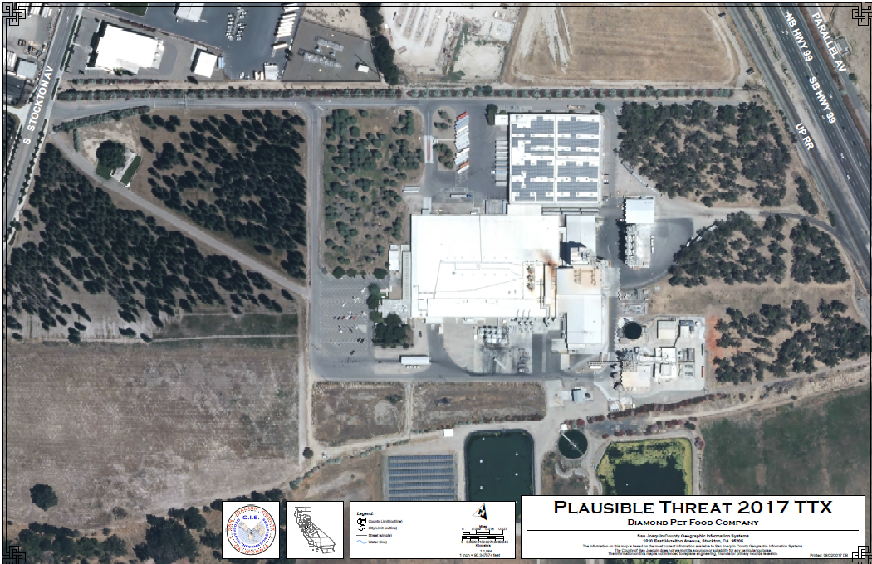

  - Receiving Bay - Aerial
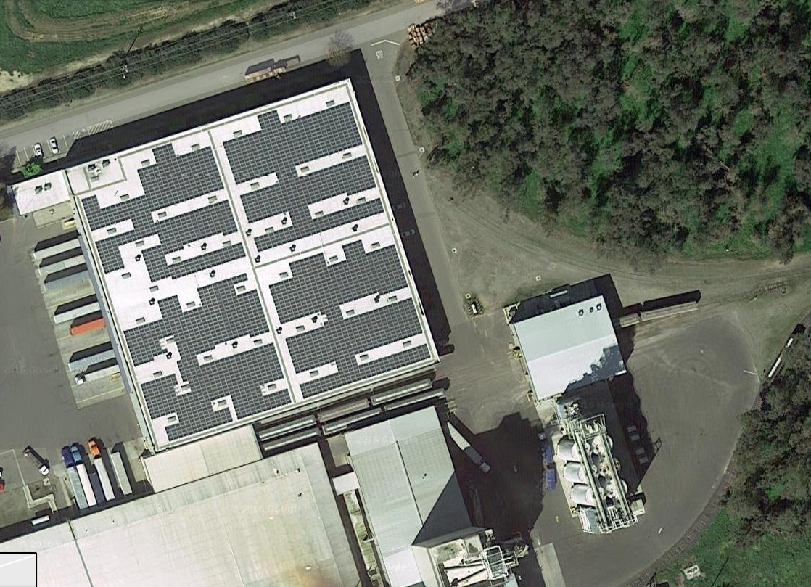
North
  - Receiving Bay – First Floor
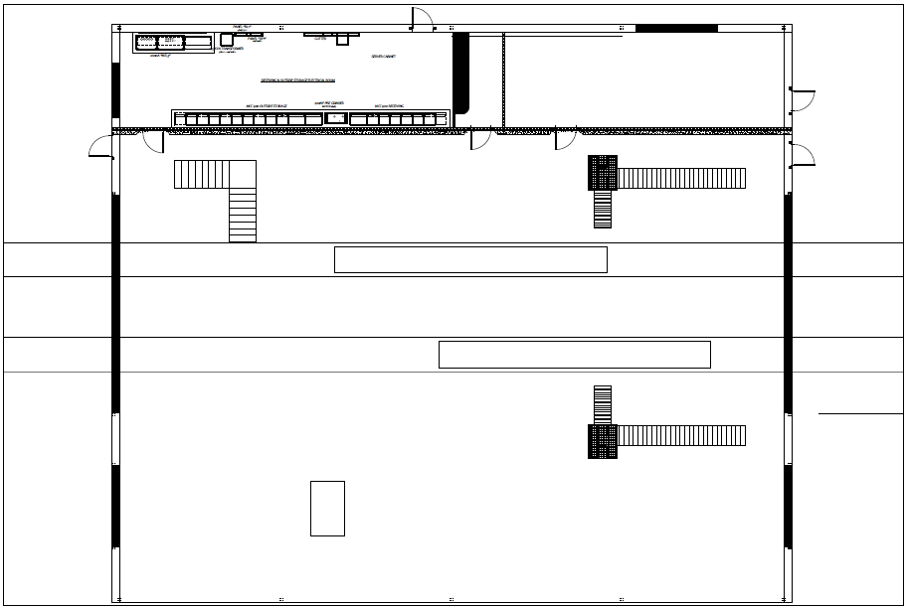
North
  - Receiving Bay – Basement
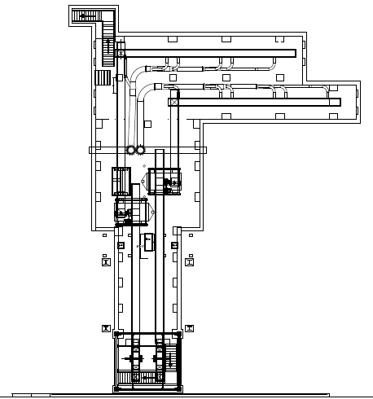
North

  - Tunnel

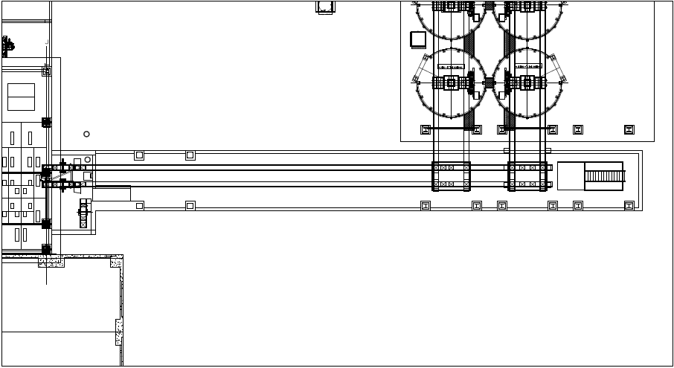
North

Appendix F: Incident Commanders’ Radio Interface
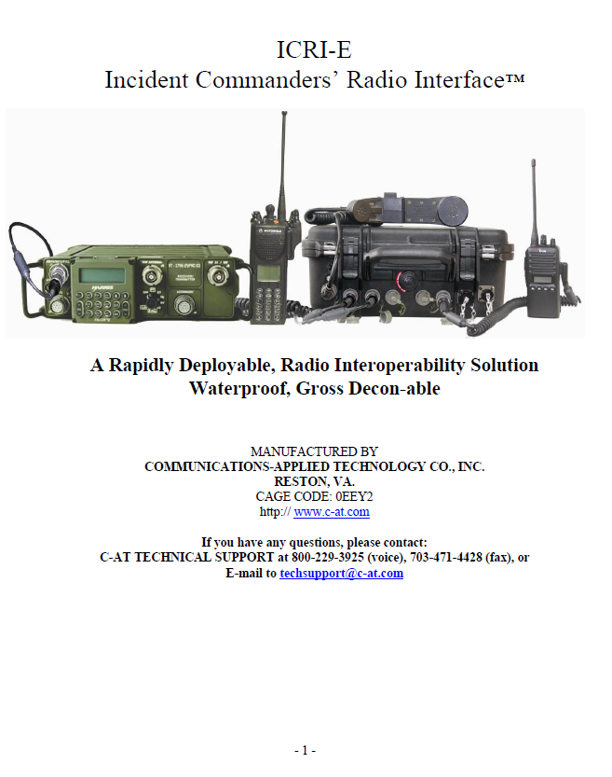
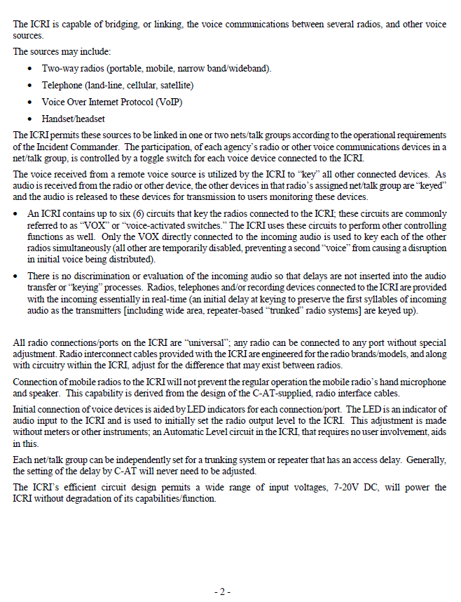
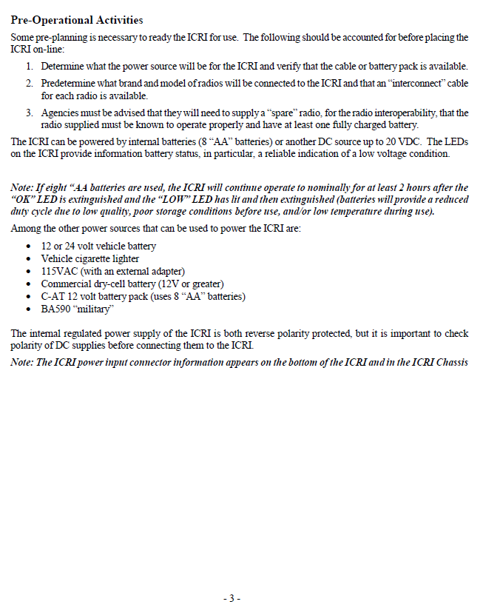

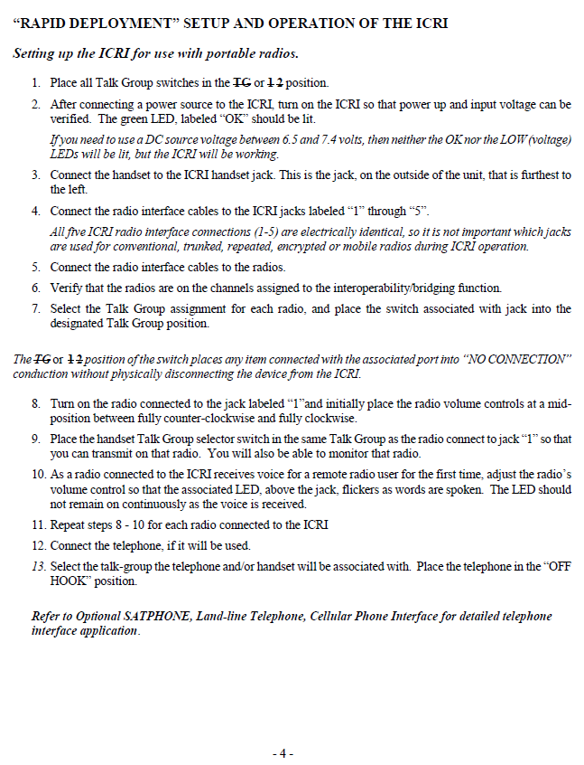

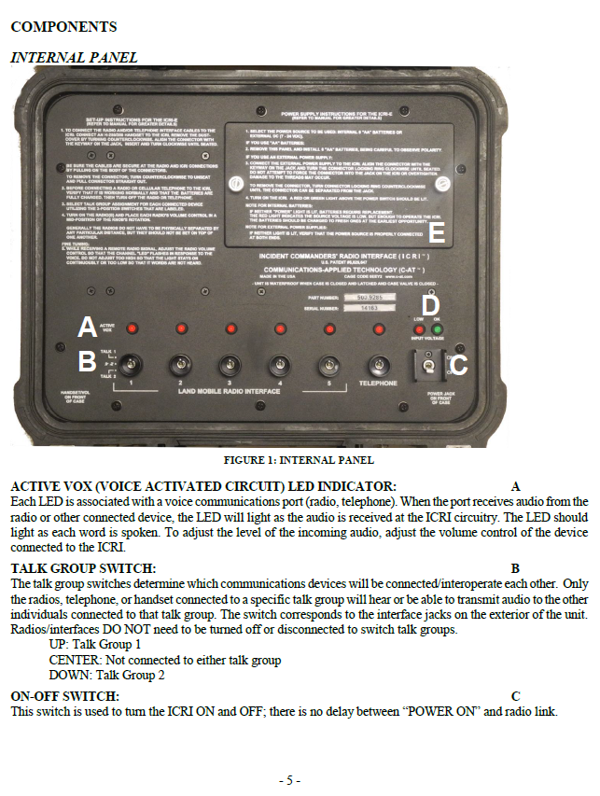

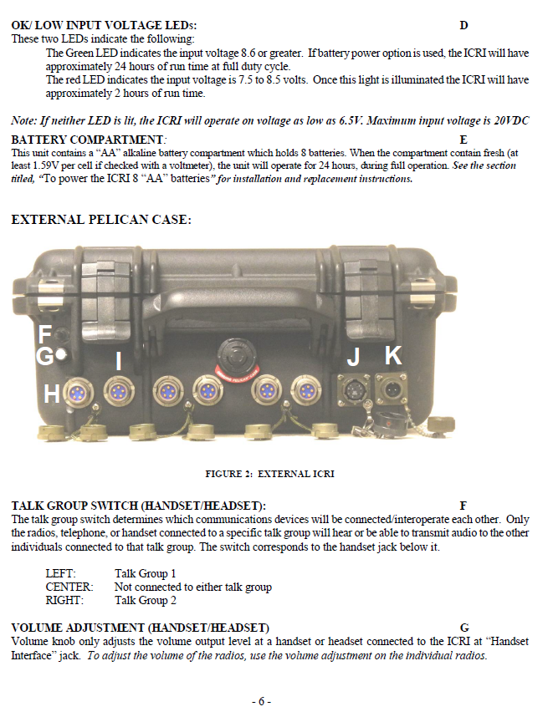

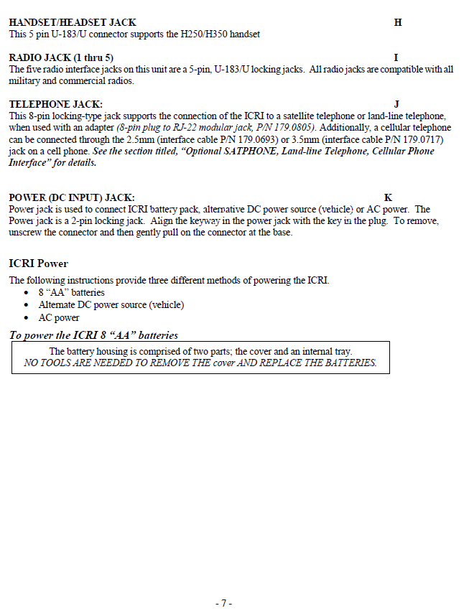

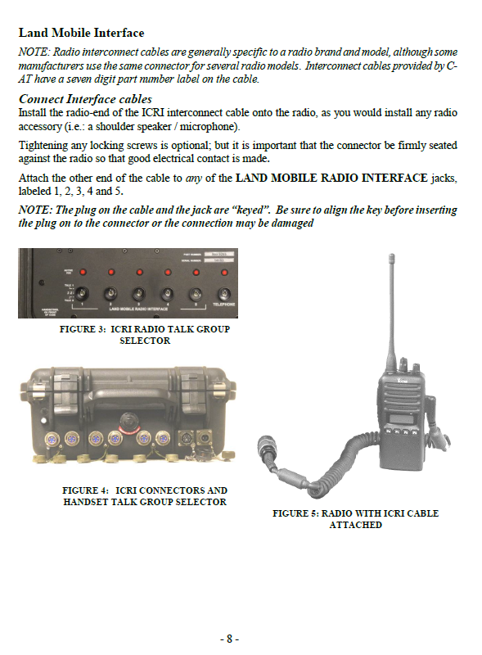

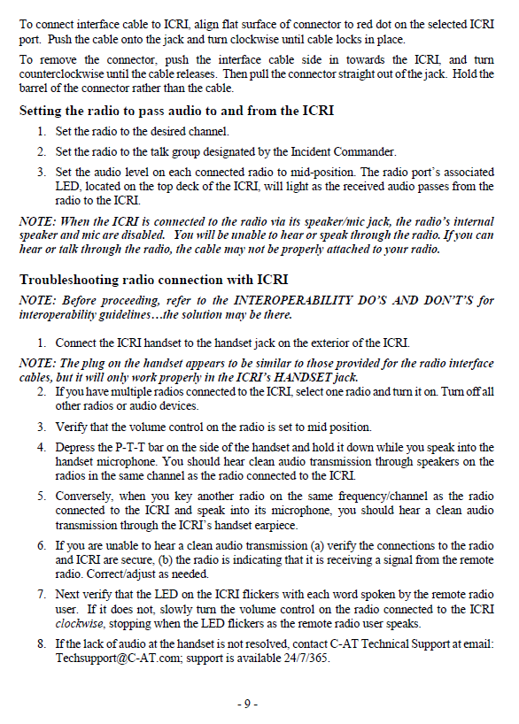

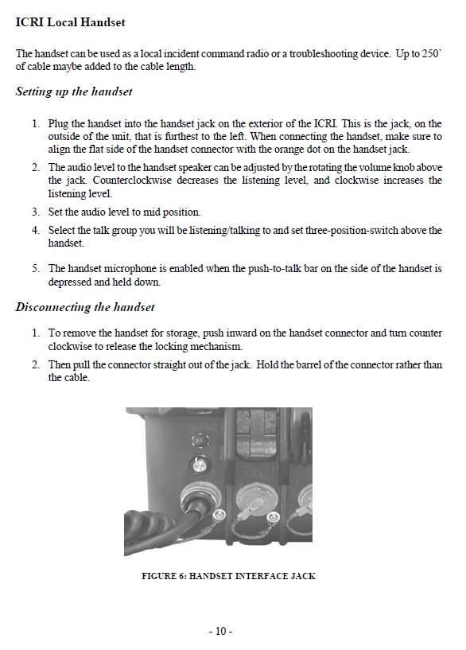

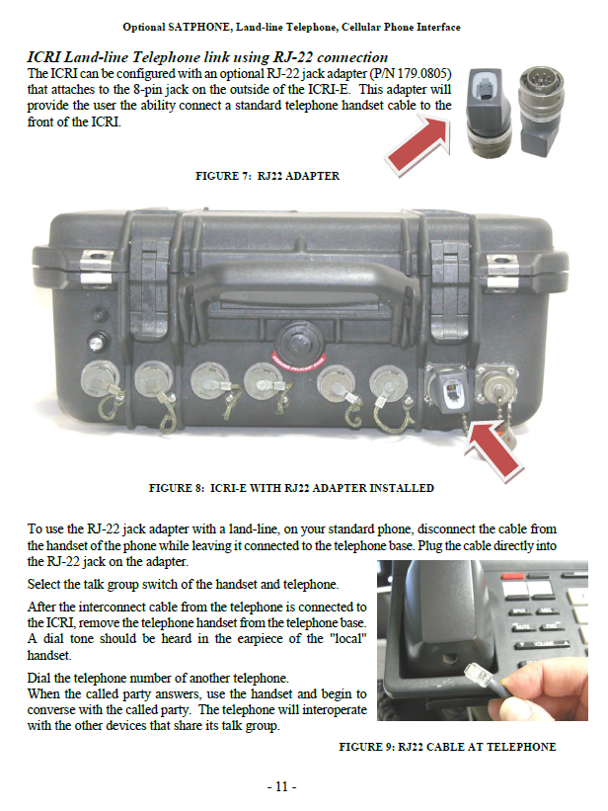

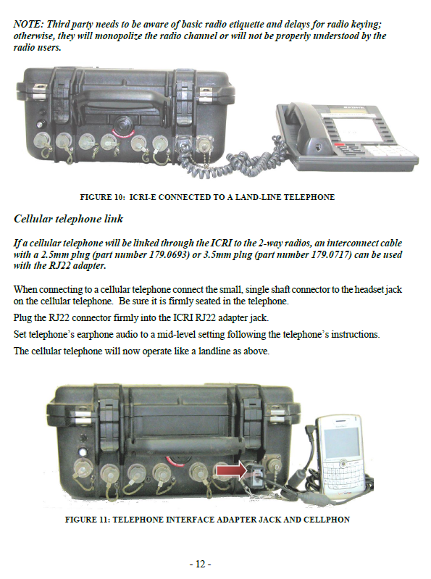

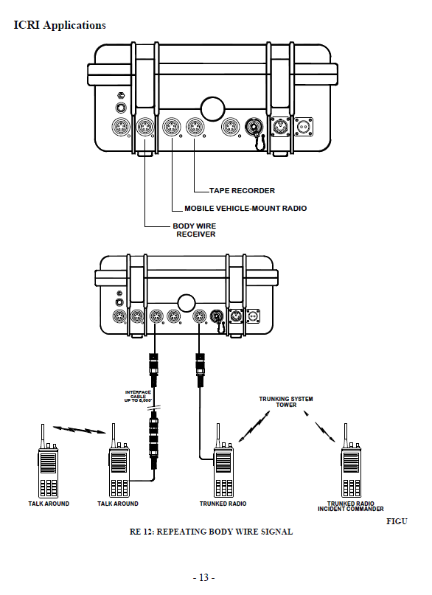

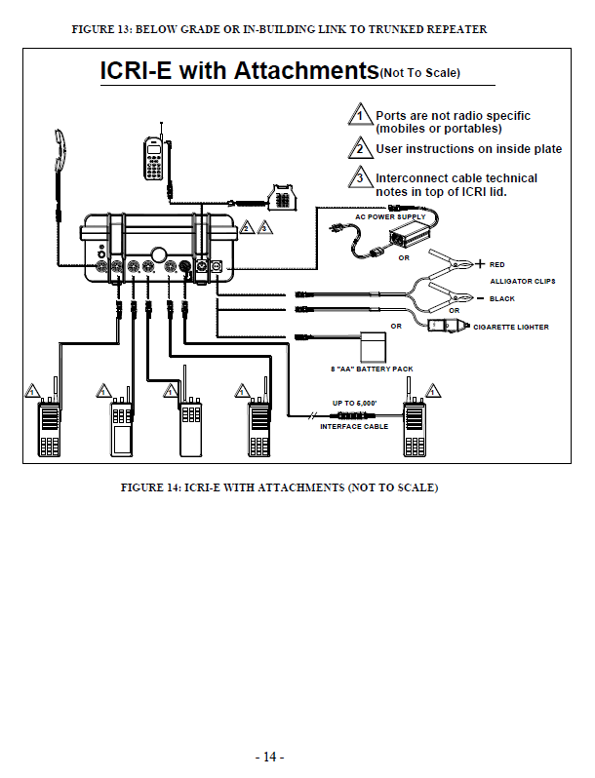

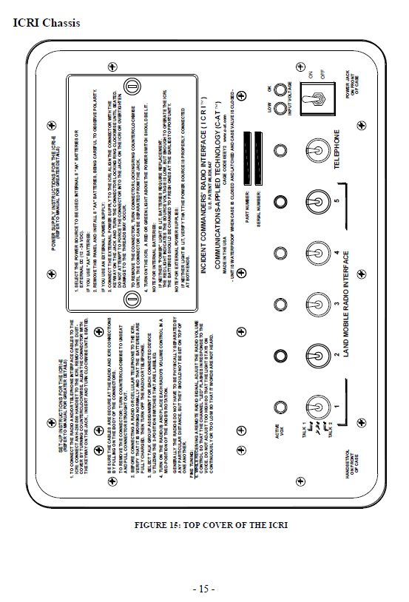

This page intentionally left blank

Appendix G: Triage Tag Instructions
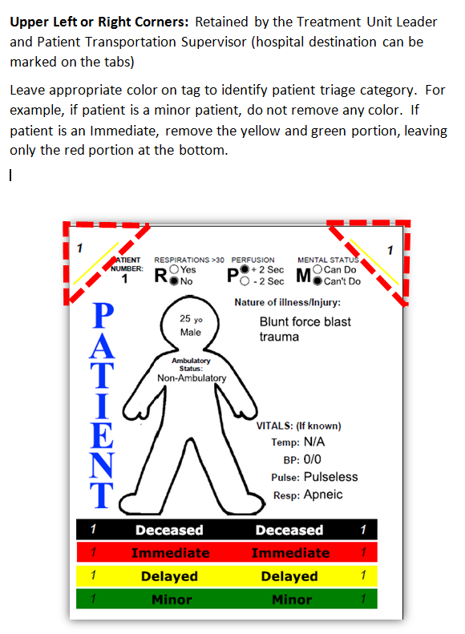

This page intentionally left blank

Appendix H: Acronyms
Acronym | Term
ALS | Advance Life Support
AAR/IP | After Action Report/Improvement Plan
ASHE | Active Shooter/Hostile Event
BLS | Basic Life Support
Cal OES | California Governor’s Office of Emergency Services
CSWC | California State Warning Center
DCF | Disaster Control Facility
DHS | U.S. Department of Homeland Security
EMAC | Emergency Management Assistance Compact
EMS | Emergency Management Services
EMSA | California Emergency Medical Services Authority
ETA | Estimated time of arrival
FOUO | For Official Use Only
HSEEP | Homeland Security Exercise and Evaluation Program
IC | Incident Commander
ICS | Incident Command System
ICRI | Incident Commanders’ Radio Interface
MCI | Multi-Casualty Incident
MGS | Medical Group Supervisor
MHOAC | Medical Health Operational Area Coordinator
MICN | Mobile Intensive Care Nurse
MSEL | Master Scenario Events List
NIMS | National Incident Management System
POC | Point of Contact
PSAP | Public Safety Answering Point (i.e., 9-1-1 call center)
PTGS | Patient Transportation Group Supervisor
RDMHC | Regional Disaster Medical Health Coordinator
RDMHS | Regional Disaster Medical Health Specialist
RTF | Rescue Task Force
SEMS | Standardized Emergency Management System
SitMan | Situation Manual
SME | Subject Matter Expert
TTX | Tabletop Exercise

This page intentionally left blank

Appendix I: Participant Feedback Form
Please enter your responses in the form field or check box after the appropriate selection.
Name: |  |  |  |  |  | Title:
Agency:
Role: | Player |  | Facilitator | Observer |  | Evaluator

Part I: Recommendations and Corrective Actions
- Based on the discussions today and the tasks identified, list the top three strengths and/or areas that need improvement.

- Identify the action steps that should be taken to address the issues identified above. For each action step, indicate if it is a high, medium, or low priority.
Corrective Action | Priority

- Describe the corrective actions that relate to your area of responsibility. Who should be assigned responsibility for each corrective action?
Corrective Action | Recommended Assignment
- List the policies, plans, and procedures that should be reviewed, revised, or developed. Indicate the priority level for each.
Item for Review | Priority

Part II: Assessment of Exercise Design and Conduct
Please rate, on a scale of 1 to 5, your overall assessment of the exercise relative to the statements provided below, with 1 indicating strong disagreement with the statement and 5 indicating strong agreement.
Assessment Factor | Strongly  Disagree |  |  | Strongly Agree
The exercise was well structured and organized. | 1 | 2 | 3 |  | 4 | 5
The exercise scenario was plausible and realistic. | 1 | 2 | 3 |  | 4 | 5
The multimedia presentation helped the participants understand and become engaged in the scenario. | 1 | 2 | 3 |  | 4 | 5
The facilitator(s) was knowledgeable about the material, kept the exercise on target, and was sensitive to group dynamics. | 1 | 2 | 3 |  | 4 | 5
The Situation Manual used during the exercise was a valuable tool throughout the exercise. | 1 | 2 | 3 |  | 4 | 5
Participation in the exercise was appropriate for someone in my position. | 1 | 2 | 3 |  | 4 | 5
The participants included the right people in terms of level and mix of disciplines. | 1 | 2 | 3 |  | 4 | 5

Part III: Participant Feedback
What changes would you make to this exercise? Please provide any recommendations on how this exercise or future exercises could be improved or enhanced.

https://www.fema.gov/mission-areas
https://www.fema.gov/core-capabilities

