San Joaquin County



Plausible Threat 2016

Tabletop Exercise -

Field Operations

Situation Manual

August 8, 2016

  - 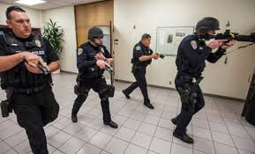



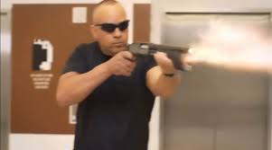



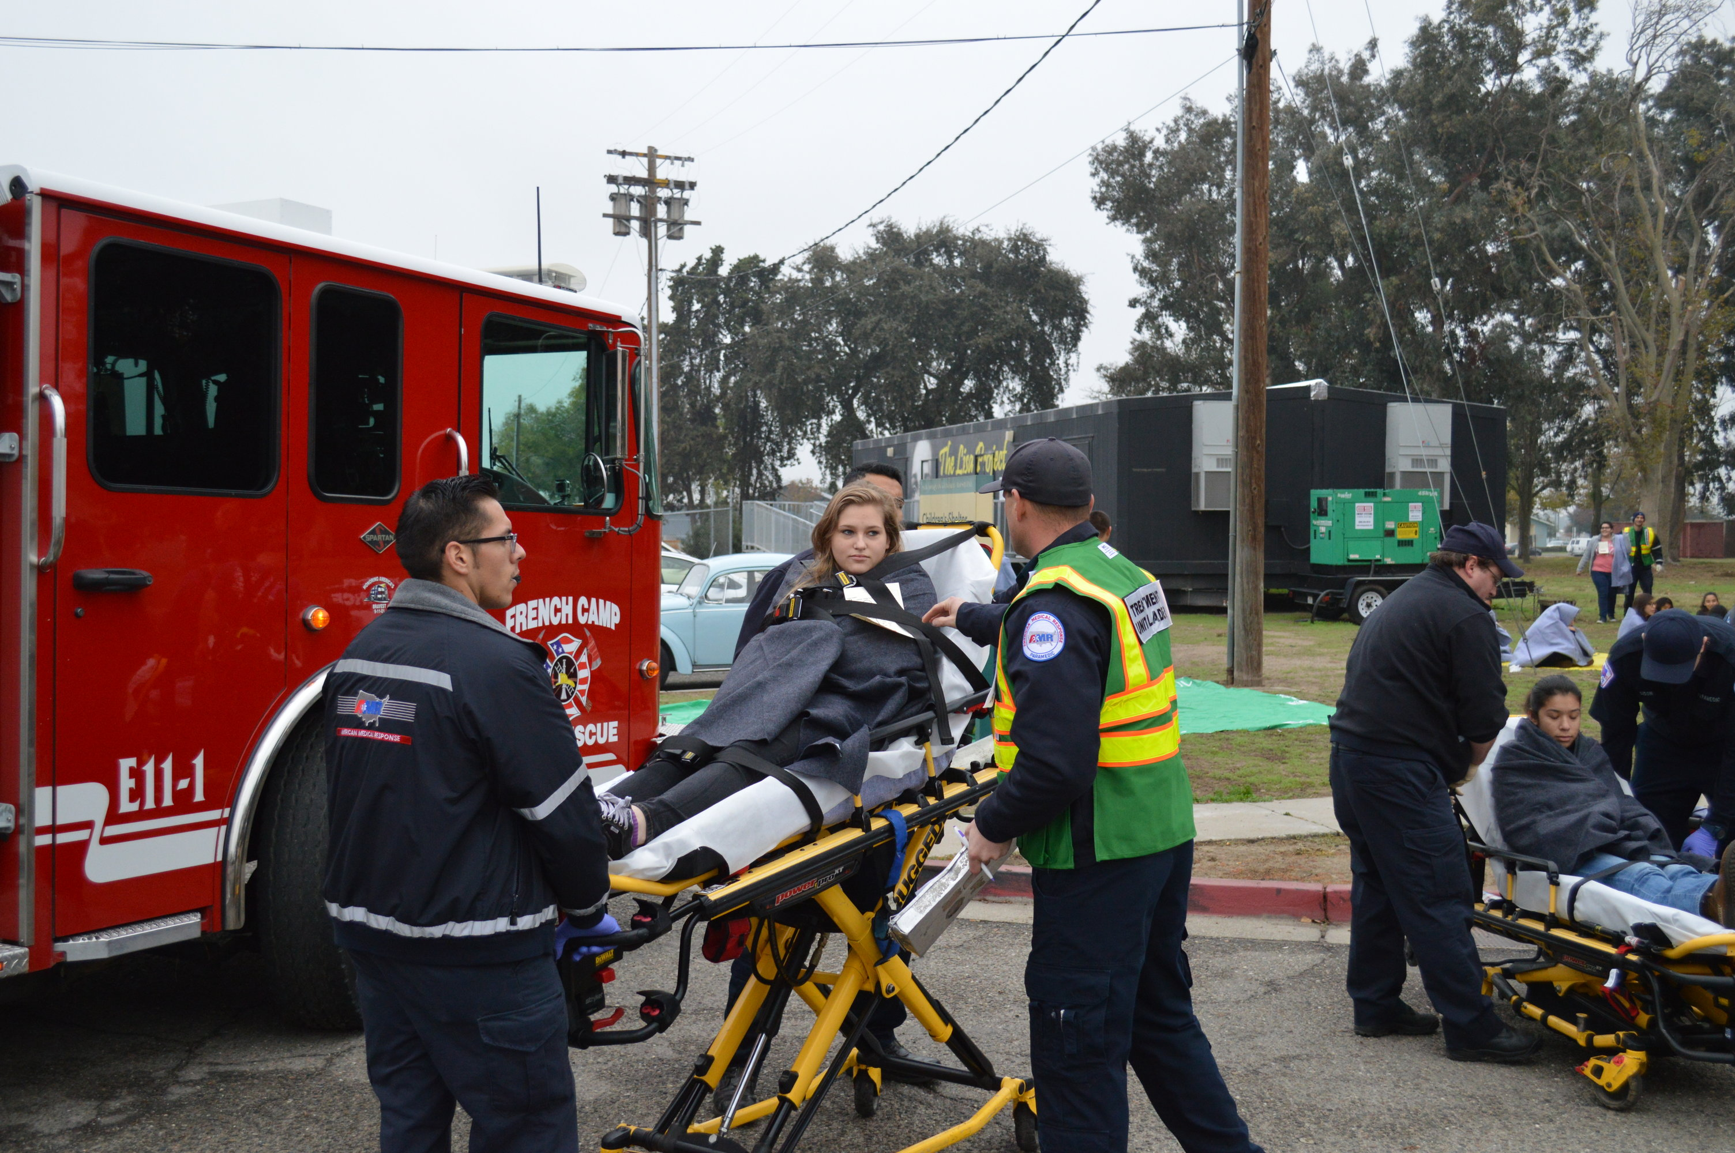

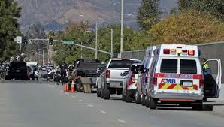

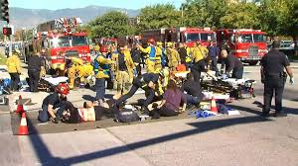

This page intentionally left blank

Table of Contents
Exercise Overview 1
Preface 2
General Information 2
Module 1: Initial Response 5
Module 2: MCI – Reinforced Response 8
Module 3: Multi-Branch Response 12
Appendix A: Exercise Schedule A-1
Appendix B: San Joaquin County Active Threat Plan B-1
Appendix C: Active Threat Plan – ICS Modular Development C-1
Appendix D: ICS 201 Form D-1
Appendix E: Acronyms E-1
Appendix F: Incident Map F-1
Appendix G: Participant Feedback Form G-1

Exercise Overview
Exercise Name | San Joaquin County Plausible Threat 2016 Tabletop Exercise – Field Operations
Exercise Date | August 8, 2016, 0800 to 1200 Hours
Scope | This exercise is a tabletop exercise, planned for four hours at the San Joaquin County Agriculture Center, Stockton, California.
Mission Area | Response
Core Capabilities | - Operational Coordination  - Operational Communications  - On-scene Security, Protection and Law Enforcement  - Public Health, Healthcare and Emergency Medical Services
Objectives | - Evaluate the San Joaquin County Active Threat Plan (EMS Policy No. 7210) in response to a simulated Active Shooter/Hostile Event (ASHE).  - Improve participants understanding of the San Joaquin County Active Threat Plan and use of a Rescue Task Force (RTF).
Threat or Hazard | Active Shooter/Hostile Event (ASHE)
Scenario | Active Shooter/Hostile Event (ASHE) occurs during a high school football game.
Sponsors | San Joaquin County EMS Agency and San Joaquin Operational Area Healthcare Coalition.
Participating Organizations | Law Enforcement, EMS and Fire agencies from the seven incorporated cities and unincorporated areas of San Joaquin County, who are likely to respond to an Active Shooter/Hostile Event (ASHE), and the San Joaquin County EMS Agency
Point of Contact | Phillip Cook  San Joaquin Emergency Medical Services Agency  P.O. Box 220,  French Camp, CA, 95231  209-468-6818  pcook@sjgov.org

Preface
The Plausible Threat 2016 Tabletop Exercise – Field Operations is sponsored by the San Joaquin County EMS Agency and San Joaquin Operational Area Healthcare Coalition. The exercise was designed to evaluate the San Joaquin County Active Threat Plan and to improve the response, management and mitigation of an Active Shooter/Hostile Event in San Joaquin County. This Situation Manual (SitMan) follows guidance set forth by the U.S. Department of Homeland Security (DHS) Homeland Security Exercise and Evaluation Program (HSEEP).

The Plausible Threat 2016 Tabletop Exercise – Field Operations SitMan provides exercise participants with all the necessary tools for their roles in the exercise. It is tangible evidence of the San Joaquin County EMS Agency’s commitment to preparedness excellence through collaborative planning and exercises that will improve the survivability of victims of an Active Shooter/Hostile Event (ASHE).

The Plausible Threat 2016 Tabletop Exercise – Field Operations is an unclassified exercise. Control of this exercise information is based on public sensitivity regarding the nature of the exercise rather than the actual exercise content. All exercise participants may view the SitMan.

General Information

Participant Roles and Responsibilities
The term participant encompasses many groups of people, not just those playing in the exercise. Groups of participants involved in the exercise, and their respective roles and responsibilities, are as follows:
- Players. Players are personnel who have an active role in discussing or performing their regular roles and responsibilities during the exercise. Players discuss or initiate actions in response to the simulated emergency.
- Observers. Observers do not directly participate in the exercise; however they may support the group in developing responses to the situation during the discussion.
- Facilitators. Facilitators provide situation updates and moderate discussions. They also provide additional information or resolve questions as required. Key Exercise Planning Team members also may assist with facilitation as subject matter experts (SMEs) during the exercise.
- Evaluators. Evaluators are assigned to observe and document certain objectives during the exercise. Their primary role is to document player discussions, including how and if those discussions conform to plans, polices, and procedures.

Exercise Structure
This exercise will be a multimedia, facilitated exercise. Players will participate in the following three (3) modules:
- Module 1: Initial Response
- Module 2: Reinforced Response
- Module 3: Multi-Branch Response

Each module begins with a multimedia update that summarizes key events occurring within that time period. After the updates, participants review the situation and engage in functional group discussions of appropriate response issues. For this exercise, the functional groups are as follows:
- City of Escalon
- City of Lathrop
- City of Lodi
- City of Manteca
- City of Ripon
- City of Stockton
- City of Tracy
- Unincorporated Area

After these functional group discussions, participants will engage in a moderated plenary discussion in which a spokesperson from each group will present a synopsis of the group’s actions, based on the scenario.

Exercise Guidelines
- This exercise will be held in an open, low-stress, no-fault environment. Varying viewpoints, even disagreements, are expected.
- Respond to the scenario using your knowledge of current plans and capabilities (i.e., you may use only existing assets) and insights derived from your training.
- Decisions are not precedent setting and may not reflect your organization’s final position on a given issue. This exercise is an opportunity to discuss and present multiple options and possible solutions.
Issue identification is not as valuable as suggestions and recommended actions that could improve response efforts. Problem-solving efforts should be the focus.
During exercise discussions, if a player states that they are going to ask for/provide mutual aid, they need to state specifically under which plan and to which agency they will do so.

Exercise Assumptions and Artificialities
In any exercise, assumptions and artificialities may be necessary to complete play in the time allotted and/or account for logistical limitations. Exercise participants should accept that assumptions and artificialities are inherent in any exercise, and should not allow these considerations to negatively impact their participation. During this exercise, the following apply:
- The exercise scenario is plausible, and events occur as they are presented.
- The high school in the scenario is located within each functional group’s jurisdiction.
- There is no hidden agenda, and there are no trick questions.
- All players receive information at the same time.

Exercise Evaluation
Evaluation of the exercise is based on the exercise objectives. Players will be asked to complete participant feedback forms. These documents, coupled with facilitator observations and notes, will be used to evaluate the exercise and compile the After-Action Report (AAR).

Module 1: Initial Response

Friday September 23, 2016:

1930 hours
Paradise verses San Joaquin football game begins, hosted by the home team Paradise High School. There are approximately 650 people in attendance.

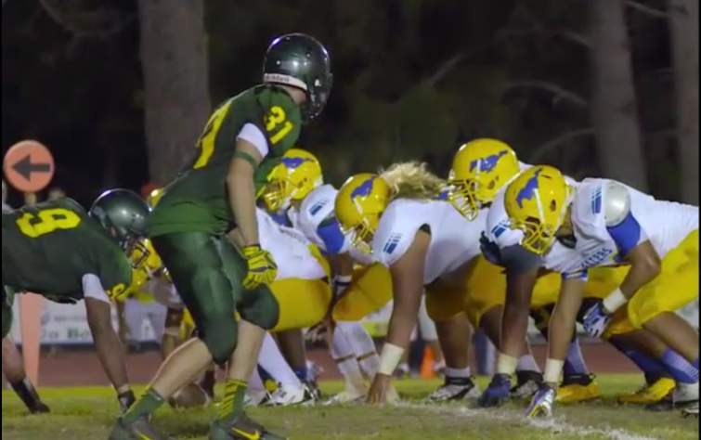
1948 hours
With 6:55 minutes remaining in the second quarter, an explosion in the home team bleachers occurs. Immediately following the explosion, gunshots are heard and several people are shot.

Panic ensues, spectators and players begin running in all directions. The location of the shooter(s) is unknown at this time.

The local PSAPs are inundated with 9-1-1 calls reporting the explosion and shooting. Additional gunshot can be heard in the background by one of the dispatchers receiving a call.

1950 hours
Law, Fire and EMS are dispatched to the incident.

Key Issues
- Numerous people have been injured by the explosion and gunshots
- The scene is in chaos
- The location of the shooter(s) is unknown
- The shooting actively continues

Questions
Based on the information provided, participate in the discussion concerning the issues raised in Module 1. Identify any critical issues, decisions, requirements, or questions that should be addressed at this time.

Instructions
Take 20 minutes to discuss the questions below. Assign a group scribe to document your group’s answers and a spokesperson to share your group’s findings.
- Describe the initial response to this incident in your jurisdiction.
  - What types and numbers of resources would be initially dispatched?
Law:
Fire:
EMS:
Other:

  - Document this on page 4 of your ICS-201 Form

- What are your initial priorities and incident objectives at this point?

  - Document this on page 2 of your ICS-201 Form

- Describe which other agencies, entities, or organizations need to be immediately notified of this incident.

  - Why?

- Identify the Incident Commander

- Which ICS positions need to be filled for the initial response?

  - Which agencies will fill each position?

Appendix A: Exercise Schedule
Time | Activity
August 8, 2016
0730 - 0800 | Check-In and Registration
0800 - 0815 | Welcome and Exercise Overview
0815 - 0915 | Module 1: Initial Response
0915 - 0925 | BREAK
0925 - 1025 | Module 2: Reinforced Response
1025 - 1035 | BREAK
1035 - 1135 | Module 3: Multi-Branch Response
1135 - 1200 | Hot Wash, Wrap-up and Closing Comments

Appendix B: San Joaquin County Active Threat Plan EMS Agency Policy No.

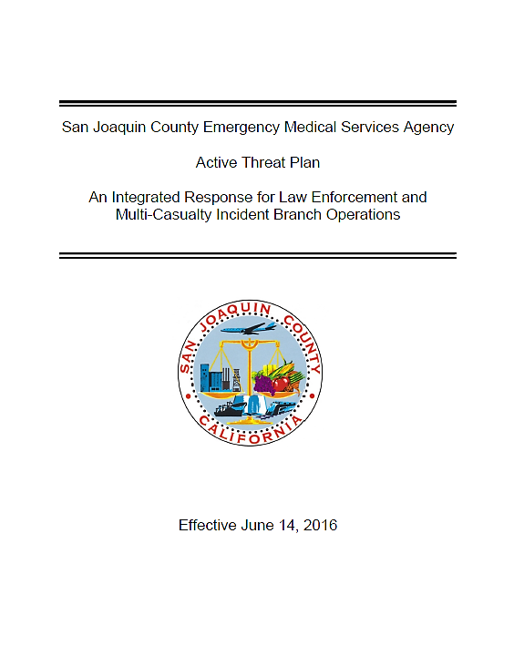

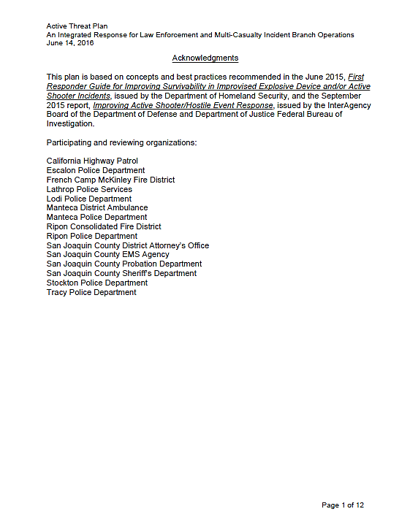

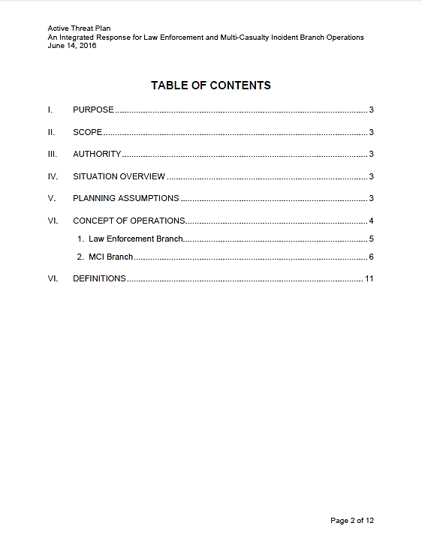
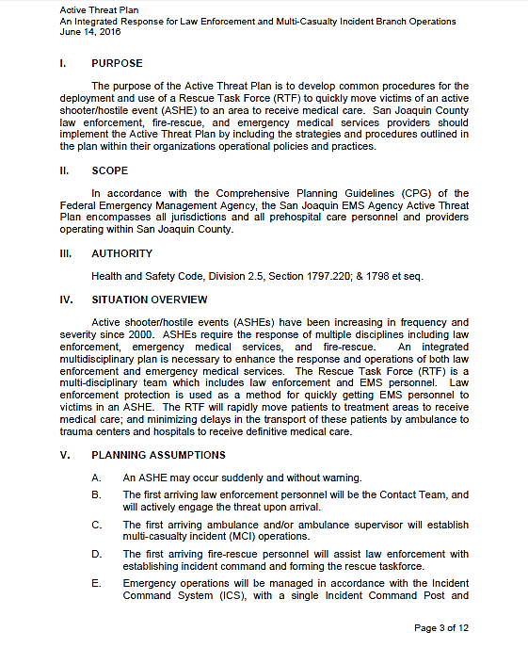

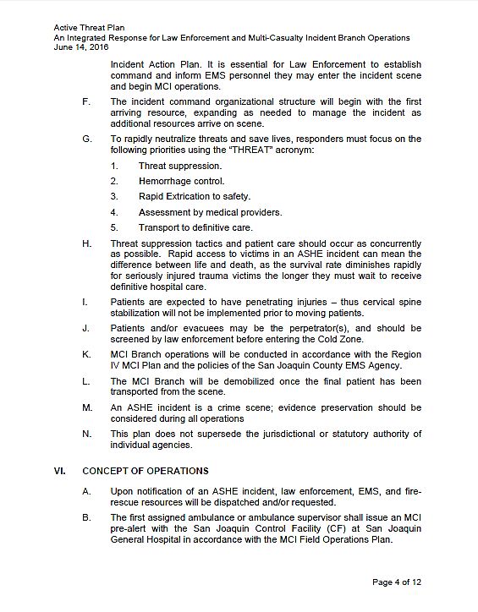
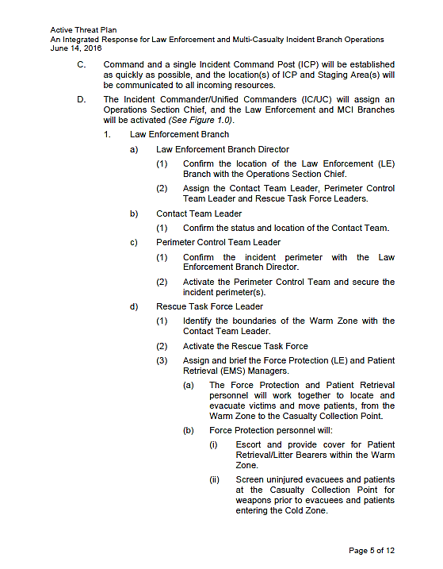

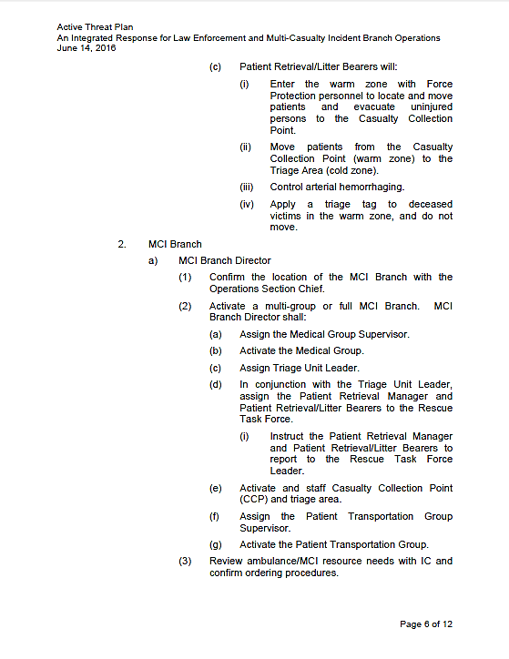

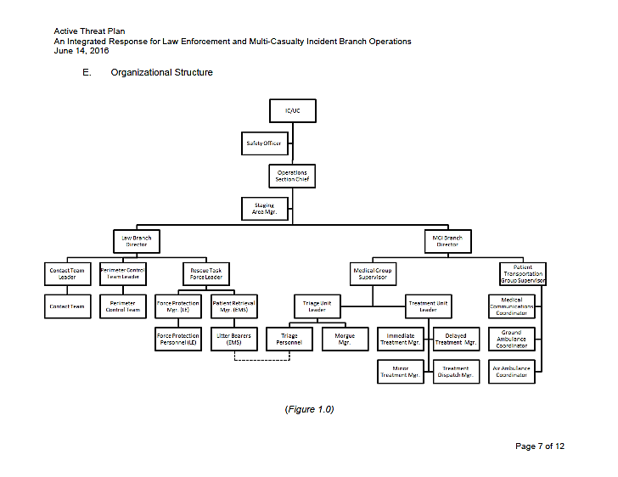

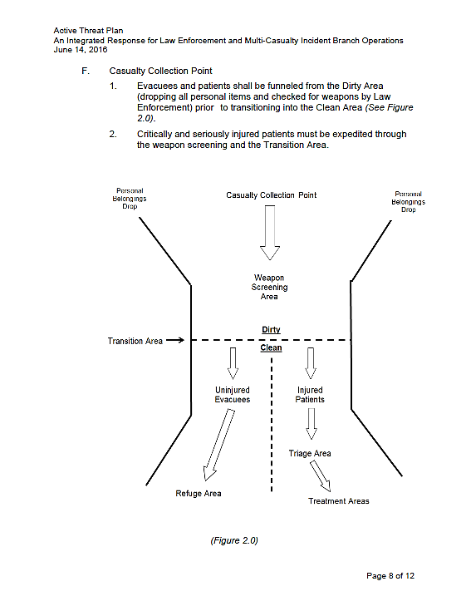

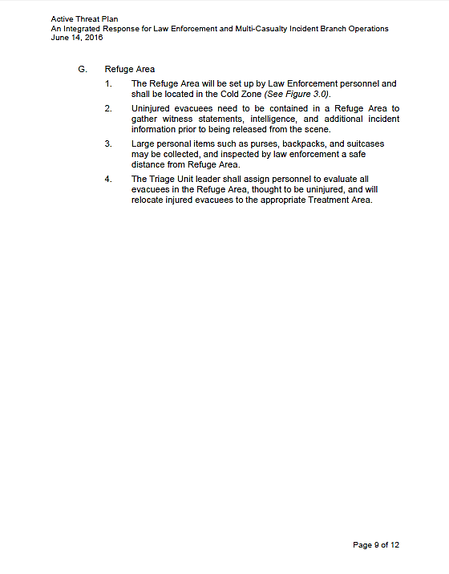

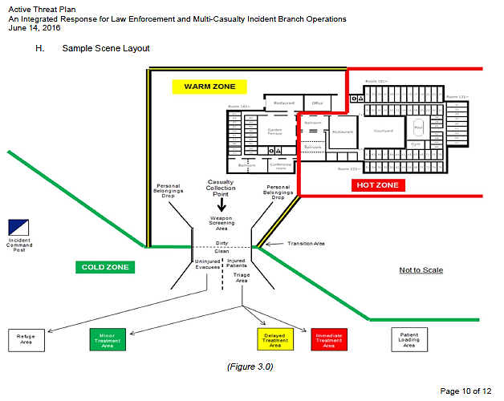

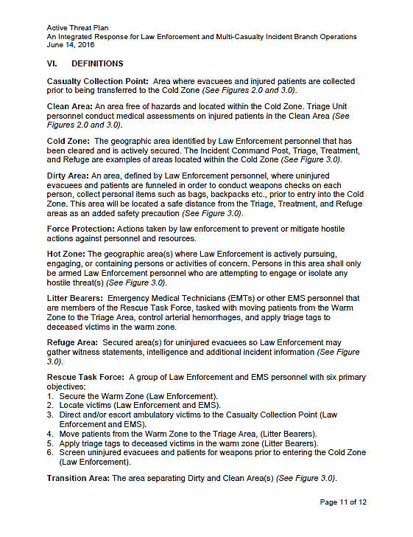

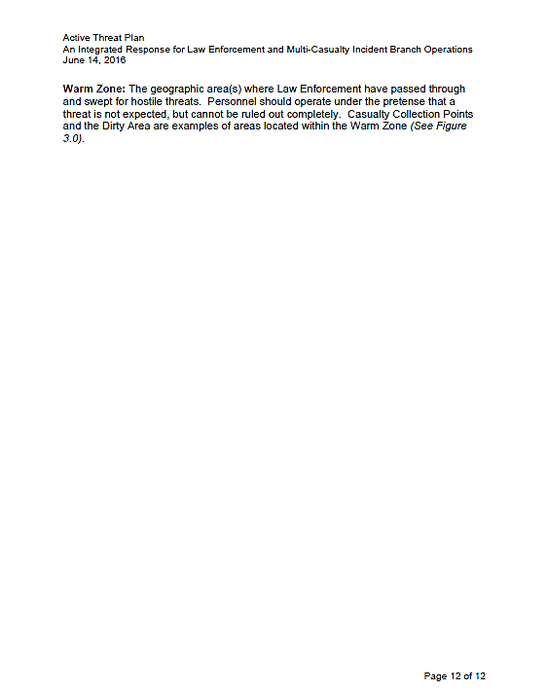

Appendix C: Active Threat Plan ICS Modular Development
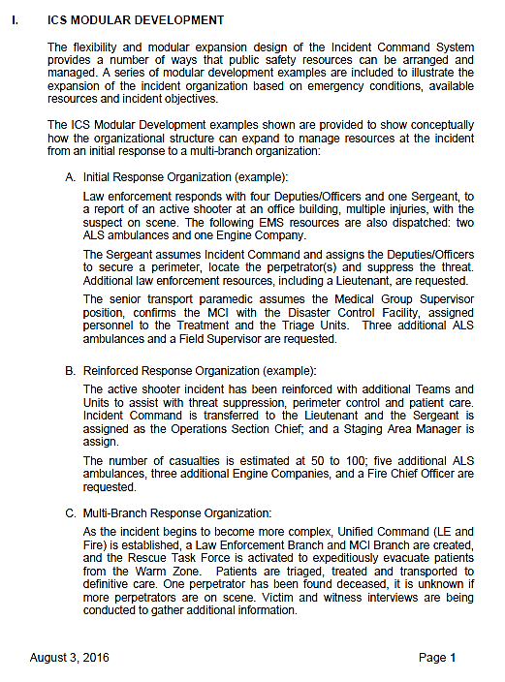
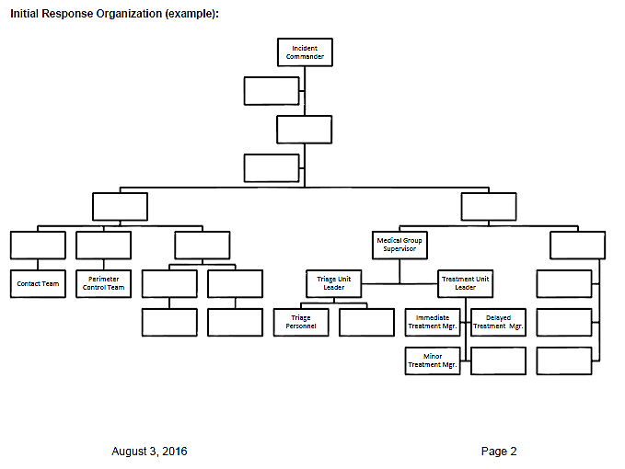

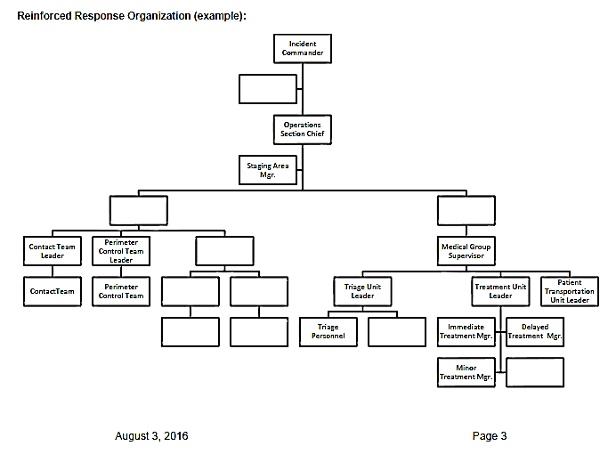

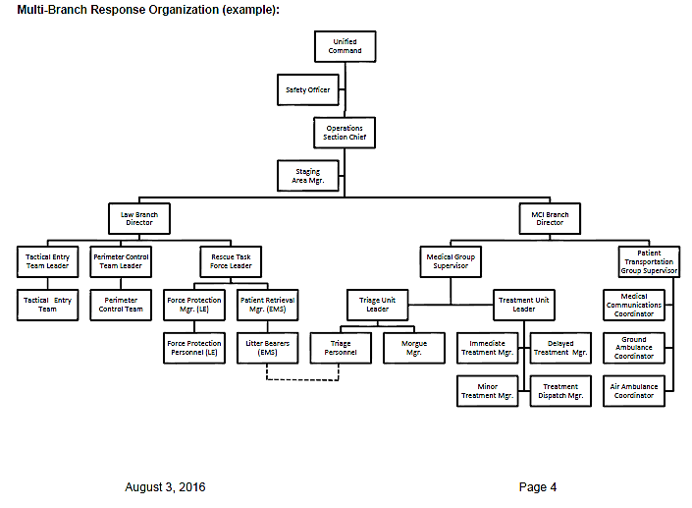

Appendix D: ICS-201 Form
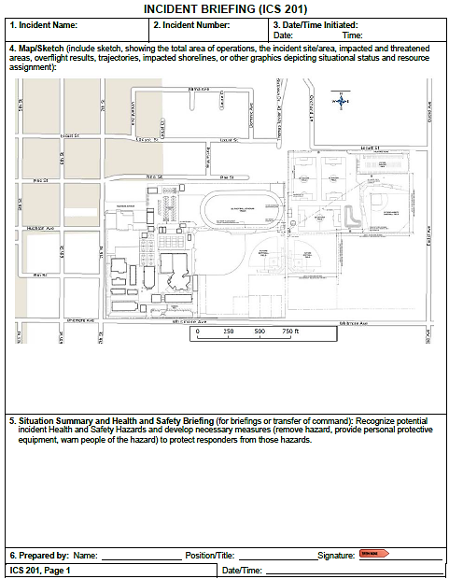
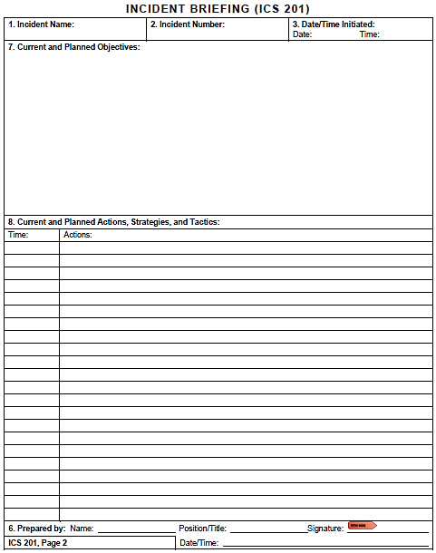
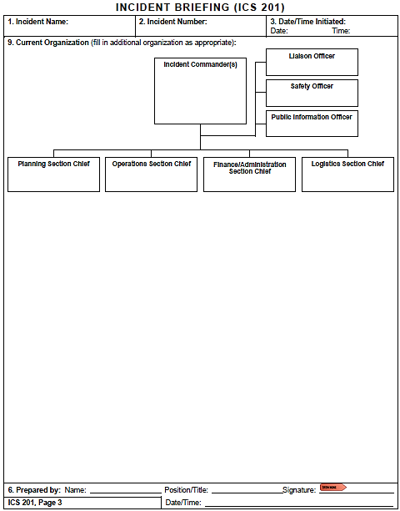
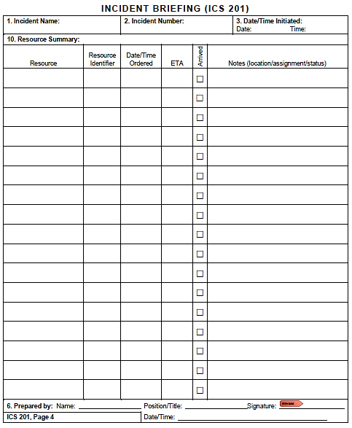

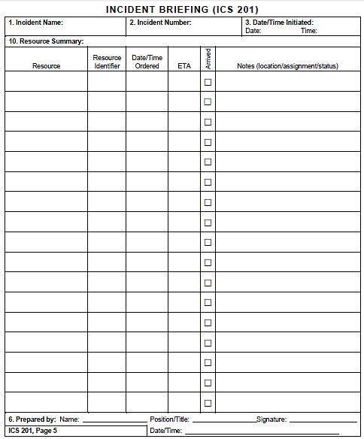

Appendix E: Acronyms

Acronym | Term
ALS | Advance Life Support
AAR/IP | After Action Report/Improvement Plan
ASHE | Active Shooter/Hostile Event
BLS | Basic Life Support
Cal OES | California Governor’s Office of Emergency Services
CSWC | California State Warning Center
DCF | Disaster Control Facility
DHS | U.S. Department of Homeland Security
EMAC | Emergency Management Assistance Compact
EMS | Emergency Management Services
EMSA | California Emergency Medical Services Authority
ETA | Estimated time of arrival
FOUO | For Official Use Only
HSEEP | Homeland Security Exercise and Evaluation Program
IC | Incident Commander
ICS | Incident Command System
MCI | Multi-Casualty Incident
MGS | Medical Group Supervisor
MHOAC | Medical Health Operational Area Coordinator
MICN | Mobile Intensive Care Nurse
MSEL | Master Scenario Events List
NIMS | National Incident Management System
POC | Point of Contact
PSAP | Public Safety Answering Point (i.e., 9-1-1 call center)
PTGS | Patient Transportation Group Supervisor
RDMHC | Regional Disaster Medical Health Coordinator
RDMHS | Regional Disaster Medical Health Specialist
RTF | Rescue Task Force
SEMS | Standardized Emergency Management System
SitMan | Situation Manual
SME | Subject Matter Expert
TTX | Tabletop Exercise

This page intentionally left blank

Appendix F: Incident Map
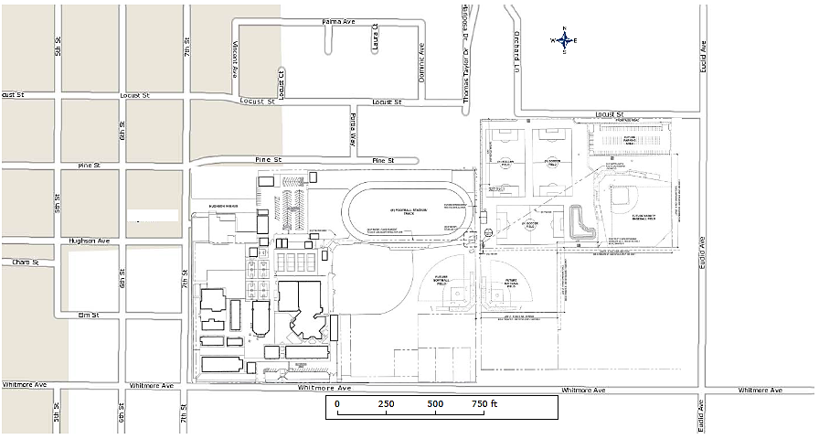

Appendix G: Participant Feedback Form
Please enter your responses in the form field or check box after the appropriate selection.
Name: |  |  |  |  |  | Title:
Agency:
Role: | Player |  | Facilitator | Observer |  | Evaluator

Part I: Recommendations and Corrective Actions
- Based on the discussions today and the tasks identified, list the top three strengths and/or areas that need improvement.

- Identify the action steps that should be taken to address the issues identified above. For each action step, indicate if it is a high, medium, or low priority.
Corrective Action | Priority

- Describe the corrective actions that relate to your area of responsibility. Who should be assigned responsibility for each corrective action?
Corrective Action | Recommended Assignment

- List the policies, plans, and procedures that should be reviewed, revised, or developed. Indicate the priority level for each.
Item for Review | Priority

Part II: Assessment of Exercise Design and Conduct
Please rate, on a scale of 1 to 5, your overall assessment of the exercise relative to the statements provided below, with 1 indicating strong disagreement with the statement and 5 indicating strong agreement.
Assessment Factor | Strongly  Disagree |  |  | Strongly Agree
The exercise was well structured and organized. | 1 | 2 | 3 |  | 4 | 5
The exercise scenario was plausible and realistic. | 1 | 2 | 3 |  | 4 | 5
The multimedia presentation helped the participants understand and become engaged in the scenario. | 1 | 2 | 3 |  | 4 | 5
The facilitator(s) was knowledgeable about the material, kept the exercise on target, and was sensitive to group dynamics. | 1 | 2 | 3 |  | 4 | 5
The Situation Manual used during the exercise was a valuable tool throughout the exercise. | 1 | 2 | 3 |  | 4 | 5
Participation in the exercise was appropriate for someone in my position. | 1 | 2 | 3 |  | 4 | 5
The participants included the right people in terms of level and mix of disciplines. | 1 | 2 | 3 |  | 4 | 5

Part III: Participant Feedback
What changes would you make to this exercise? Please provide any recommendations on how this exercise or future exercises could be improved or enhanced.

https://www.fema.gov/mission-areas
https://www.fema.gov/core-capabilities

