San Joaquin Operational Area Healthcare Coalition



Behavioral Health

Seminar and Tabletop Exercise

Situation Manual

April 30, 2019

  - 

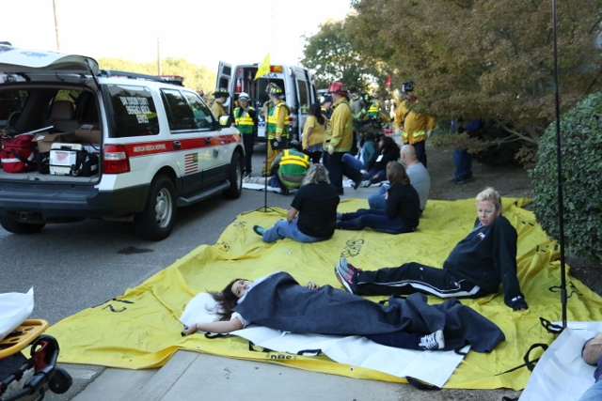









This page intentionally left blank

Table of Contents
Exercise Overview 1
Preface 2
General Information 2
Seminar: Behavioral Health Services Presentation 5
Seminar: SJACIST Presentation 13
Module 1: Initial Incident 21
Module 2: Response 27
Appendix A: Exercise Schedule A-1
Appendix B: Acronyms B-1
Appendix C: Behavioral Health Service Options C-1
Appendix D: Participant Feedback Form D-1

Exercise Overview
Exercise Name | San Joaquin Operational Area Healthcare Coalition Behavioral Health Seminar and Tabletop Exercise
Exercise Date | April 30, 2019 - 0800 to 1200 Hours
Mission Areas | Response and Recovery
Objectives / Capabilities
  Objectives | Capabilities
  Provide participants with an overview of post-emergency healthcare responder behavioral health signs and symptoms, and available resources. | Public Health, Healthcare, and Emergency Medical Services  Continuity of Healthcare Services
  Evaluate coalition member employee post-emergency support policies, plans and procedures.
Threat or Hazard | Vehicle Accident
Scenarios | - Multi-Casualty Incident  - Co-worker Fatality
Sponsors | San Joaquin Operational Area Healthcare Coalition.
Participating Organizations | San Joaquin Operational Area Healthcare Coalition member organizations  San Joaquin Area Critical Incident Support Team
Point of Contact | Phillip Cook  San Joaquin Emergency Medical Services Agency  P.O. Box 220,  French Camp, CA, 95231  209-468-6818  pcook@sjgov.org

Preface
The San Joaquin Operational Area Healthcare Coalition Behavioral Health Seminar and Tabletop Exercise is sponsored by the San Joaquin San Joaquin Operational Area Healthcare Coalition. The exercise was designed to provide healthcare coalition members with behavioral health resources to enhance healthcare worker resilience programs, to effectively address post-emergency support, such as psychological first aid; distributing information on expected stress responses; conducting self and peer-assessment and monitoring activities; critical incident stress management; providing access to employee assistance programs, and professional behavioral health services. In addition, this exercise is designed to evaluate coalition member organization’s employee post-emergency support policies, plans and procedures. This Situation Manual (SitMan) follows guidance set forth by the U.S. Department of Homeland Security (DHS) Homeland Security Exercise and Evaluation Program (HSEEP).
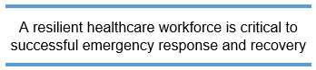
This SitMan provides exercise participants with all the necessary tools for their roles in the exercise, and is tangible evidence of the San Joaquin San Joaquin Operational Area Healthcare Coalition’s commitment to preparedness excellence through collaborative planning and exercises to improve healthcare worker resiliency.

General Information

Participant Roles and Responsibilities
The term participant encompasses many groups of people, not just those playing in the exercise. Groups of participants involved in the exercise, and their respective roles and responsibilities, are as follows:
- Players. Players are personnel who have an active role in discussing or performing their regular roles and responsibilities during the exercise. Players discuss or initiate actions in response to the simulated emergency.
- Observers. Observers do not directly participate in the exercise; however they may support the group in developing responses to the situation during the discussion.
- Facilitators. Facilitators provide situation updates and moderate discussions. They also provide additional information or resolve questions as required. Key Exercise Planning Team members also may assist with facilitation as subject matter experts (SMEs) during the exercise.
- Evaluators. Evaluators are assigned to observe and document certain objectives during the exercise. Their primary role is to document player discussions, including how and if those discussions conform to plans, polices, and procedures.

Exercise Structure
The Seminar (S) will be a facilitated multimedia presentation, followed by questions and answers.
The Tabletop Exercise (TTX) will be a multimedia, facilitated exercise. Players will participate in the following two (2) modules:
- Module 1: Initial Incident
- Module 2: Response

Each module begins with a multimedia update that summarizes key events occurring within that time period. After the updates, participants review the situation and engage in functional group discussions of appropriate response issues. For this exercise, the functional groups are as follows:
- Hospitals
- Other Healthcare Facilities (clinics, long term care, dialysis, etc.)
- Prehospital Care
- County Agencies

After these functional group discussions, participants will engage in a moderated plenary discussion in which a spokesperson from each group will present a synopsis of the group’s actions, based on the scenario.

Exercise Guidelines
- This exercise will be held in an open, low-stress, no-fault environment. Varying viewpoints, even disagreements, are expected.
- Respond to the scenario using your knowledge of current plans and capabilities (i.e., you may use only existing assets) and insights derived from your training.
- Decisions are not precedent setting and may not reflect your organization’s final position on a given issue. This exercise is an opportunity to discuss and present multiple options and possible solutions.
Issue identification is not as valuable as suggestions and recommended actions that could improve response efforts. Problem-solving efforts should be the focus.
During exercise discussions, if a player states that they are going to ask for/provide mutual aid, they need to state specifically under which plan and to which agency they will do so.

Exercise Assumptions and Artificialities
In any exercise, assumptions and artificialities may be necessary to complete play in the time allotted and/or account for logistical limitations. Exercise participants should accept that assumptions and artificialities are inherent in any exercise, and should not allow these considerations to negatively impact their participation. During this exercise, the following apply:
- The exercise scenario is plausible, and events occur as they are presented.
- There is no hidden agenda, and there are no trick questions.
- All players receive information at the same time.

Exercise Evaluation
Evaluation of the exercise is based on the exercise objectives. Players will be asked to complete participant feedback forms. These documents, coupled with facilitator observations and notes, will be used to evaluate the exercise and compile the After-Action Report (AAR).

Seminar

San Joaquin County Behavioral Health Services - Presentation
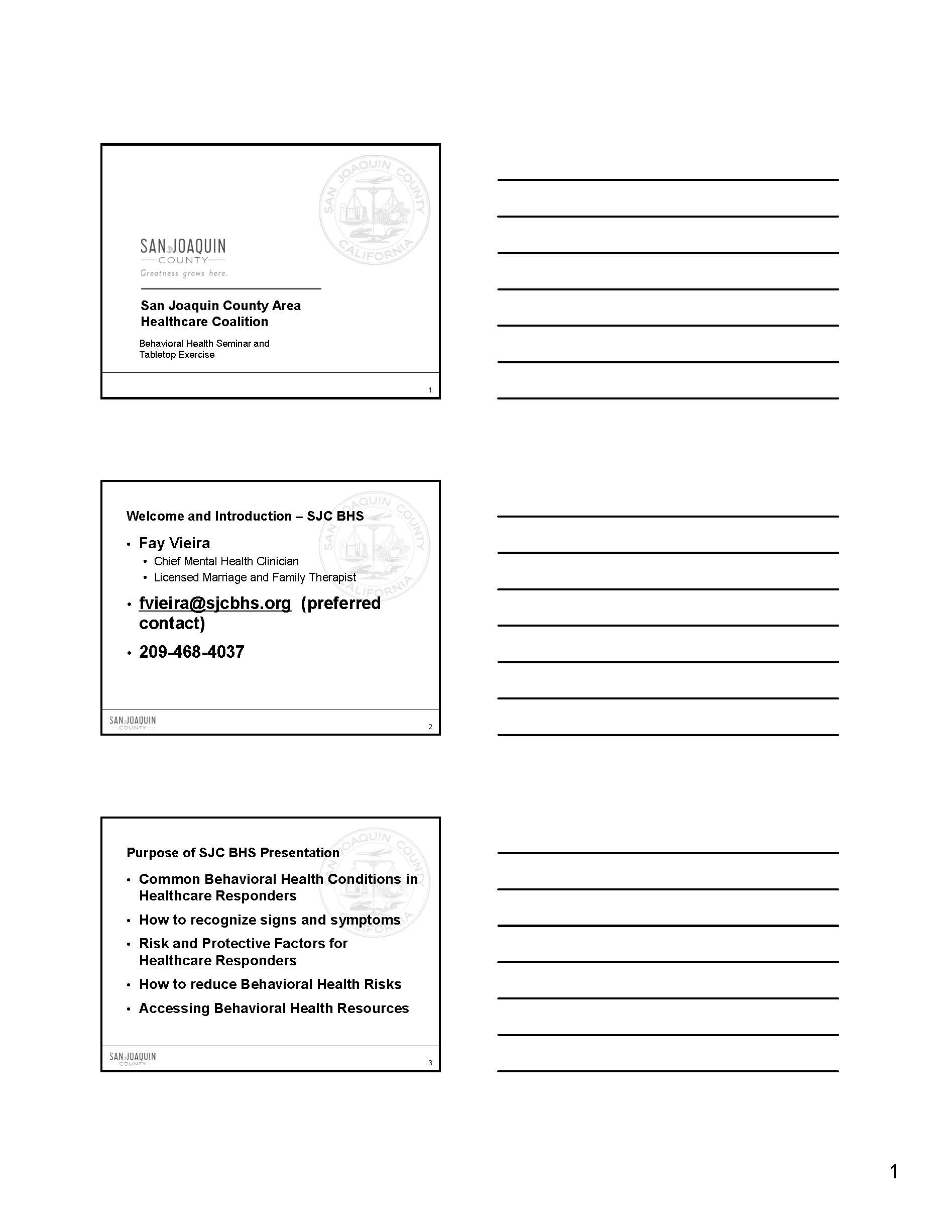
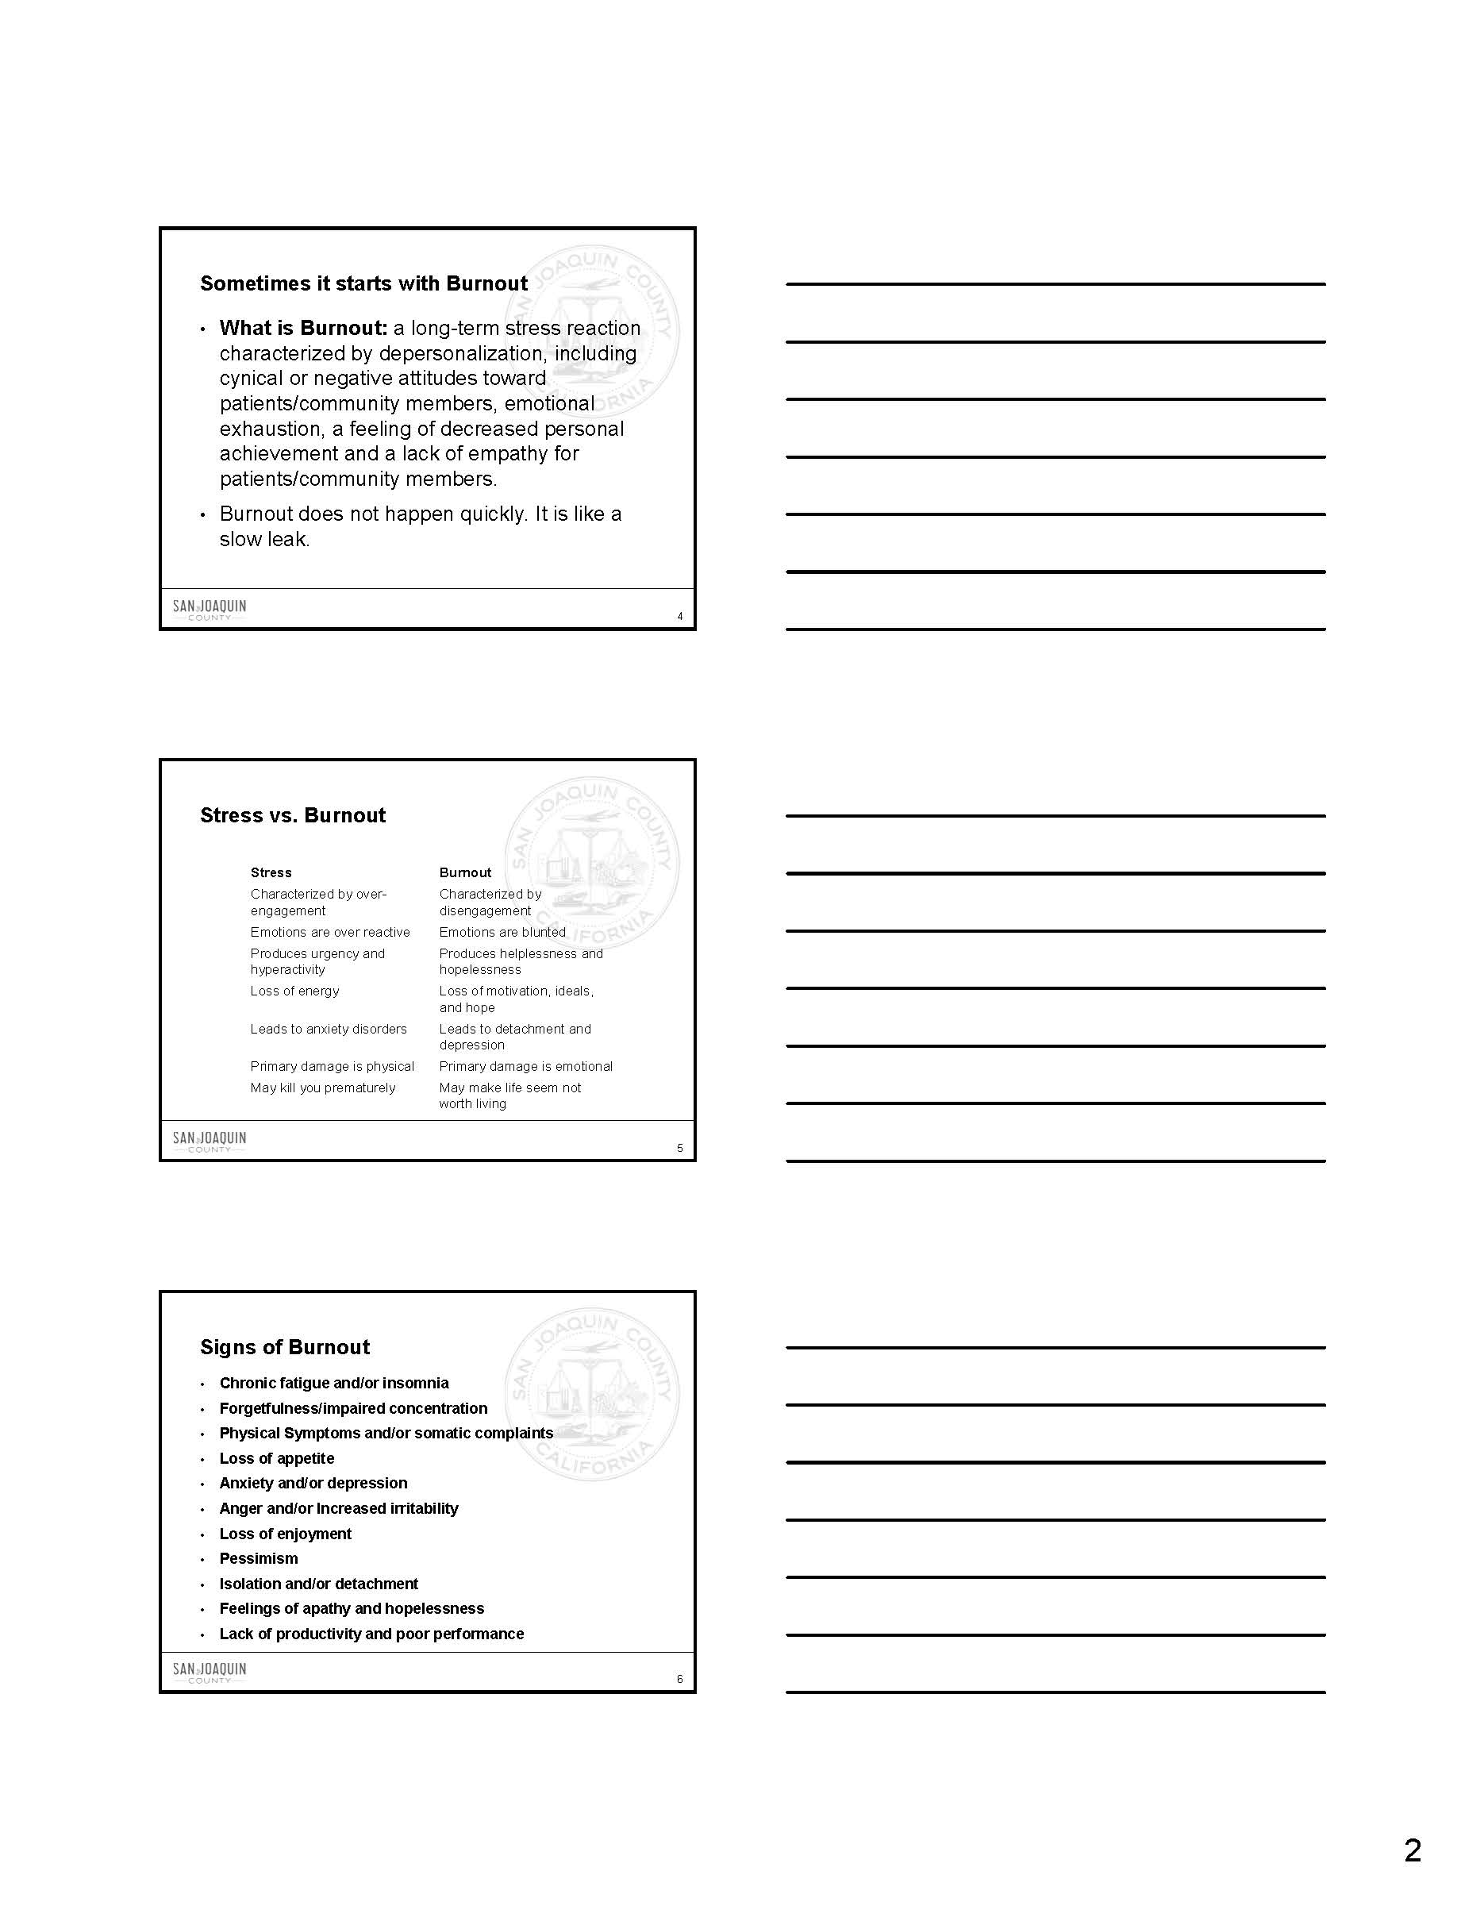

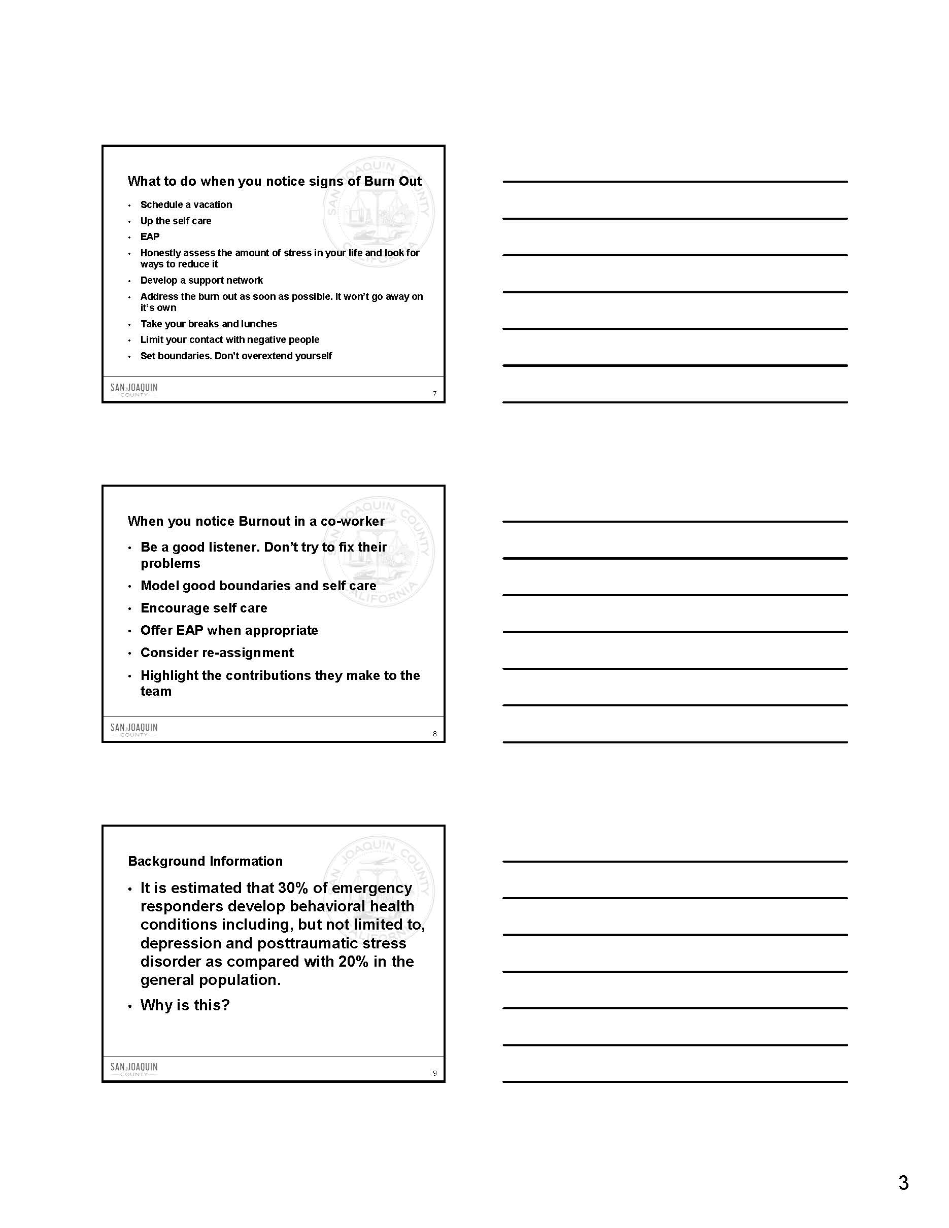

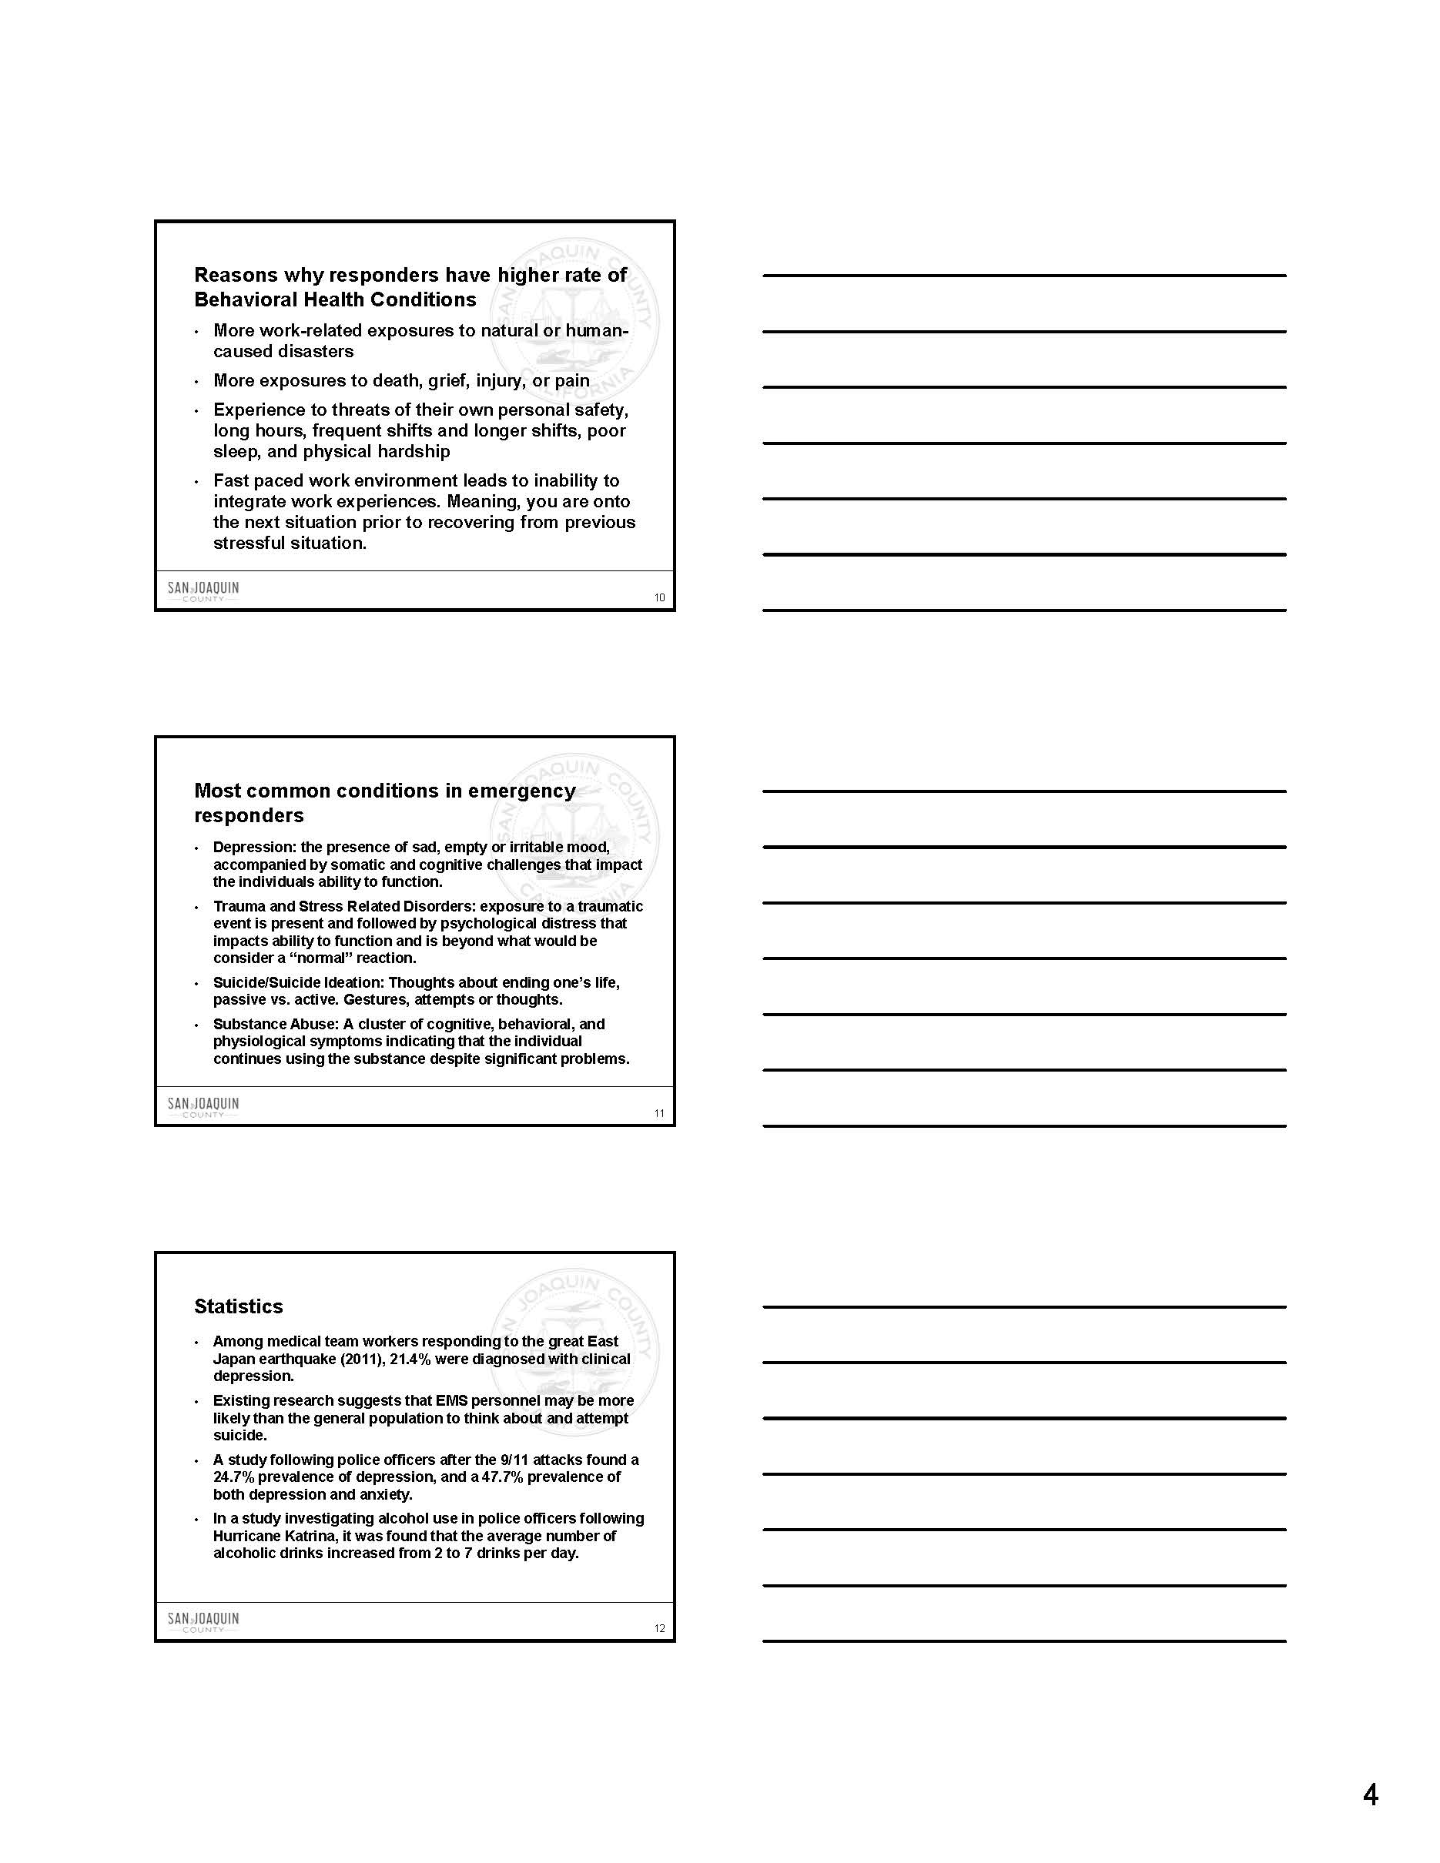

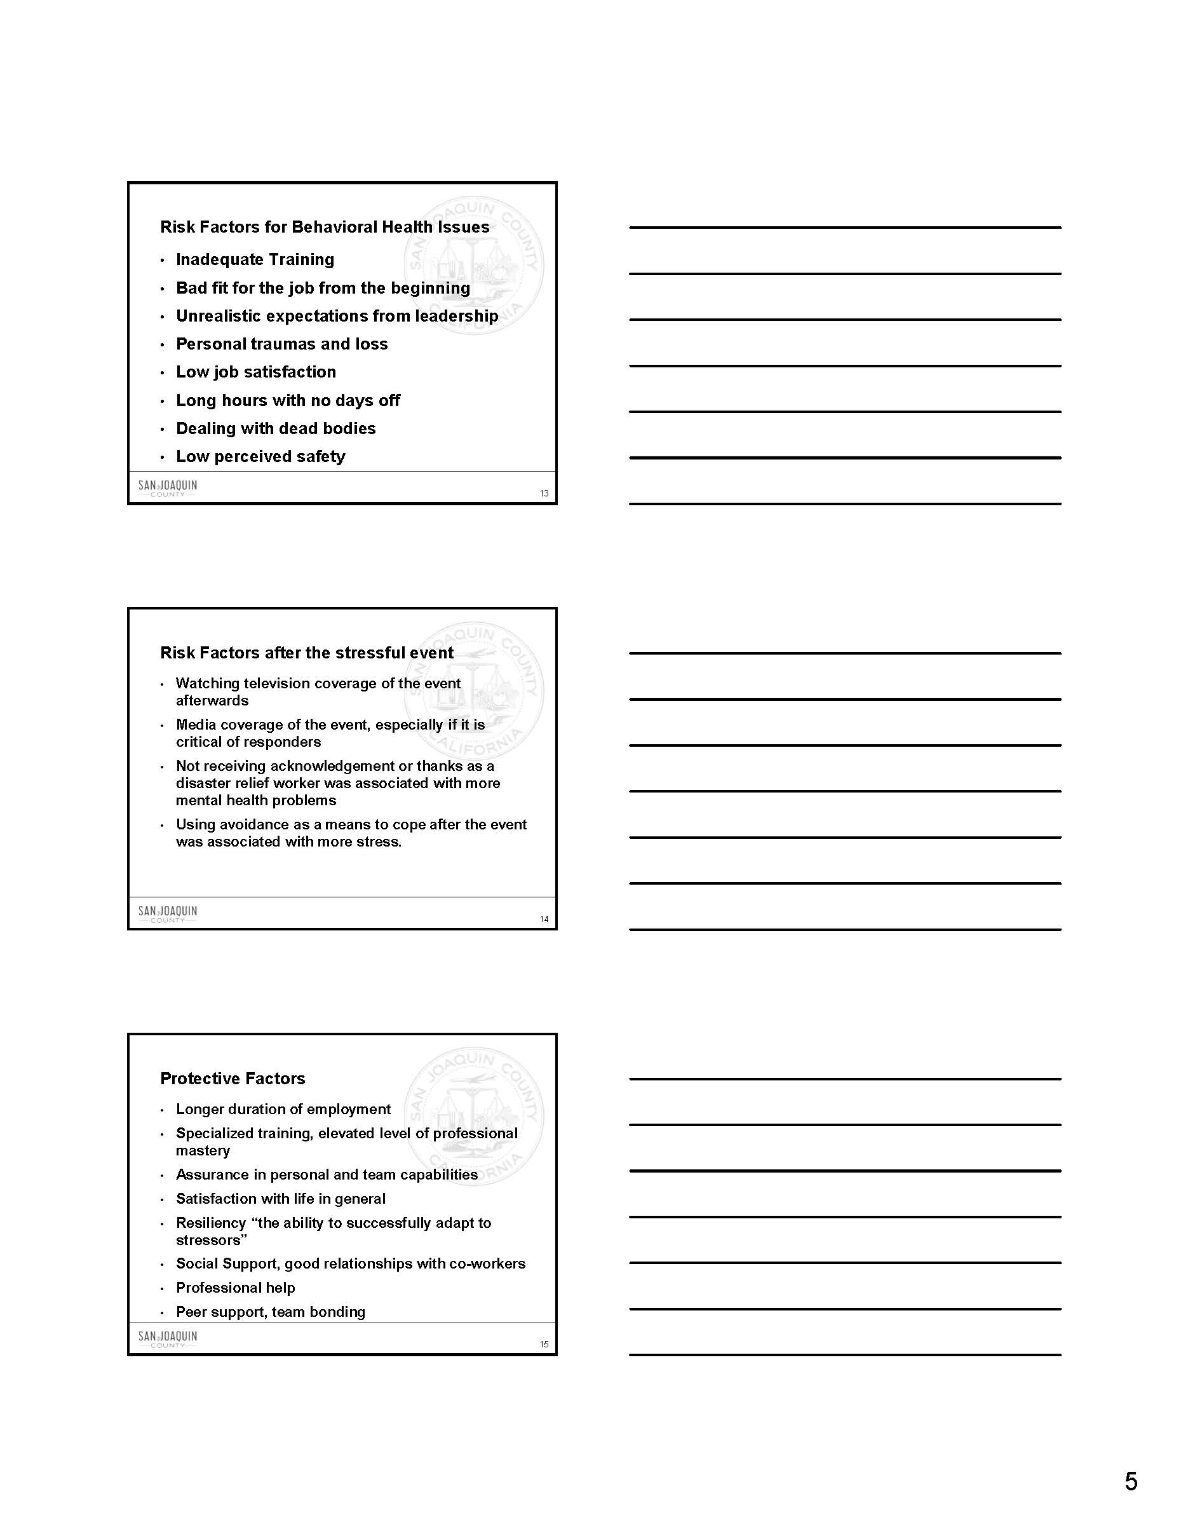
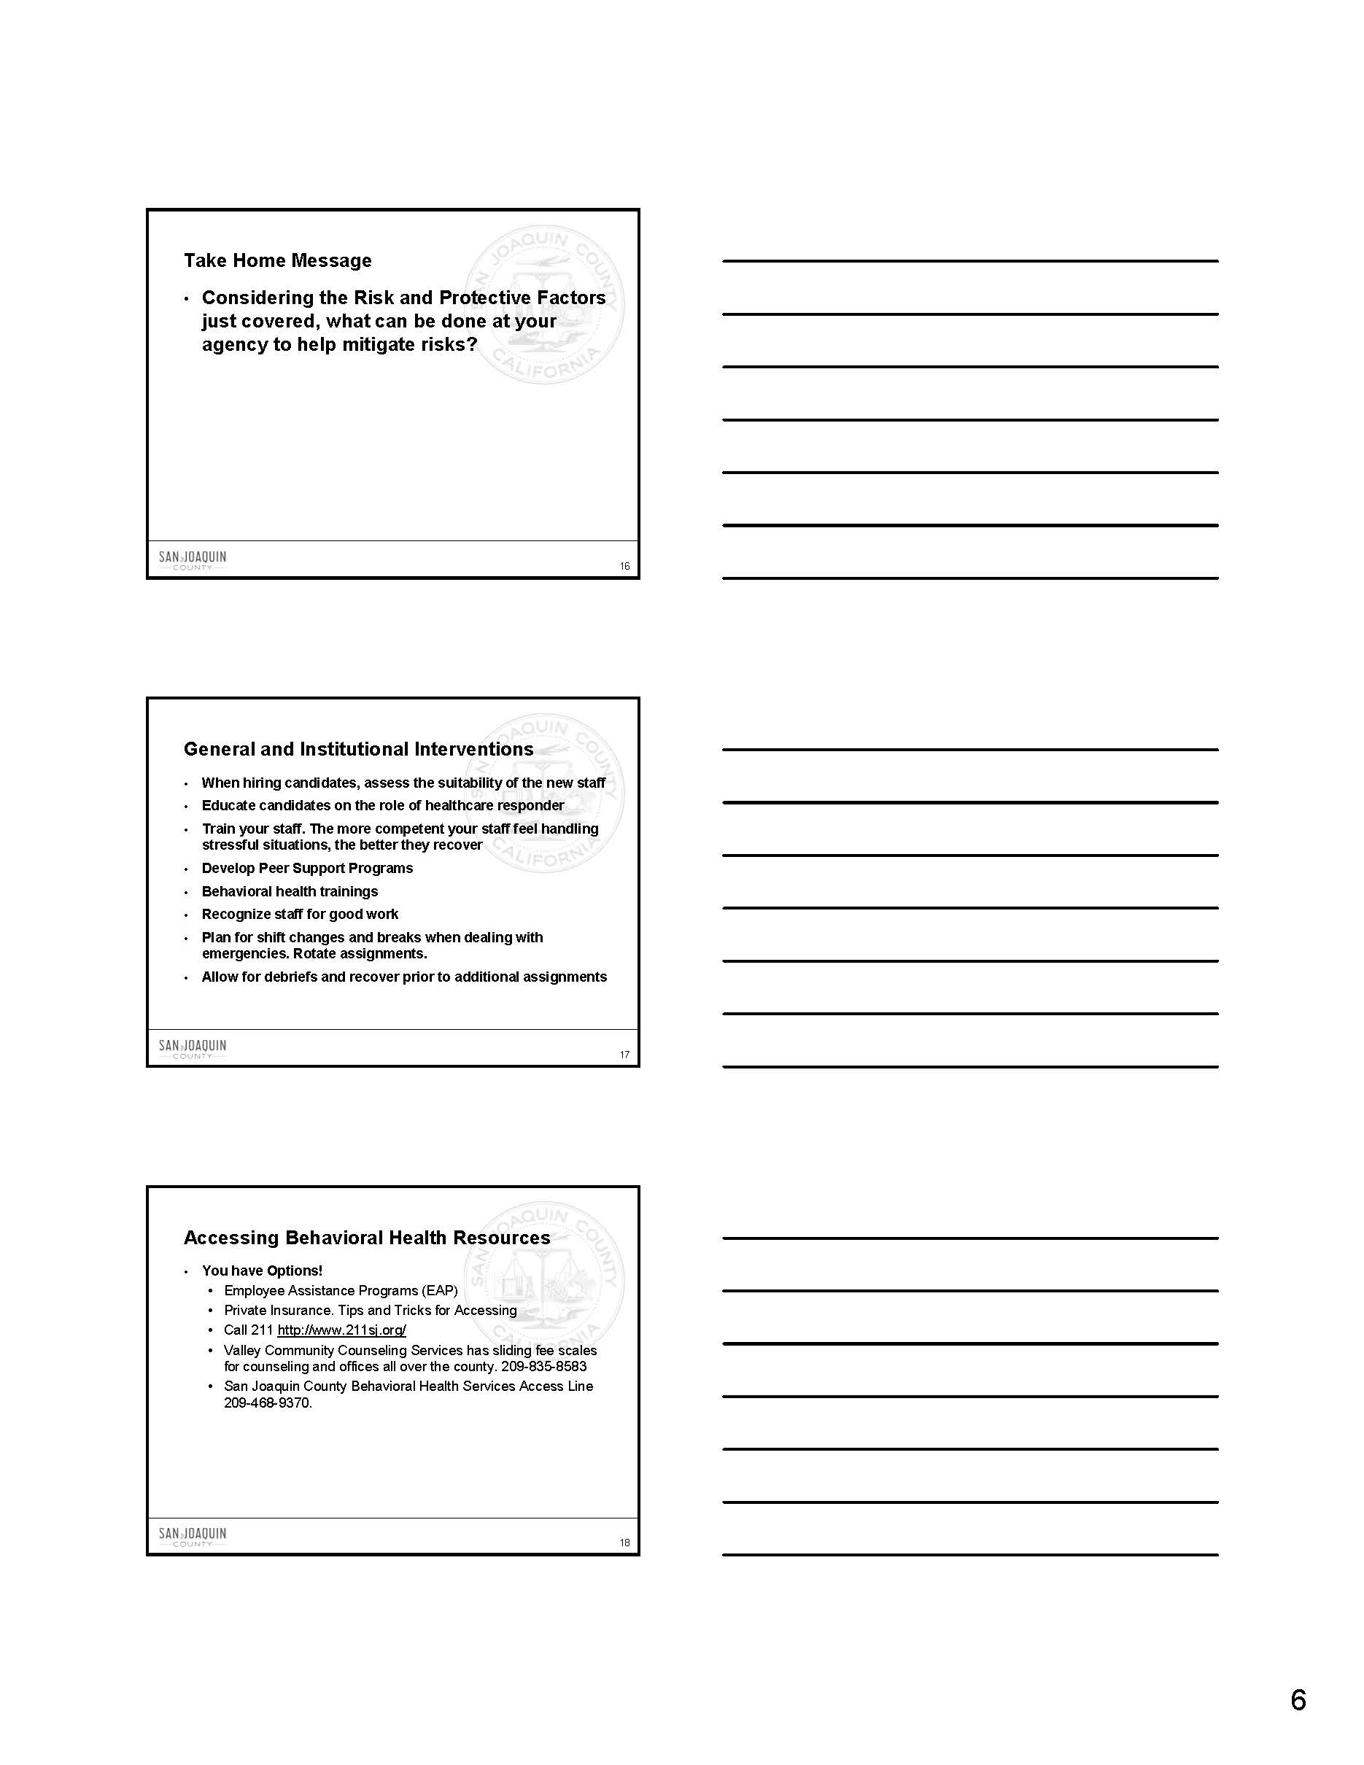

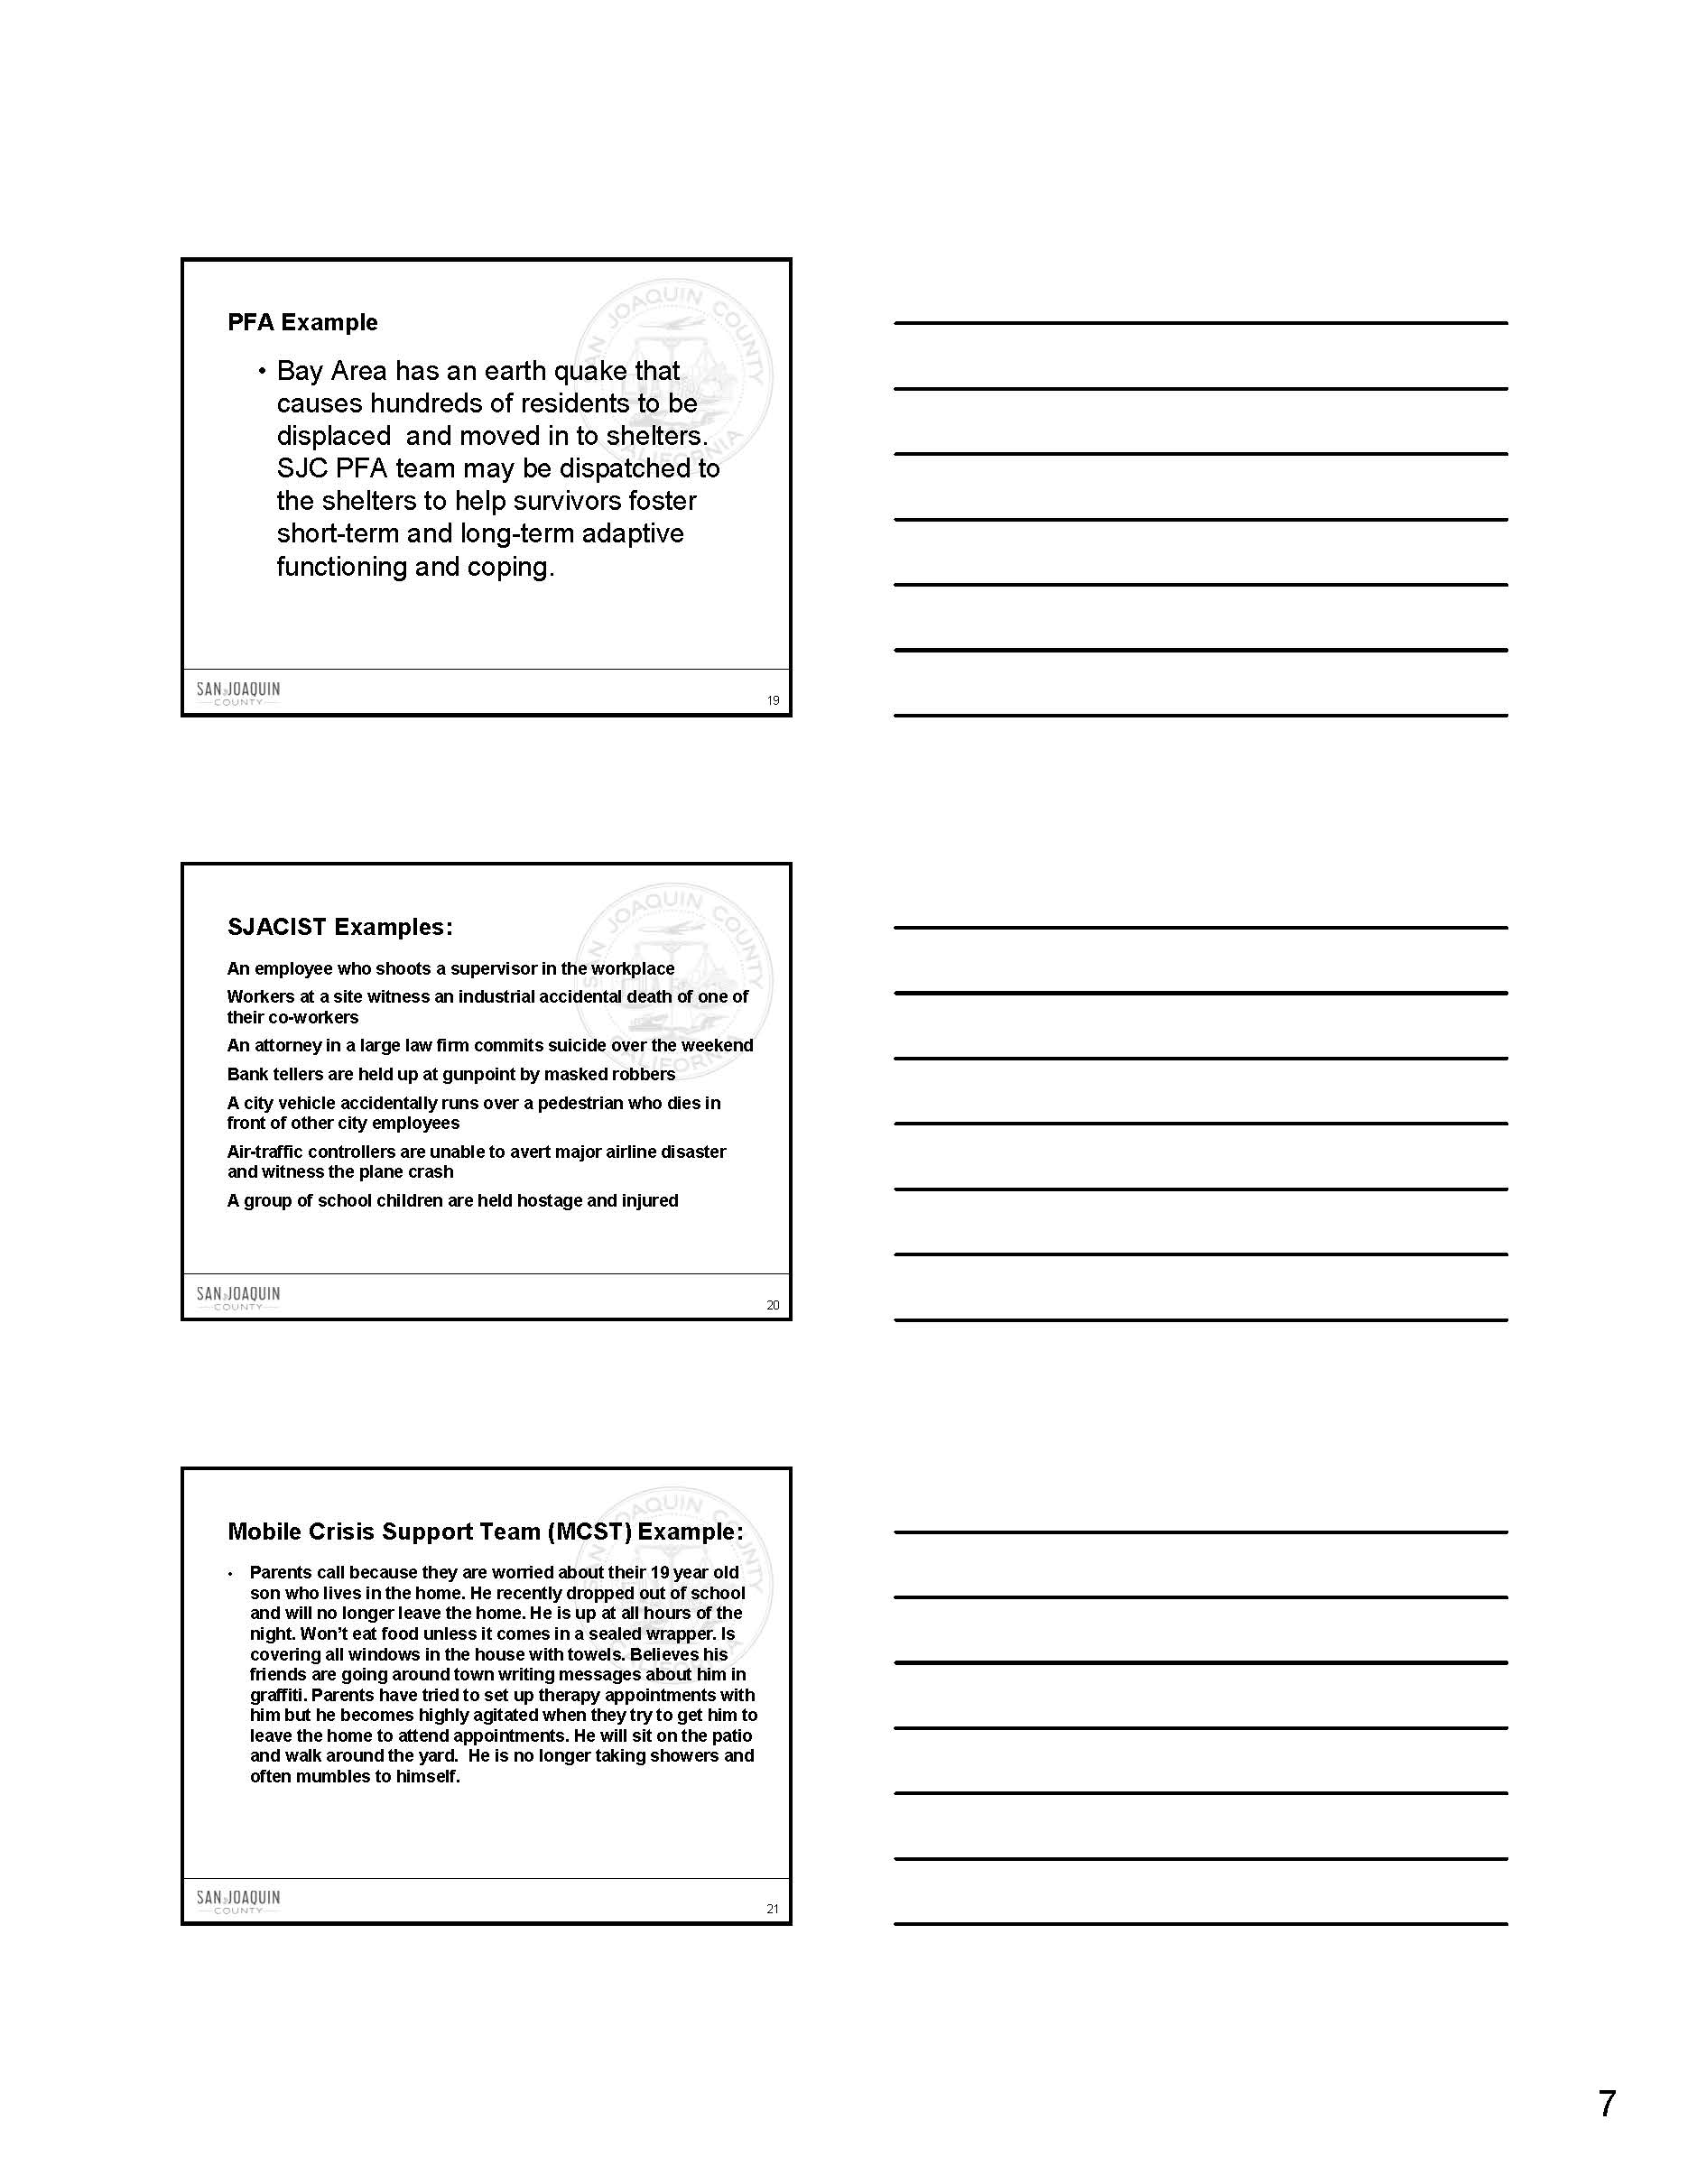

This page intentionally left blank

San Joaquin Area Critical Incident Support Team - Presentation

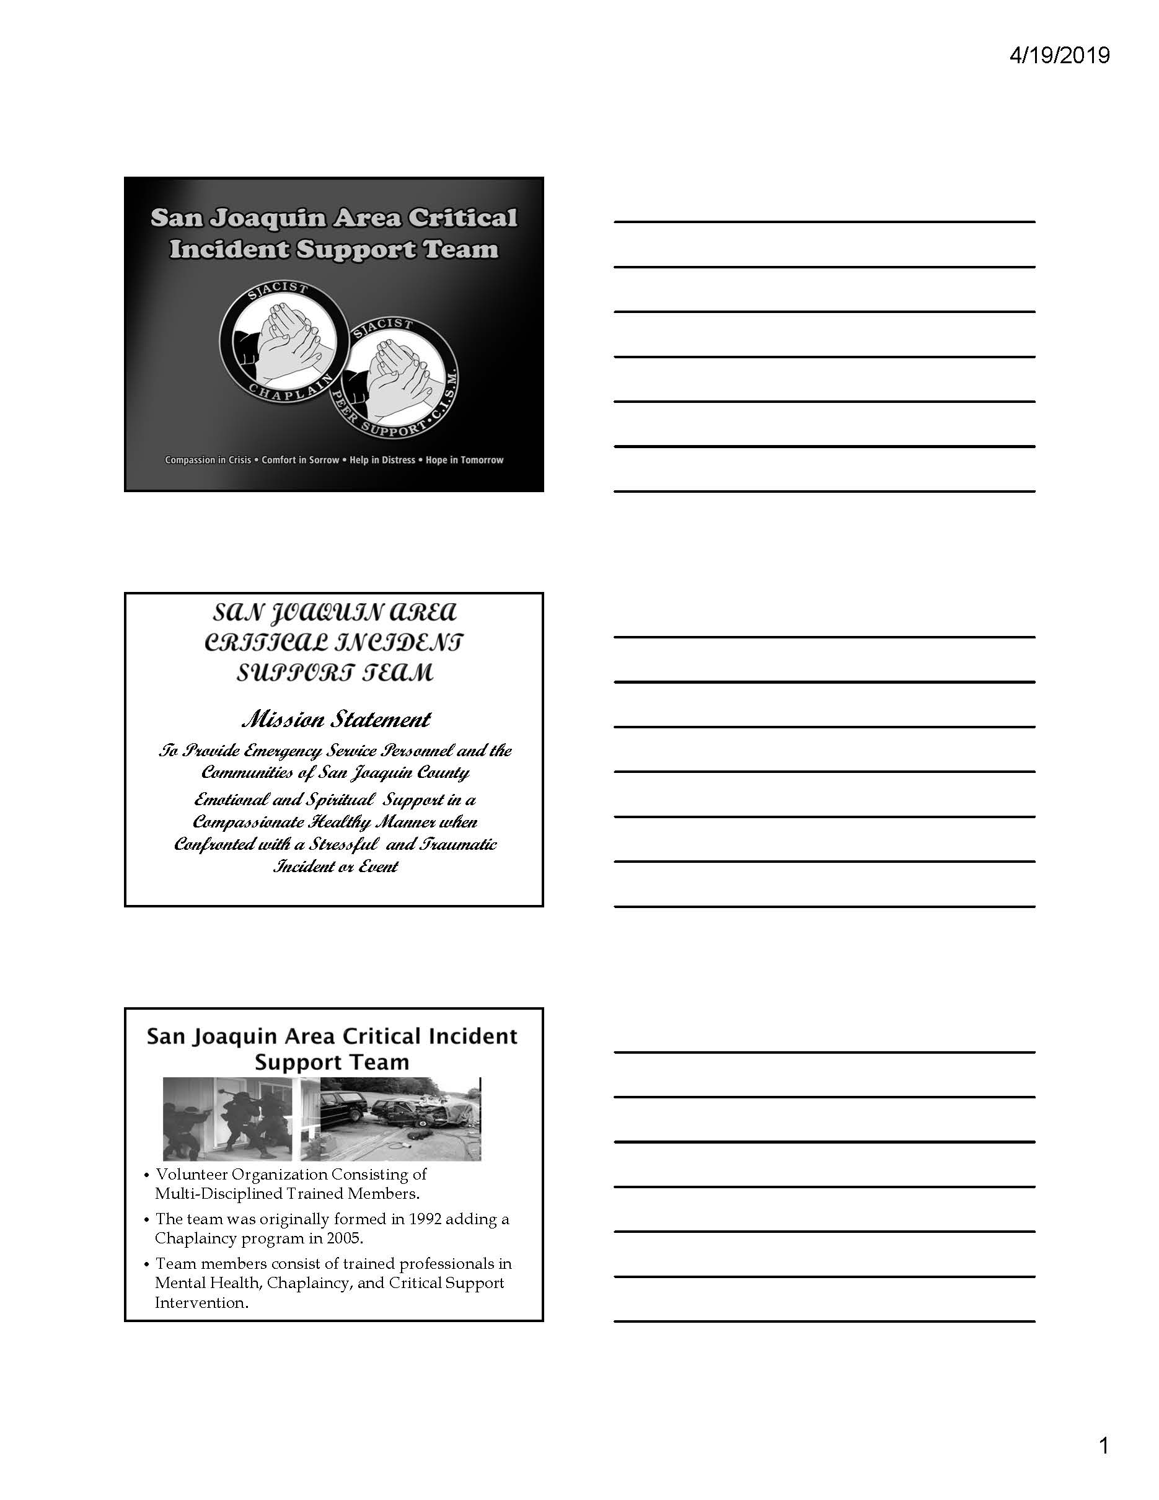

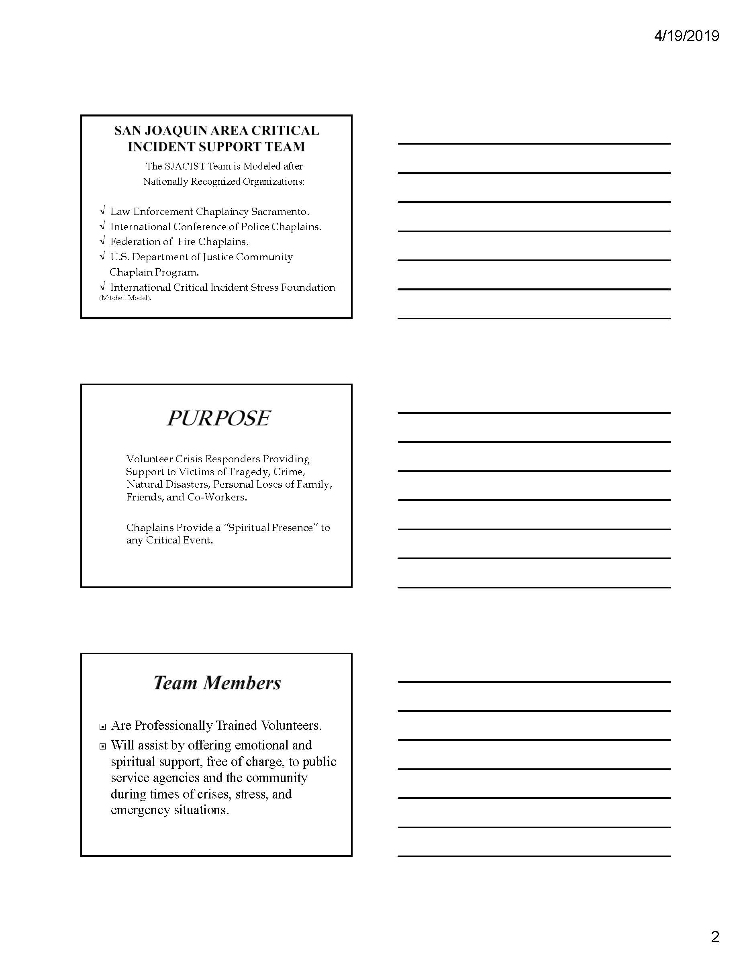

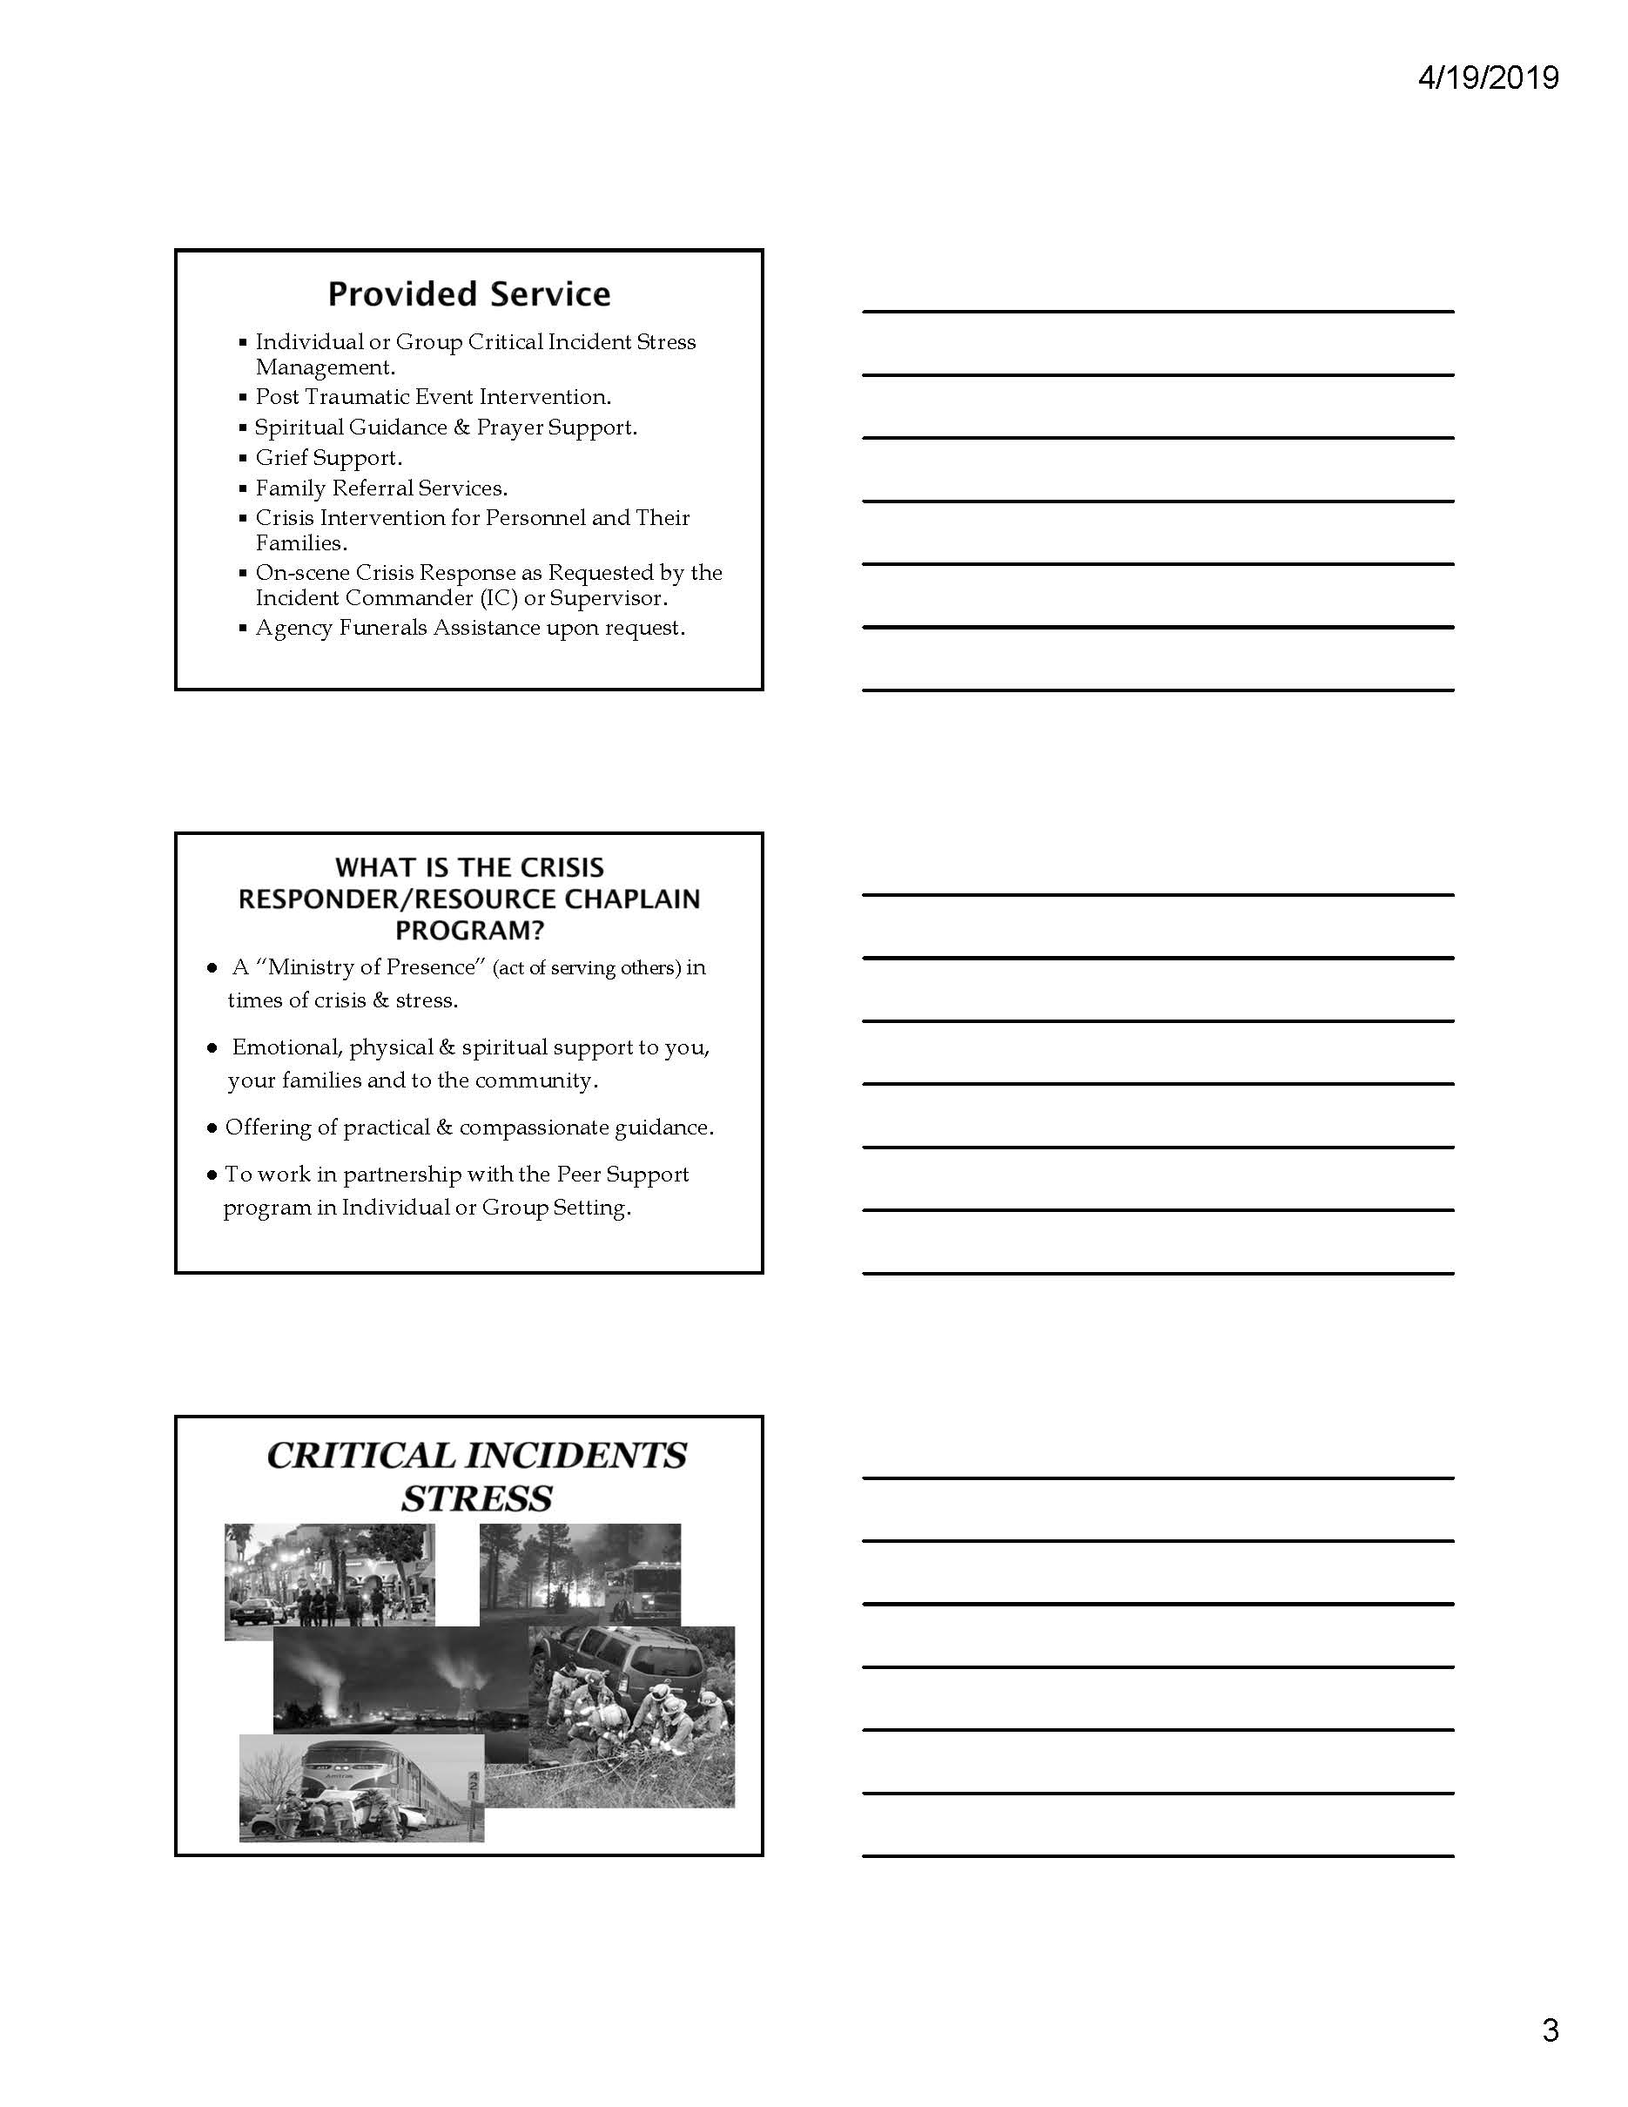

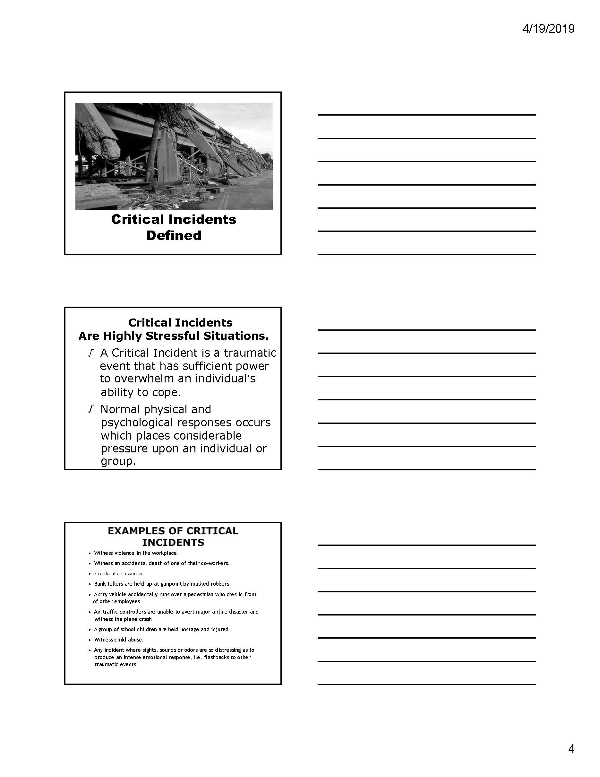

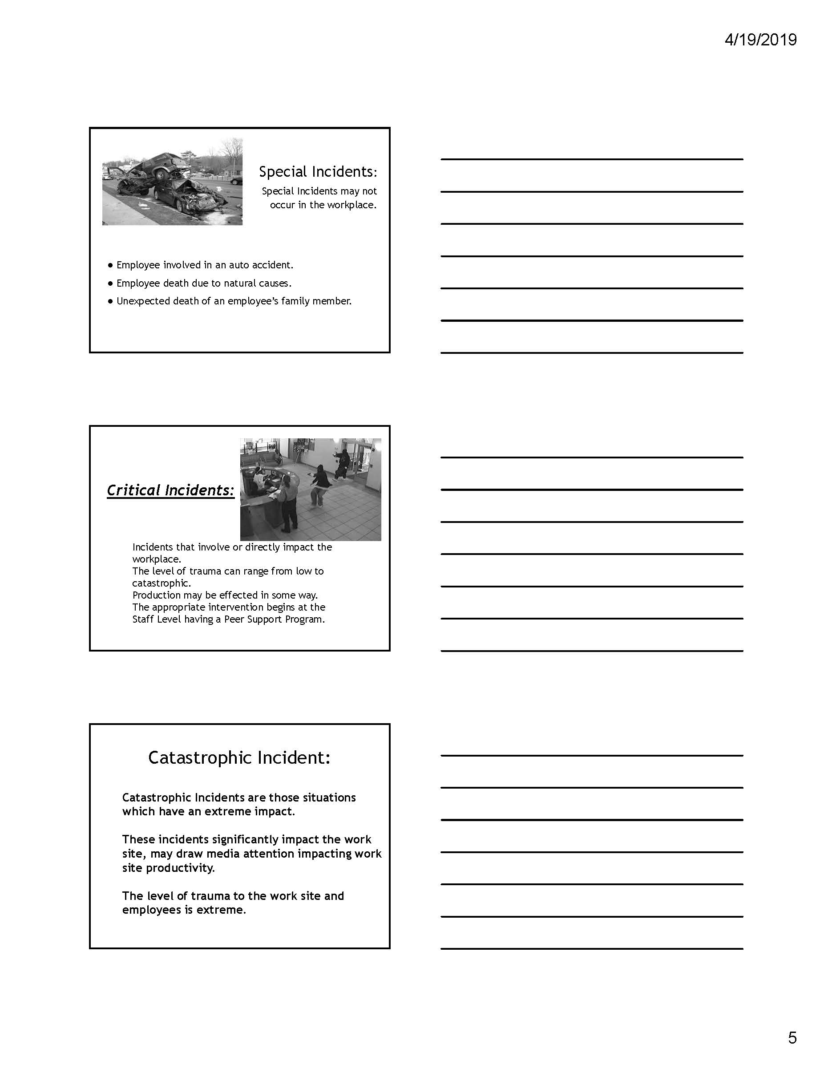

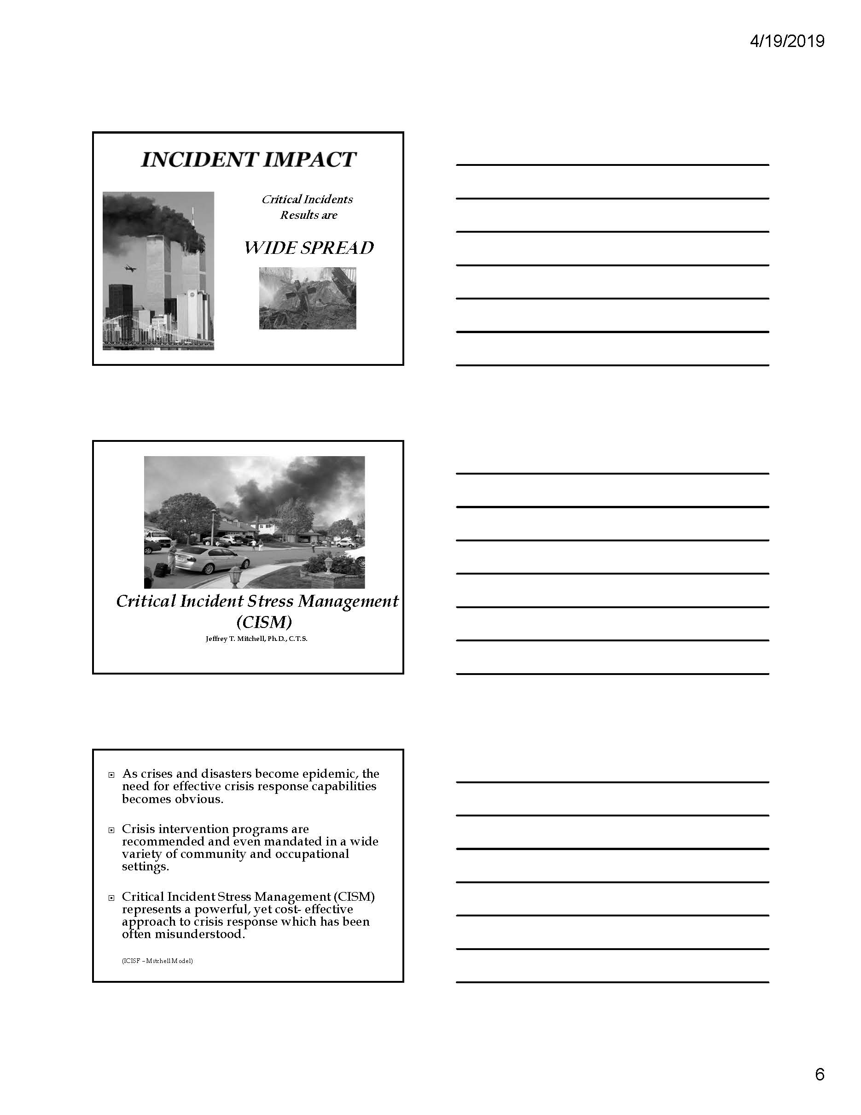

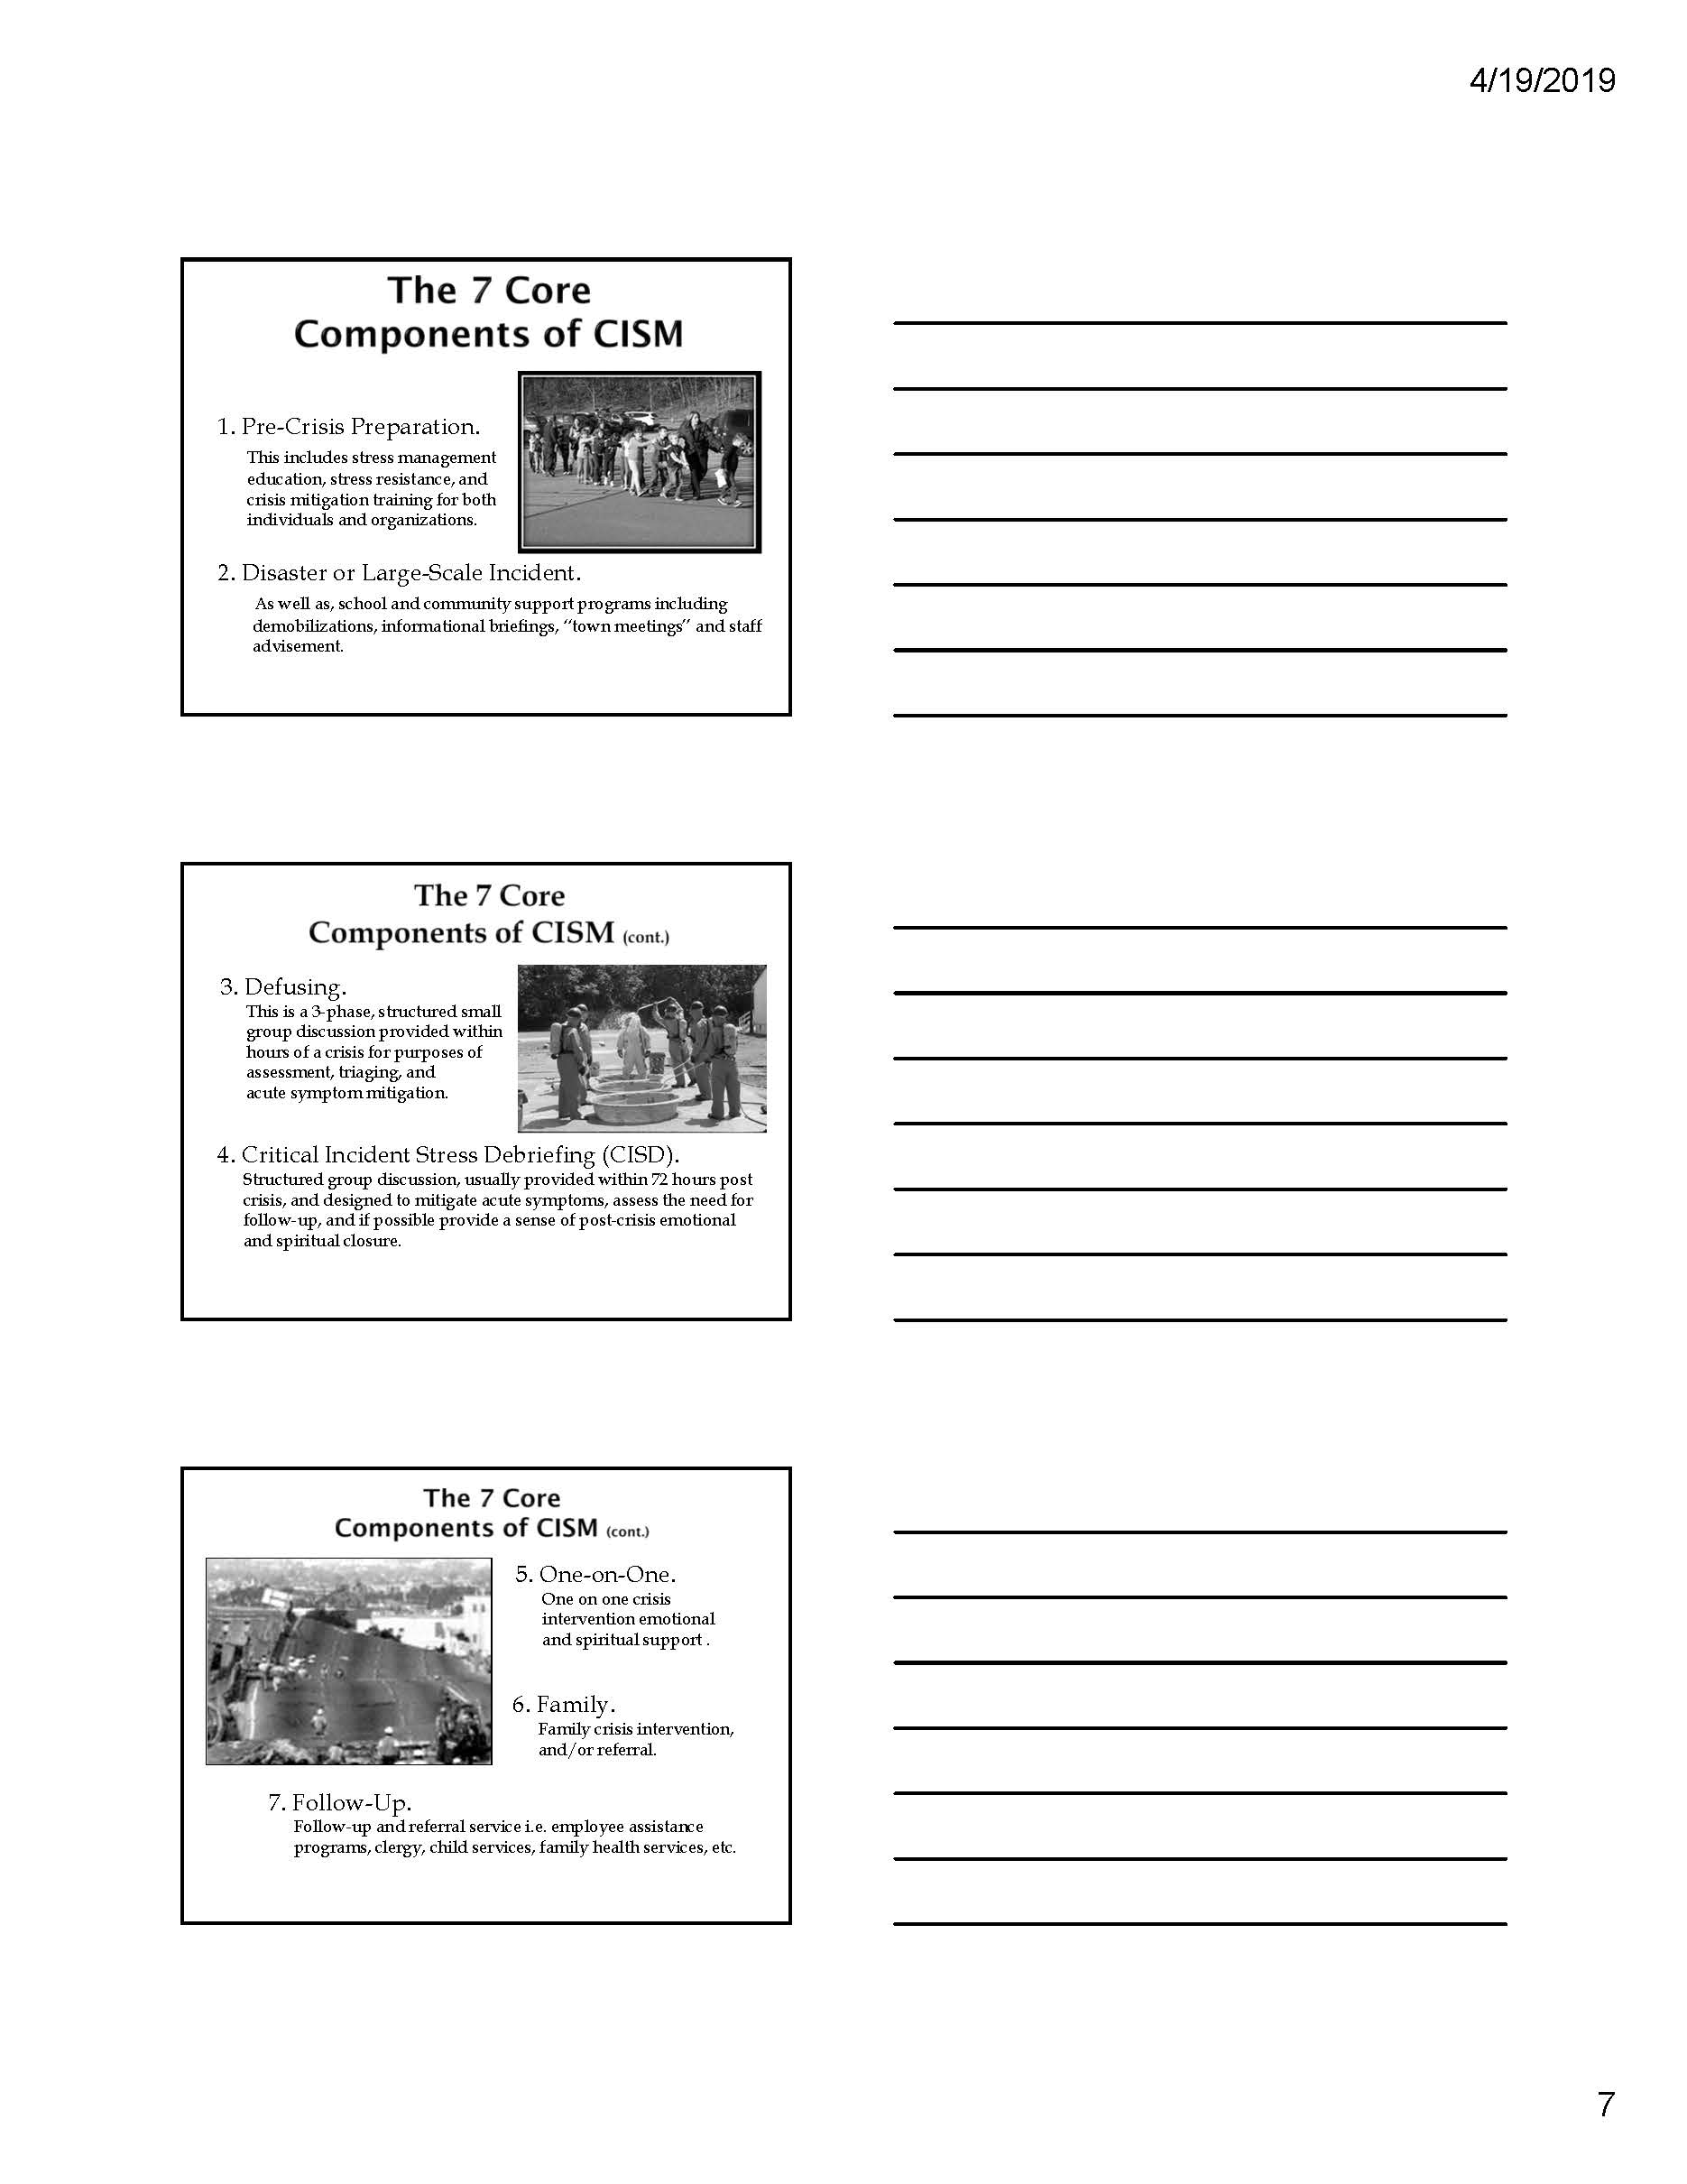

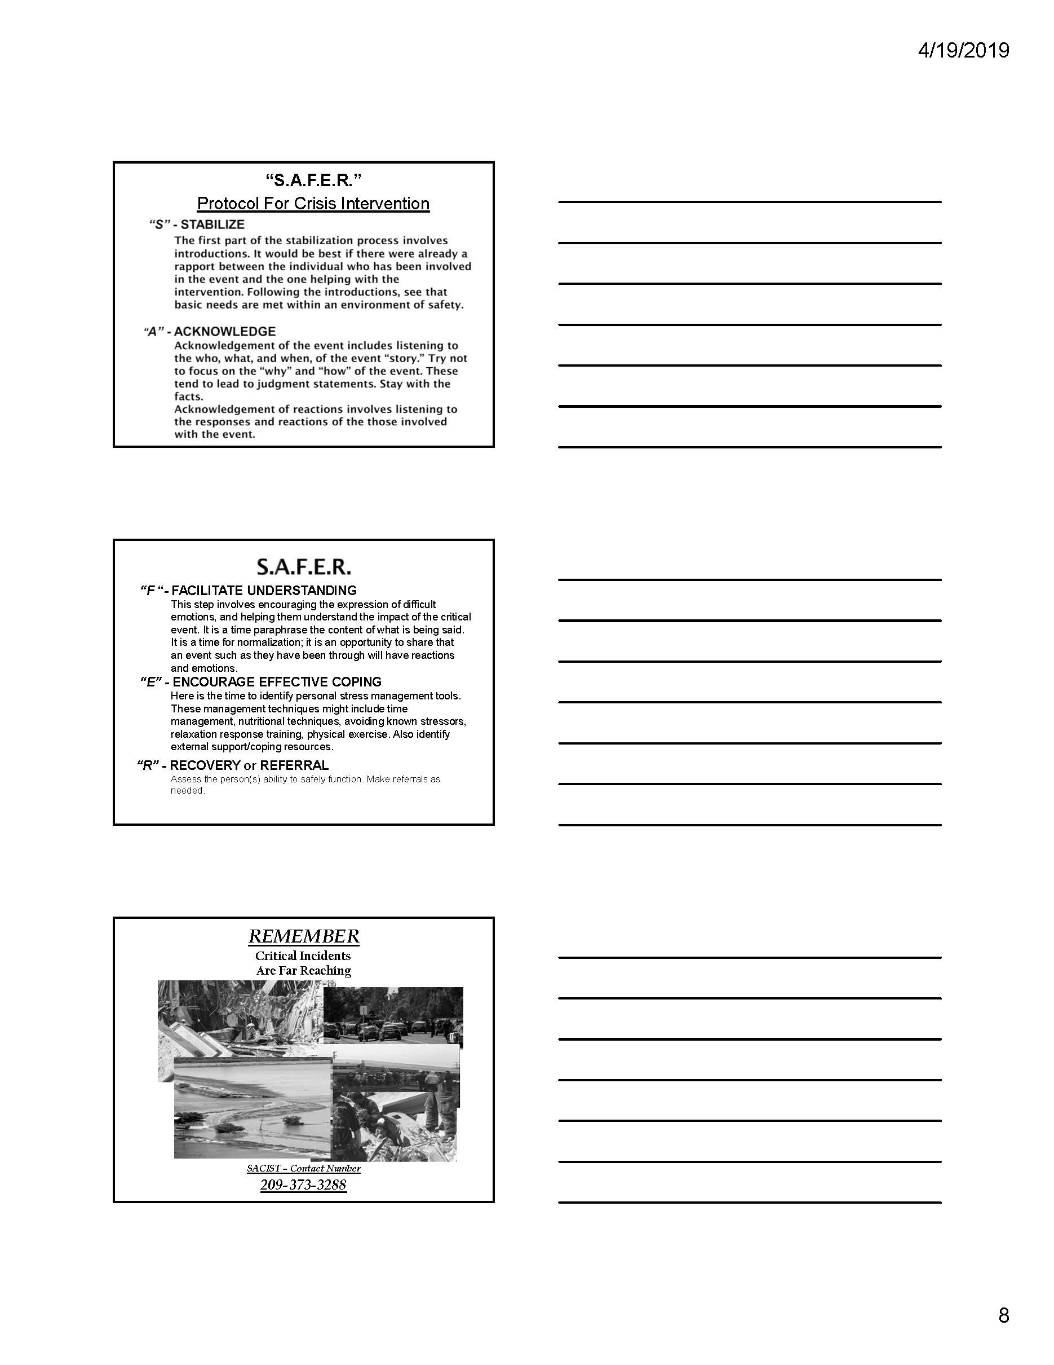

Module 1: Initial Incident

Tuesday April 30, 2019:

0946 hours
A well liked co-worker, on his way out of town for a vacation with his family, stopped by work to quickly sign some papers that needed to be submitted today. While he was in the office, his wife and family members wait in their vehicle.

1000 hours
While pulling out of the driveway your co-worker’s vehicle was hit by an SUV traveling at approximately 90 miles per hours.

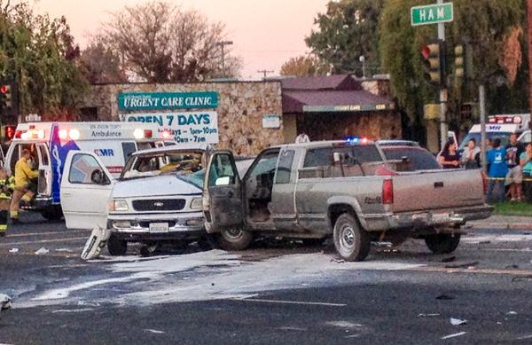
Everyone in the office hears the accident and runs outside to see what happened. A supervisor calls 9-1-1, while you and other co-workers run to the accident to provide care for the injured.

The scene is horrific, bloody and chaotic. A total of six vehicles are involved in the accident and your co-worker shows sign of obvious death.

1001 hours
Law, Fire and EMS are dispatched to the incident.

1005 hours

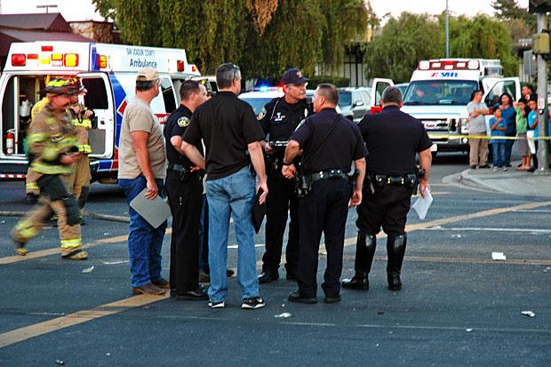
The Control Facility created an MCI event in EMResource, to poll receiving hospitals for how many Immediate, Delayed, and Minor patients they can take.

1005 to 1009 hours
Law, Fire and EMS arrive on scene. The Medical Group Supervisor contacted the Control Facility and confirmed the MCI, will call back with a patient count.

1012 hours
Medical Group Supervisor provided the Control Facility with the following patient counts, and requested destinations:
5 - Immediate
- 5 YO male with head and leg injuries
- 10 YO male with head and chest injuries
- 5 YO male with head and face injuries
- 30 YO pregnant female with head injuries
- Adult male, being extricated from the vehicle
2 - Delayed
6 - Minor
1 - Decease

1015 hours
The Immediate Treatment Unit Leader recognized the 30 YO pregnant female as a co-worker, then realizes the co-worker’s husband and children are amongst the other patients.

1018 hours
Medical Group Supervisor provided the Control Facility with a patient triage update, the 5 YO male with head and leg injuries and the 10 YO male with head and chest injuries have changed to decease.

Key Issues
- Employees witness the death and injury of a co-worker and family members.
- The employees are in shock.
- The accident scene is horrific, with three fatalities (one adult and two children).

Questions
Based on the information provided, participate in the discussion concerning the issues raised in Module 1. Identify any critical issues, decisions, requirements, or questions that should be addressed at this time.

Instructions
Take 20 minutes to discuss the questions below. Assign a group scribe to document your group’s answers and a spokesperson to share your group’s findings.
- Hospitals
  - Describe the initial actions your organization would take to meet the post-emergency support needs of employees at this time.

  - Explain your organization’s plans or procedures for providing post-emergency support for large numbers of employees.

  - How would you access post-emergency support needs of the staff at this stage in the incident?

- Healthcare Facilities:

  - Describe the initial actions your organization would take to meet the post-emergency support needs of employees at this time.

  - Explain your organization’s plans or procedures for providing post-emergency support for large numbers of employees.

  - How would you access post-emergency support needs of the staff at this stage in the incident?

- Pre-Hospital Care Providers:

  - Describe the initial actions your organization would take to meet the post-emergency support needs of employees at this time.

  - Explain your organization’s plans or procedures for providing post-emergency support for large numbers of employees.

  - How would you access post-emergency support needs of the staff at this stage in the incident?

- County Agencies:

  - Describe the initial actions your organization would take to meet the post-emergency support needs of employees at this time.

  - Explain your organization’s plans or procedures for providing post-emergency support for large numbers of employees.

  - How would you access post-emergency support needs of the staff at this stage in the incident?

Module 2: Response

Tuesday April 30, 2019:

1100 hours
All patients have been transported to hospitals or declined medical treatment on scene.

Law enforcement continues to conduct their accident investigation, and preliminary findings indicate that the driver, who caused the accident, was speeding, talking the phone, and may have been intoxicated.

A number of media reporters and crews are on scene.

1243 hours
Three additional victims, from the accident, have died at local hospitals.


The death toll is now six: two adults and four children (including the unborn child). Your co-worker and their whole family has perished in the accident.

1422 hours
A television reporter has shown up in the main lobby asking to interview co-workers of the deceased employee.

1603 hours

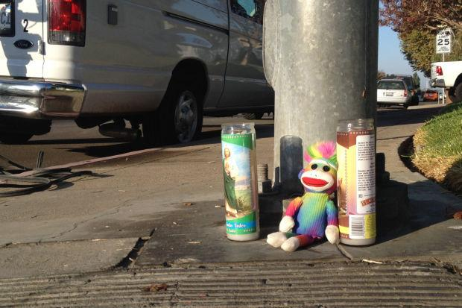
Community members begin to leave stuffed animals, cards and candles on the sidewalk adjacent to the accident scene, as a memorial to the victims.

Key Issues
- 40% of employees display signs of needing some form of post-emergency support.
- 10% of the employees have asked to go home, they are crying and are too upset to continue working today.
- 20% of off duty personnel are calling in sick for the next shift, they are too upset to come to work.
- A two employees were overheard talking about trying to find out which hospital the perpetrator was transported too. There are very angry and may wish to confront the individual.
- The media continues to request interviews with employees for their reactions to the tragic accident.

Questions
Based on the information provided, participate in the discussion concerning the issues raised in Module 2. Identify any critical issues, decisions, requirements, or questions that should be addressed at this time.

Instructions
Take 20 minutes to discuss the questions below. Assign a group scribe to document your group’s answers and a spokesperson to share your group’s findings.
- Hospitals
  - Describe the signs or symptom that employees may need post-emergency support.

  - What resources does your organization have to assist staff with post-emergency support?

    - Will these be adequate to meet the current needs for this incident?

    - Where can you get additional assistance?

  - Describe your employee debriefing process.

  - Explain your organizations Employee Assistance Program (EAP) referral process.

  - Explain the actions your organization is will take in order to maintain adequate staffing, to ensure the delivery of mission critical services.

  - Describe your policy for an employee that is experiencing a mental health crisis, e.g., has become a danger to themselves or others.

    - Does your policy address treatment against the employee’s will?

- Healthcare Facilities:

  - Describe the signs or symptom that employees may need post-emergency support.

  - What resources does your organization have to assist staff with post-emergency support?

    - Will these be adequate to meet the current needs for this incident?

    - Where can you get additional assistance?

  - Describe your employee debriefing process.

  - Explain your organizations Employee Assistance Program (EAP) referral process.

  - Explain the actions your organization is will take in order to maintain adequate staffing, to ensure the delivery of mission critical services.

  - Describe your policy for an employee that is experiencing a mental health crisis, e.g., has become a danger to themselves or others.

    - Does your policy address treatment against the employee’s will?

- Pre-Hospital Care Providers:

  - Describe the signs or symptom that employees may need post-emergency support.

  - What resources does your organization have to assist staff with post-emergency support?

    - Will these be adequate to meet the current needs for this incident?

    - Where can you get additional assistance?

  - Describe your employee debriefing process.

  - Explain your organizations Employee Assistance Program (EAP) referral process.

  - Explain the actions your organization is will take in order to maintain adequate staffing, to ensure the delivery of mission critical services.

  - Describe your policy for an employee that is experiencing a mental health crisis, e.g., has become a danger to themselves or others.

    - Does your policy address treatment against the employee’s will?
- County Agencies:

  - Describe the signs or symptom that employees may need post-emergency support.

  - What resources does your organization have to assist staff with post-emergency support?

    - Will these be adequate to meet the current needs for this incident?

    - Where can you get additional assistance?

  - Describe your employee debriefing process.

  - Explain your organizations Employee Assistance Program (EAP) referral process.

  - Explain the actions your organization is will take in order to maintain adequate staffing, to ensure the delivery of mission critical services.

  - Describe your policy for an employee that is experiencing a mental health crisis, e.g., has become a danger to themselves or others.

    - Does your policy address treatment against the employee’s will?

Appendix A: Exercise Schedule
Time | Activity
0730 - 0800 | Check-In and Registration
0800 - 0810 | Welcome and Exercise Overview
0810 - 0900 | San Joaquin County Behavioral Health Services Presentation
0900 - 0910 | BREAK
0910 - 1000 | San Joaquin Area Critical Incident Support Team Presentation
1000 -1010 | BREAK
1010 -1050 | Module 1: Initial Incident
1050 - 1140 | Module 2: Response
1140 -1200 | Hot Wash, Wrap-up and Closing Comments

This page intentionally left blank

Appendix B: Acronyms

Acronym | Term
ALS | Advance Life Support
AMA | Against Medical Advice
AAR/IP | After Action Report/Improvement Plan
BLS | Basic Life Support
CF | Control Facility
CISM | Critical Incident Stress Management
EMS | Emergency Management Services
ETA | Estimated time of arrival
HSEEP | Homeland Security Exercise and Evaluation Program
IC | Incident Commander
ICS | Incident Command System
MCI | Multi-Casualty Incident
MGS | Medical Group Supervisor
MHOAC | Medical Health Operational Area Coordinator
MICN | Mobile Intensive Care Nurse
NIMS | National Incident Management System
OA | Operational Area
PFA | Psychological First Aid
SEMS | Standardized Emergency Management System
SitMan | Situation Manual
S | Seminar
SME | Subject Matter Expert
TTX | Tabletop Exercise

This page intentionally left blank

Appendix C: Behavioral Health Service Options

Name of Service | Description | Provider | Contact Information
Psychological First Aid (PFA) | PFA is an evidence-informed modular approach to help children, adolescents, adults, and families in the immediate aftermath of disaster and terrorism. PFA is designed to reduce the initial distress caused by traumatic events and to foster short- and long-term adaptive functioning and coping. PFA is not therapy but can assist in linking to therapy if needed. | San Joaquin County Behavioral Health | 209-468-8686
Critical Incident Stress Management | The San Joaquin Critical Incident Support Team or "SJACIST" is a program for San Joaquin County consisting of volunteer chaplains and peer support personnel who work with victims of tragedy, crime, disasters and similar unfortunate events. They utilize Critical Incident Stress Management (CISM.), and are available 24 hours a day. | San Joaquin Critical Incident Support Team | (209) 373-3288
Mobile Crisis Support Team (MCST) | The MCST responds to non-emergency calls for mental health services and supports. Most referrals are through non-emergency calls for law enforcement or emergency medical assistance. Individuals and family members may contact the MCST following initial signs of difficulty associated with a mental illness. Mobile responses are typically scheduled within 48-hours of initial contact. Some callers may be referred to the BHS Crisis Unit for a more immediate response. The team uses a friendly approach to build trust. Individuals are provided with treatment options and information on how to manage symptoms and recognize the early signs of a mental health crisis. | San Joaquin County Behavioral Health | 209-468-8686
24 Hour Services Division/Crisis Intervention Services | Crisis Intervention Services is comprised of a Crisis Clinic and a Crisis Intervention Center. The Crisis phone line is a 24-hour response, with a mental health clinician on call at all times. The Crisis Intervention Center assists consumers in crisis to maintain functioning in the community to the greatest extent possible. A crisis is an event or situation that results in a person's need for immediate mental health intervention. Crisis services may be requested in person or by telephone and are provided throughout the community in San Joaquin County. | San Joaquin County Behavioral Health | 209-468-8686
Behavioral Health Outpatient Services | Provides ongoing Homeless outreach, housing, and community placement, Outpatient Psychiatric Services, case management, vocational and group therapies for Medi-Cal beneficiaries who meet medical necessity. | San Joaquin County Behavioral Health | 1-888-468-9370

Appendix D: Participant Feedback Form
Please enter your responses in the form field or check box after the appropriate selection.
Name: |  |  |  |  |  | Title:
Agency:
Role: | Player |  | Facilitator | Observer |  | Evaluator

Part I: Recommendations and Corrective Actions
- Based on the discussions today and the tasks identified, list the top three strengths and/or areas that need improvement.

- Identify the action steps that should be taken to address the issues identified above. For each action step, indicate if it is a high, medium, or low priority.
Corrective Action | Priority

- Describe the corrective actions that relate to your area of responsibility. Who should be assigned responsibility for each corrective action?
Corrective Action | Recommended Assignment

- List the policies, plans, and procedures that should be reviewed, revised, or developed. Indicate the priority level for each.
Item for Review | Priority

Part II: Assessment of Exercise Design and Conduct
Please rate, on a scale of 1 to 5, your overall assessment of the exercise relative to the statements provided below, with 1 indicating strong disagreement with the statement and 5 indicating strong agreement.
Assessment Factor | Strongly  Disagree |  |  | Strongly Agree
The exercise was well structured and organized. | 1 | 2 | 3 |  | 4 | 5
The exercise scenario was plausible and realistic. | 1 | 2 | 3 |  | 4 | 5
The multimedia presentation helped the participants understand and become engaged in the scenario. | 1 | 2 | 3 |  | 4 | 5
The facilitator(s) was knowledgeable about the material, kept the exercise on target, and was sensitive to group dynamics. | 1 | 2 | 3 |  | 4 | 5
The Situation Manual used during the exercise was a valuable tool throughout the exercise. | 1 | 2 | 3 |  | 4 | 5
Participation in the exercise was appropriate for someone in my position. | 1 | 2 | 3 |  | 4 | 5
The participants included the right people in terms of level and mix of disciplines. | 1 | 2 | 3 |  | 4 | 5

Part III: Participant Feedback
What changes would you make to this exercise? Please provide any recommendations on how this exercise or future exercises could be improved or enhanced.

https://www.fema.gov/mission-areas
https://www.fema.gov/core-capabilities
https://www.phe.gov/preparedness/planning/hpp/reports/documents/2017-2022-healthcare-pr-capablities.pdf

